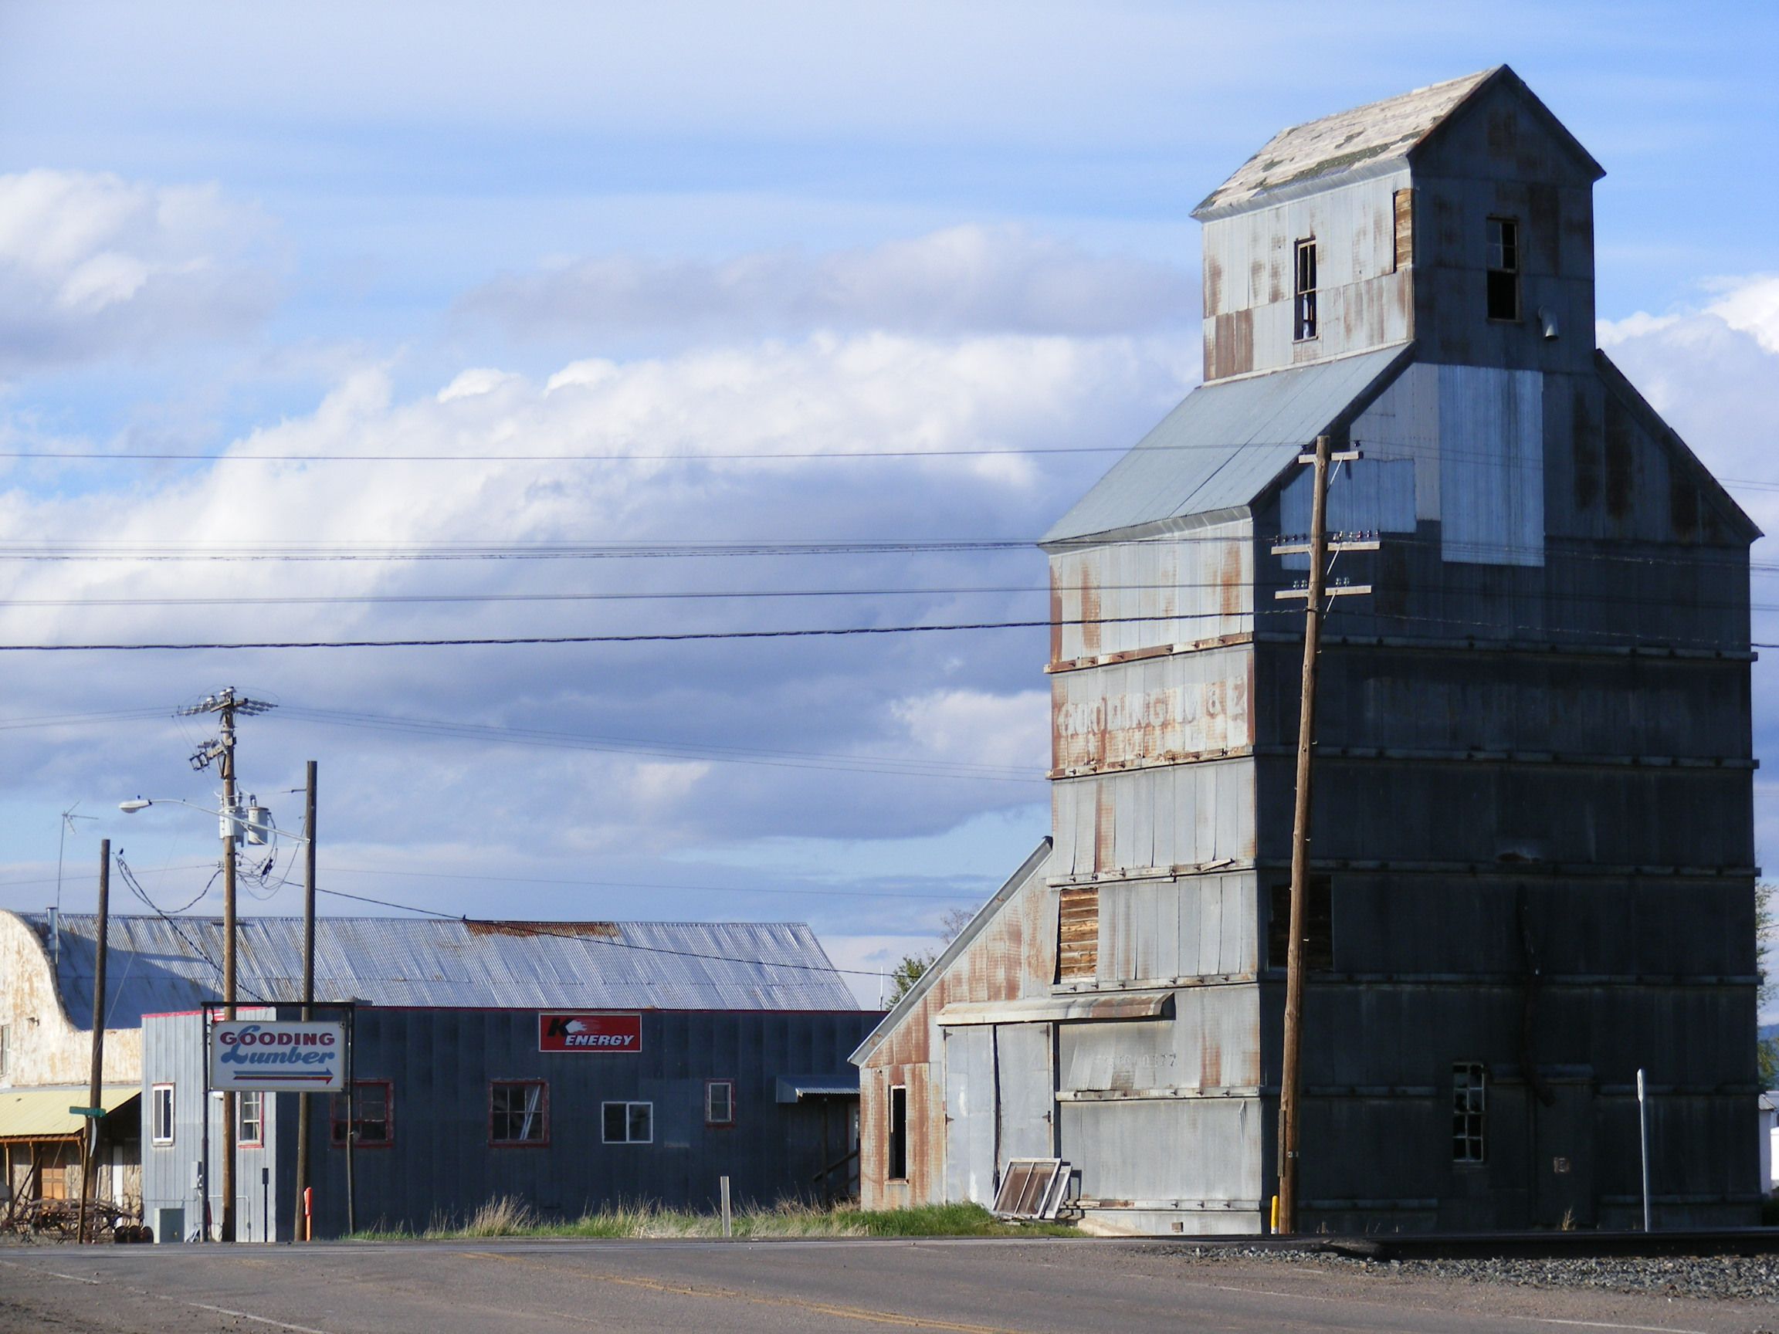
Gooding Community
Review Report

May 5-8, 2009

Cover photo by Visiting Team member Dan Everhart,
Idaho Transportation Department

Gooding Community Review
May 5-8, 2009

A report presented to
the city of Gooding and its residents by the
Idaho Community Review Program

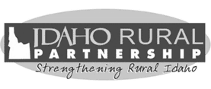

The Idaho Community Review Program is a collaboration of federal, state, tribal and local governments along with the private sector. It is coordinated by the Idaho Rural Partnership.

Contents

PART I: BACKGROUND & OVERVIEW
Introduction 1
Description of the Idaho Community Review Program 1
Monetary Value and Costs Paid by City of Gooding 2
Recent Community & Economic Development Efforts in Gooding 2
Pre-Review Survey 4
Community Expectations and Identification of Focus Areas 6
Community Identity 6
Economic Development 6
Infrastructure 7
Key Participating Individuals 7
Publicity and Public Participation 9
Review Itinerary 10
PART II: TEAM REPORTS
Community Identity 12
Community Concerns and Comments 12
Community Identity Observations, Recommendations and Resources 16
Economic Development 23
Community Concerns and Comments 23
Economic Development Observations, Recommendations and Resources 25
Infrastructure 36
Community Concerns and Comments 36
Infrastructure Observations, Recommendations and Resources 38
PART III: FINAL THOUGHTS
Community Identity 42
Economic Development 43
Infrastructure 43
What Next? 44
Conventional Strategic Planning 44
A Better Way 45
Why It Matters 48
Community Conflict Resolution 48
APPENDICES
Appendix A: Gooding Community Survey Results 52
Appendix B: Biographic and Contact Information for Visiting Team Members 80
Appendix C: Mayor’s Message, the Toponis Times, April 28, 2009 88
Appendix D: Gooding Community Review Detailed Itinerary 89
Appendix E: Write-up concerning restoration of the Schubert Theater by Visiting Team member Dan Everhart 92

Acknowledgments
The Gooding Community Review Visiting Team and coordinators thank the citizens and leaders of Gooding for sharing their opinions and ideas. The depth of caring for the community and each other showed.
The Visiting Team specifically thanks Mayor Duke Morton, Kelly Bangerter and the rest of the Gooding Home Team for the time and effort invested in preparing for our visit. Thanks also to the Lincoln Inn, Gooding Memorial Hospital, Sally’s Office Solutions, Gooding High School, the Schubert Theater, Gooding Senior Center, Gooding County Cooperative Extension and the Gooding County Commission for hosting meetings and other events and to all of the community’s citizens and leaders who took the time to meet with the Visiting Team.
Sponsoring Agencies & Organizations
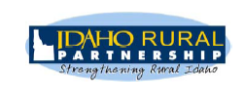
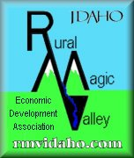
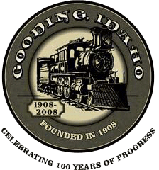

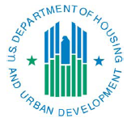

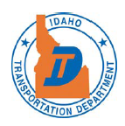

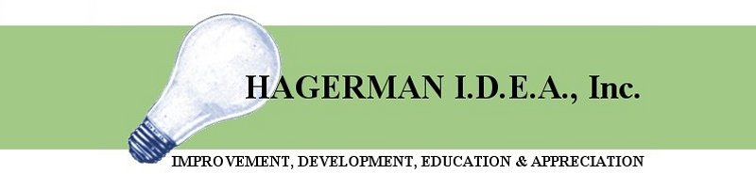
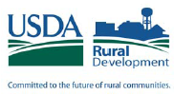





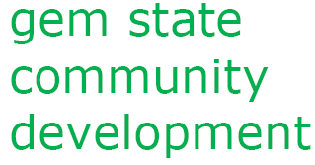
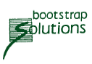

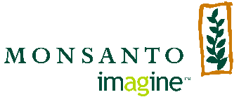

Lincoln County
Chamber of Commerce

PART I: Background & Overview

Introduction
This report describes activities, community concerns, observations, recommendations and resources associated with the community review that occurred in Gooding from May 5-8, 2009. Gooding is the 20th community to participate in the Idaho Community Review program.
The Gooding Community Review Visiting Team encourages the mayor and City Council to find ways to share this report with Gooding residents, especially the community leaders and citizens who participated in the review. We hope you continue to engage these folks and return to this report often as you follow through on your intention to create a new community strategic plan.
Individual organizations like the Rural Magic Valley Economic Development Association, Gooding Chamber of Commerce, Gooding School District and various service organizations and providers will also glean insight from the practical, outside perspective found in these pages.
Some members of the Visiting Team might be available to help you consider this report’s recommendations and follow up with available resources. But it is ultimately up to the community to determine the path that makes sense to bring about the positive changes you desire.

Description of the Idaho Community Review Program
The Idaho Community Review program provides observations, recommendations and potential resources to Idaho communities with populations of 10,000 or less. The communities participate in the program to better understand how they might effectively approach long-standing and emerging community issues and opportunities. This information is provided by a team of 12 to 18 professionals referred to as the Visiting Team. They have expertise in various aspects of community and economic development. The Visiting Team spends three days in the community learning about issues through tours, meetings and interviews with community leaders and residents. The review concludes on the evening of the third day with a presentation to community leaders.
The program cannot instantly resolve all issues, but it has been evaluated as an invigorating, validating and unifying experience by the 19 communities that participated before Gooding. Community reviews also provide invaluable networking opportunities, setting the stage for future resource referrals and follow-up activities.
Coordinated by the Idaho Rural Partnership, the Gooding Community Review was a collaborative project of the partnership, the city of Gooding, the Idaho Department of Commerce, the Idaho Transportation Department, the U.S. Department of Housing and Urban Development, USDA Rural Development and other federal, state, local, nonprofit and consulting organizations.

Monetary Value and Costs Paid by City of Gooding
The in-kind value of community reviews is estimated at $50,000 to $75,000. This includes the cost of hiring 12 professionals in land use planning, transportation, civil engineering, economic development, arts and other cultural resources, communication, grant funding and other fields of expertise for three 14-hour workdays. Pre-review planning, travel, staff time, report writing and review follow-up are all generously donated to the community by various state and federal agencies or are underwritten by private industry donations.
As with other community reviews, the direct costs to the city of Gooding were limited to food and transportation for the Visiting and Home Teams during the actual review and any city staff time spent on coordination.

Recent Community & Economic Development Efforts in Gooding
To the community’s credit, several community and economic development projects have been completed in the last few years or were under way at the time of the community review. A few notable examples are summarized below.

Gooding County Memorial Hospital
The new hospital is being built on the south side of town. When completed later this year, it will provide a higher level of care and more privacy than is currently available. Once vacated, the existing hospital will likely be available for re-use.

Basque Cultural Center
The Basque Cultural Center was completed by the Basque Association in 2003. It is used by the association to celebrate the Basque culture through food, dance, language and other activities. The Basque Picnic is one of the community’s major annual events. The cultural center is also available for rent by other community groups and private parties.

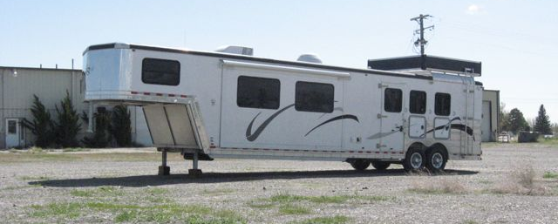
Industrial Park and Kiefer Built
Located on the north side of town along the Union Pacific Railroad mainline, the 80-acre Gooding Industrial Park was created in 2004. Kiefer Built, a manufacturer of horse trailers, leased a 126,000-square-foot building at the industrial park in 2005. Output at the facility has slowed of late but is expected to pick back up as economic recovery proceeds. Properties zoned industrial or manufacturing remain available at the industrial park.
New Gooding County Historical Museum
The museum will soon be constructing a larger and more modern facility near the site of the new hospital and Basque Cultural Center. The museum will vacate its historic, central location on Main Street. The community may have an opportunity to re-use this existing space for another purpose.

Comprehensive Plan
Gooding adopted a new comprehensive plan in 2007. It includes all of the elements required by the Idaho Local Land Use Planning Act, and it replaces the city’s first comprehensive plan dated 1976.

Irrigation System Study
In 2008 the city commissioned Keller Associates to investigate the irrigation system, recommend improvements and estimate related capital costs. The study is currently in draft form. It identifies three major alternatives: (1) rehabilitate and continue to use the existing system; (2) install a new pressure irrigation system that would continue to draw water from the Little Wood River; or (3) augment the culinary water system so that it can be used for irrigation. A public meeting to present information gathered to date and to solicit citizen input was attended by 50 people on May 13, 2009, and an advisory committee was created.

Airport Layout Plan
Completed in 2008, the Airport Layout Plan projects capital improvement needs at the Gooding Municipal Airport and prioritizes them over the next 20 years. It updates a similar plan completed in 1995. Specific projects identified in this plan include lengthening the runway, improving taxi lanes and parking areas, building a security fence, replacing hangers and making technological improvements.

Chamber of Commerce Revitalization
Over the last year, the Gooding Chamber of Commerce has been revitalized by increasing the number of member businesses and developing new leadership.

Participation in Rural Magic Valley Economic Development Association
As a member of the Rural Magic Valley Economic Development Association, the city of Gooding is cooperating with 11 other area cities and counties to improve the region’s economic well-being through job creation, work force development and commercial investment.

New sidewalks along 7th Street
New sidewalks with curbs and gutters have been constructed over the last few years to increase the safety of children walking to and from school. The improvements were financed by transportation enhancement grants from the Idaho Transportation Department.

Pre-Review Survey
As with most community reviews, the city of Gooding conducted a non-scientific survey of residents in the weeks leading up to the review visit. Surveys were made available at the library and were sent to every address on the city’s water system. They were also available on the city’s Web site.
A total of 145 individuals completed the survey with 86 percent being Gooding residents. This was impressive compared to other community reviews although the respondents did not reflect the cultural diversity of the community. A copy of the survey results is included as Appendix A.
Survey respondents expressed the highest level of satisfaction with the following community features:
- Health resources (with one exception noted below)
- Police and fire protection
- Transportation and roads (with one exception noted below)
- Water and wastewater resources
- Library
- Schools
- Community appearance (with one exception noted below)
- Social climate (e.g. friendliness)
- Local goods and services (with exceptions noted below)
Respondents gave their lowest marks for the following community features:
- Bicycle and pedestrian access
- Parks and recreations, especially recreation for teenagers
- Long-range planning and community involvement in decision making
- Local arts and cultural opportunities
- Mental health services
- Condition and availability of housing, especially rental units
- Appearance of gateways to the community
- Availability and quality of local jobs
- Lack of adequate hotel/motel accommodations and entertainment options
- Usability and helpfulness of city Web site
When invited to express themselves using their own words, survey respondents brought up these ideas and concerns most frequently:
- Appreciation for Gooding’s safe, friendly, small-town atmosphere. People in Gooding tend to watch out for each other. The safety, sense of community, and support for schools make it a great place to raise children.
- Residents recognition that something needs to be done about the irrigation system. But they did not necessarily express a detailed understanding of the problem or of viable alternatives. Some feel it is unfair to be required to pay for irrigation water that they cannot use.
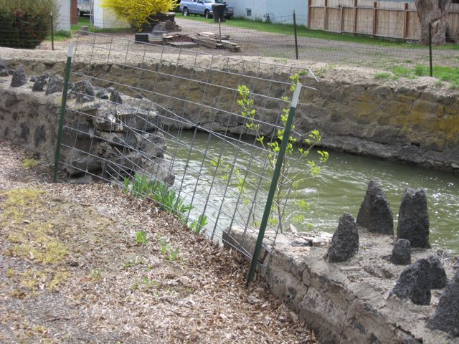
- The Little Wood River Canal wall even more frequently than the irrigation system. Clearly, residents want something done to address the hazardous condition of the wall. Some expressed support for a greenbelt-type pathway along the canal.
- A broad awareness that the debate about the North Valley Academy Charter School is divisive. Some appreciate having an alternative to the traditional Gooding schools while other are concerned about how these same schools are being impacted or could be impacted by the charter school.
- Relations between different ethnic groups in the community, particularly with respect to the Hispanic population.
- The appearance of abandoned buildings, unkempt, “trashy” yards and properties and excessive weeds.
- The strong community desire for more and higher quality jobs for young people and others.
- Strong support for sidewalks and greenbelt-like pathway improvements to make walking, biking and recreating in Gooding safer and more enjoyable. These ideas were mentioned at least as much as those involving streets.
- More transparent, inclusive communication from city hall and other agencies. They also desire opportunities to become meaningfully involved in decision-making and community development initiatives. They expressed uncertainty and some cynicism about how decisions are made by “the same few people.”

Community Expectations and Identification of Focus Areas
In its community review application to the Idaho Rural Partnership, the city of Gooding expressed its desire to receive information about the perceptions of both residents and the Visiting Team community development experts from outside the community regarding city services, economic development and the community’s self-image and identity.
The application also expressed the City Council’s intention to develop a strategic plan based on the issues, ideas and opportunities revealed through the community review process.
All communities requesting a community review are asked to select three subject areas with which they need assistance. The Visiting Team is then created and the review itinerary designed with these subjects in mind. The city of Gooding selected:

Community Identity
Community identity refers to the set of ideas and experiences a community uses to express and describe its history, values, sense of place and vision. It is the story a community tells itself and the larger society about what it is and what is important to it. In other words, what makes Gooding Gooding? It is the community’s self-image. In some ways, Gooding’s identity is similar to other communities in Idaho. In other ways, it is what sets Gooding apart. Through the review, the city sought ideas about how to create a focused community vision and purpose while honoring the many cultural and physical elements that make up its identity.
In some past community reviews, especially in cities which are rapidly growing or developing revitalization efforts, this focus area has also included topics related to community design. While some design-related issues were touched on during the review and are explored in this report, the community identity team spent the majority of its time and energy looking at the more social and cultural dimensions of community identity. Other communities have used the ‘civic life and community involvement’ focus area to look at similar issues.
The members of the Visiting Team assigned to look at community identity met with about 50 Gooding residents in small stakeholder groups of five to 10 people each during the community review. These individual groups are identified on page 10.

Economic Development
Economic development includes supporting the growth of existing businesses, assisting current residents who want to start new businesses and attracting new businesses from outside the community. The desire and responsibility to help support and expand existing business was specifically described in the city’s community review application. The economic development focus area team’s observations and recommendations are based on the six stakeholder group meetings it conducted.

Infrastructure
The city is clearly aware that its most urgent infrastructure issues are the irrigation system and the Little Wood River Canal and wall system. While indirectly related, there is a major difference between the two issues. Because it is the city’s responsibility to operate it, addressing problems with the irrigation system is squarely on the city’s shoulders. In essence, it is a city-owned utility not unlike the sewer and culinary water systems. Conversely, rebuilding or rehabilitating the river canal and wall system will require a strong partnership between the city and the U.S. Army Corps of Engineers.
Infrastructure also includes Gooding’s culinary water system, sewer system, streets and sidewalks and airport. In some community reviews, public safety – police and fire protection – and city administration are also included in the infrastructure focus area. In Gooding’s case, no significant administration or public safety issues or needs were specifically identified in the application or during the review itself.

Key Participating Individuals
Locally, success of the Gooding Community Review is largely due to the work of Gooding Mayor Duke Morton, Kelly Bangerter of the Rural Magic Valley Economic Development Association, Greg Wokersien and Adrian Celaya. Additional credit and thanks must also go to Gooding County Commissioner Helen Edwards, city of Gooding Public Works Director Todd Bunn, City Clerk Carmen Korsen, Police Chief Jeff Perry, the Gooding City Council, Gooding County Memorial Hospital Administrator Earl Fitzpatrick and staff, business owner Sally Walker and Gooding Senior Center Director Lynn Corbett. Finally, the Gooding Community Review could not have happened without the more than 125 community leaders, business owners and residents who chose to spend time meeting with members of the Visiting Team.
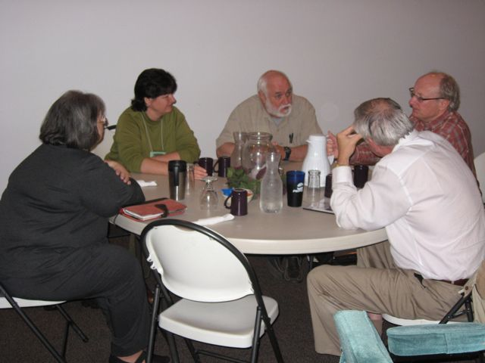
The Visiting Team was composed of 12 community and economic development professionals, who were recruited based on their experience and expertise with Gooding’s selected focus areas. They came from local, state and federal agencies and from nonprofit organizations and private consulting firms. A biography and contact information for each Visiting Team member is included as Appendix B.
The following individuals worked with the Home Team and Visiting Team to coordinate pre-review planning and on-site logistics:
- Shelby Kerns, Idaho Rural Partnership
- Vickie Winkel, Idaho Rural Partnership
- Brian Dale, U.S. Department of Housing and Urban Development
- Jerry Miller, Idaho Department of Commerce
- Jon Barrett, Clearstory Studios
Individual Visiting Team members are identified below by focus area.

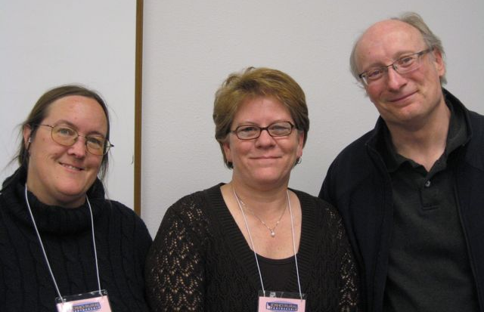
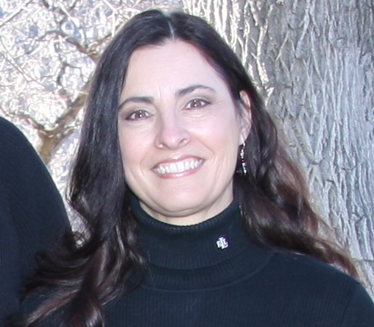
Community Identity team members (left to right) Sharon Fisher, focus area leader, Lynn Hoffmann and Dick Gardner.
Community Identity team member Julie Oxarango-Ingram.

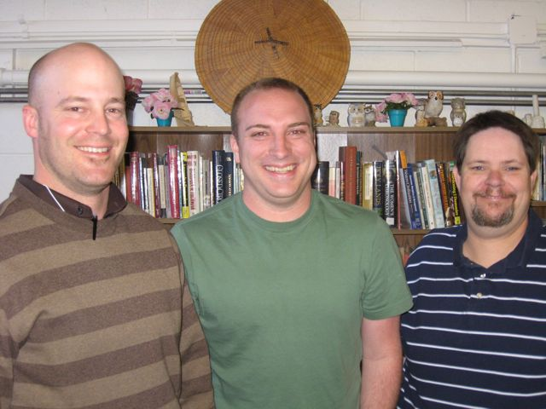

Economic Development team members Randy Wheatley, Dan Everhart and Jerry Miller, focus area leader.

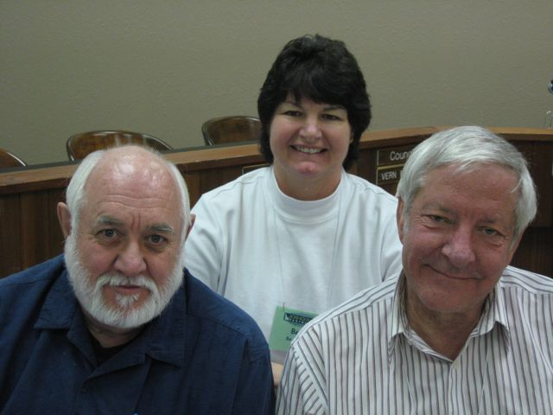
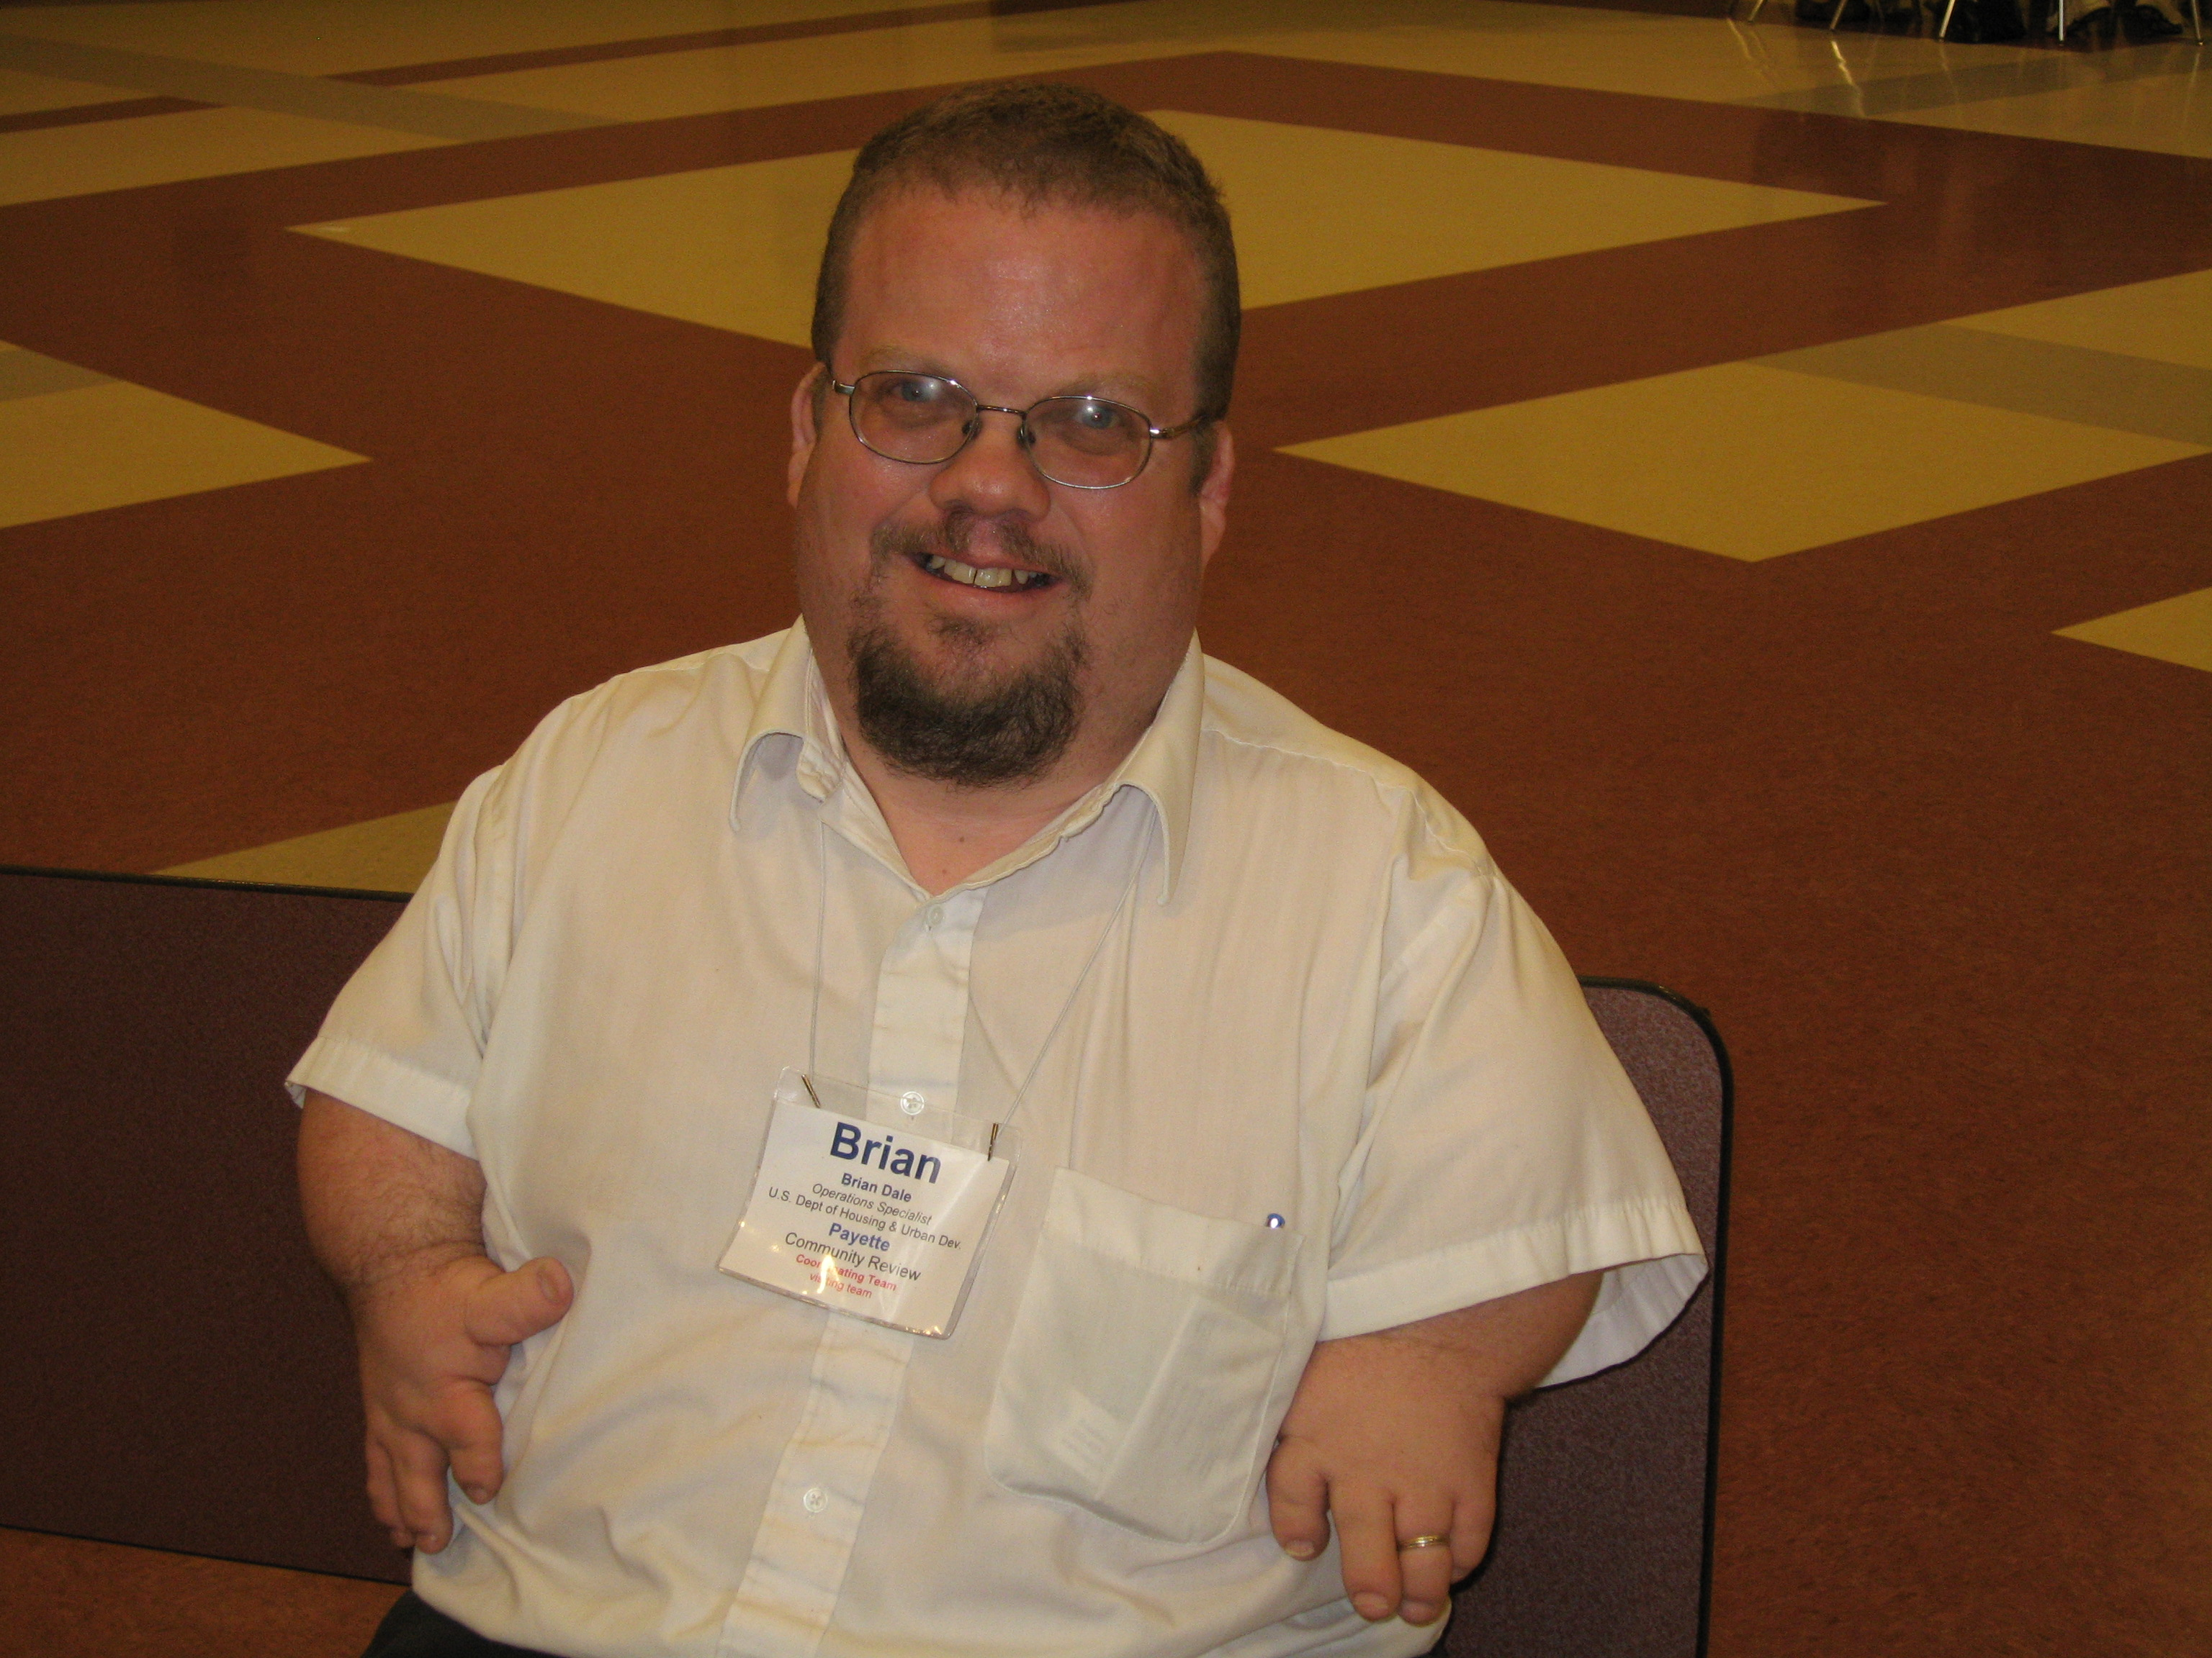
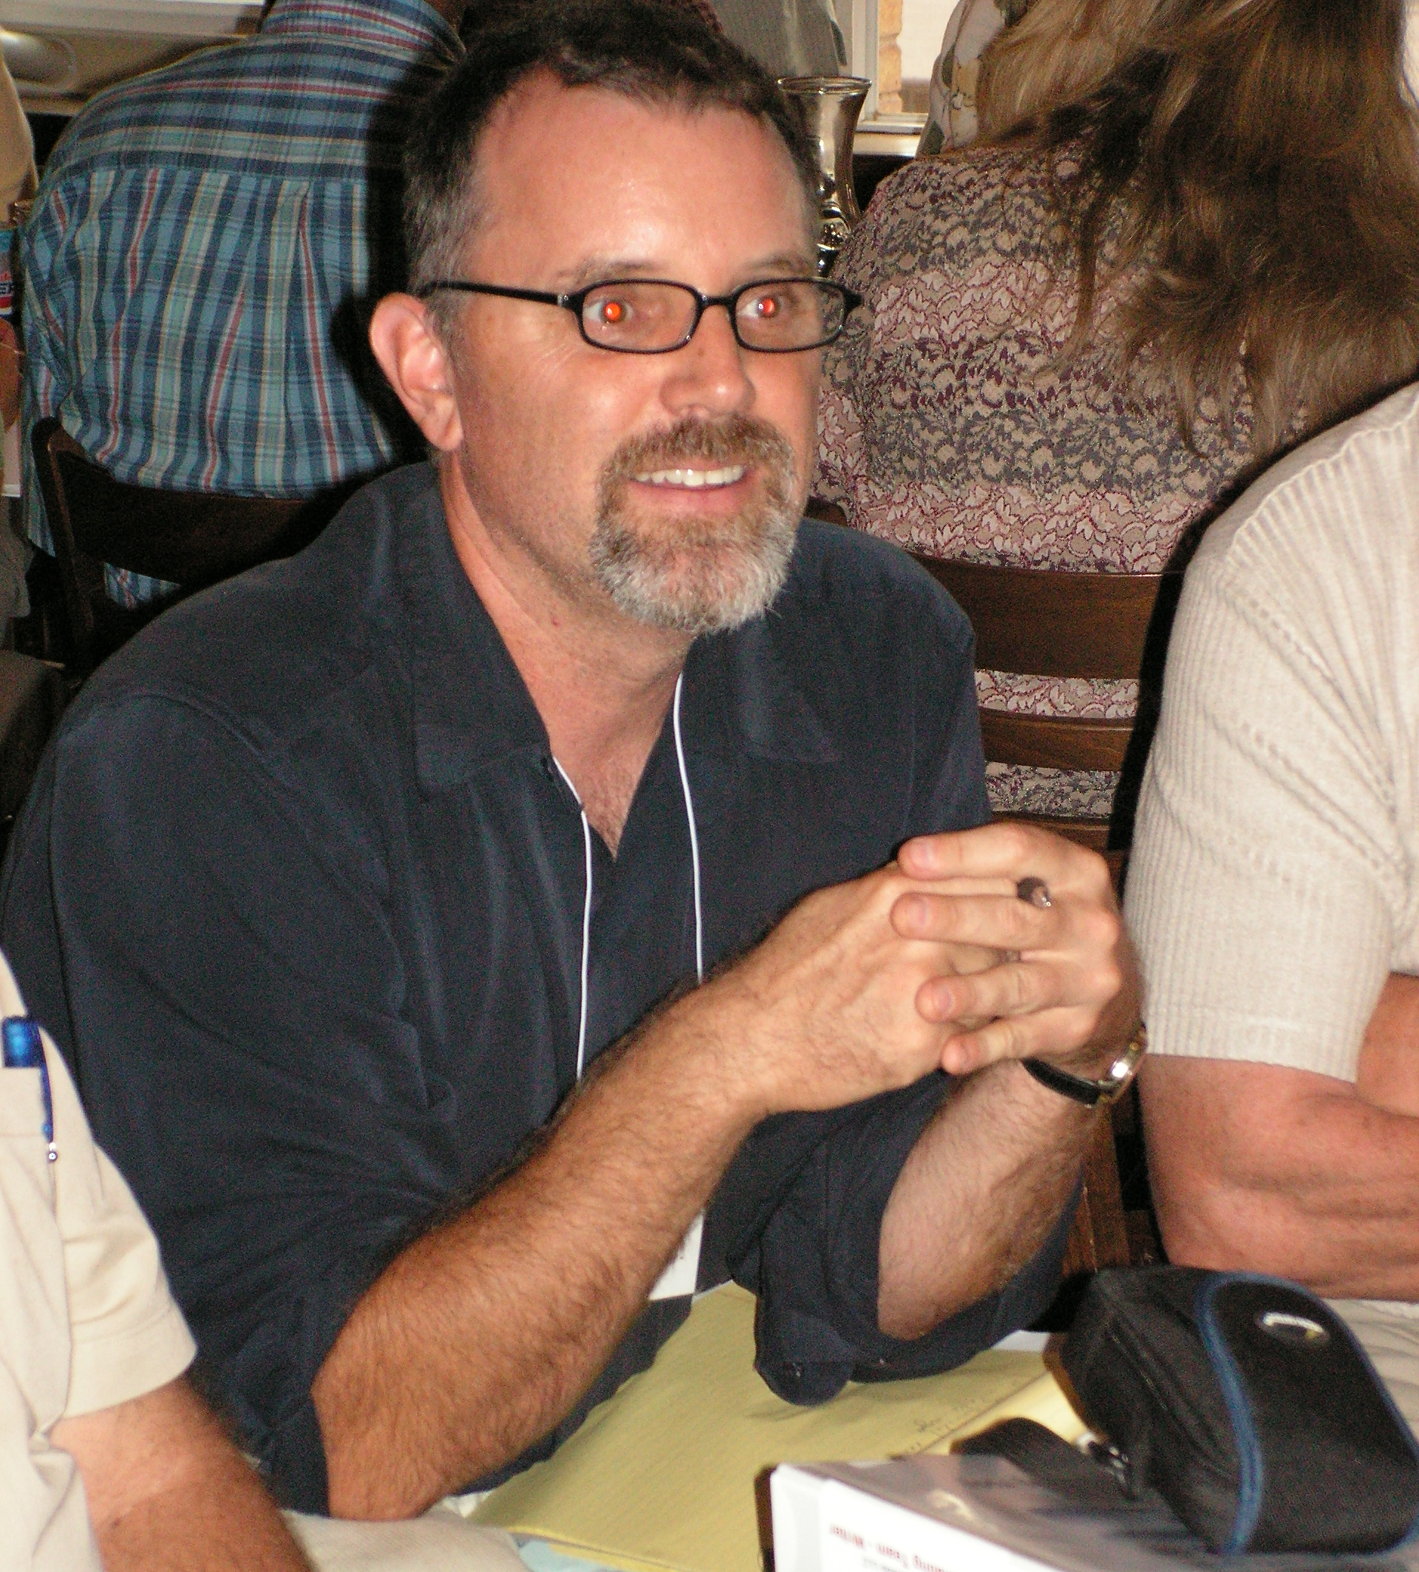
Economic Development team members Jim Scott, Becky Dean, Pat Madarieta, focus area leader.

On-site coordinators for the Visiting Team Brian Dale (left) and Jon Barrett.

Publicity and Public Participation
Pre-review publicity included a front page “Mayor’s Message” column in the April 28, 2009, Toponis Times that focused on the community review. This column is included as Appendix C. Editor Sally Walker again publicized the review in her “Editor’s Note” on the bottom of the front page. Notices about the community review were also posted in visible locations in the Gooding City Hall.
Public participation was strong throughout the review. Local folks who participated in the various small group meetings were 100 percent engaged and eager to share their perspectives and experiences. Approximately 25 people attended the town hall meeting.
But there were a couple of issues related to public participation. Opportunities for the Visiting Team to have informal conversations with Gooding residents and young people were limited. Whether in the formal stakeholder group meetings or the informal conversations, the Visiting Team also had limited interaction with Basque, Hispanic and other ethnic groups in the community. Additional interaction of this kind would have been beneficial, given that over 15 percent of Gooding’s population is Hispanic.

Review Itinerary
A complete itinerary for the May 5-8 Gooding Community Review is attached as Appendix D.
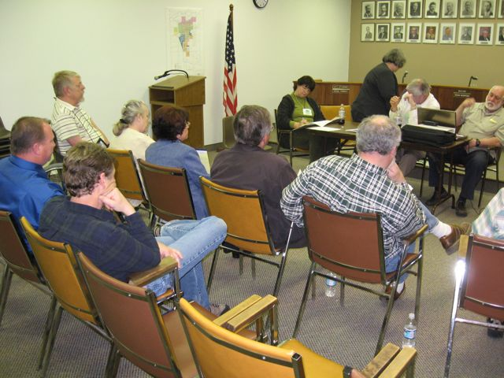

PART II: Team Reports

Community Identity

Community Concerns and Comments
Community identity refers to the set of ideas and experiences a community uses to express and remember its history, values and sense of place. It’s the story the community tells itself and the larger society about what it is and what is important to it. In other words, what makes Gooding Gooding? It is the city’s self-image. In some ways, Gooding’s identity is similar to other communities in Idaho. In other ways it is what sets Gooding apart.
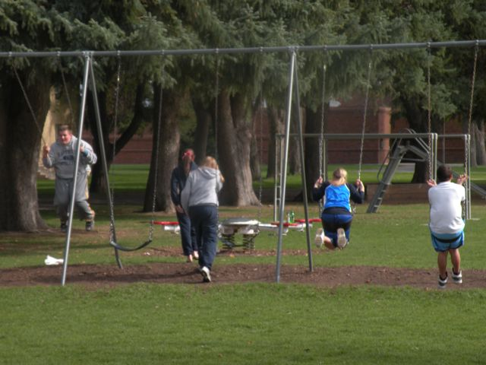
Community identity clearly relates to both economic development and infrastructure. A community’s experience with past community and economic development projects including those that were most successful and those that did not reach their intended goals influences its thinking about what is possible. These experiences also affect perceptions of what a community can do for itself versus what it needs help from outside sources to achieve. Also, a community’s identity can be used to build broad consensus around the type of new businesses a community wants to encourage and the amenities it chooses to create or improve.
Describing a community’s identity is not much easier than describing a nation’s identity. Each member of the community has his or her own experience, and transcribers are interpreting what they are hearing from their unique perspectives. Still, the five members of the community identity focus area team can confidently report that a few major themes emerged from meetings with about 50 Gooding residents in small stakeholder groups of five to 10 people each. The individual groups are identified on page 10. These themes were used as a basis for the observations, recommendations and resources that follow.
Gooding citizens in all of the stakeholder groups and the respondents to the pre-review community survey spoke often and eloquently about the safety, peace and quiet and neighbor-to-neighbor friendliness in Gooding. Other more specific themes are summarized below.
Agricultural and Western Heritage
Gooding citizens and leaders acknowledged and appreciated the area’s agricultural and western heritage. This heritage continues to evolve due to economic and other factors. It remains an important part of Gooding’s identity, expressing itself through various community events –many of them involving horses – businesses and values about self-sufficiency and a cooperative, helpful spirit.
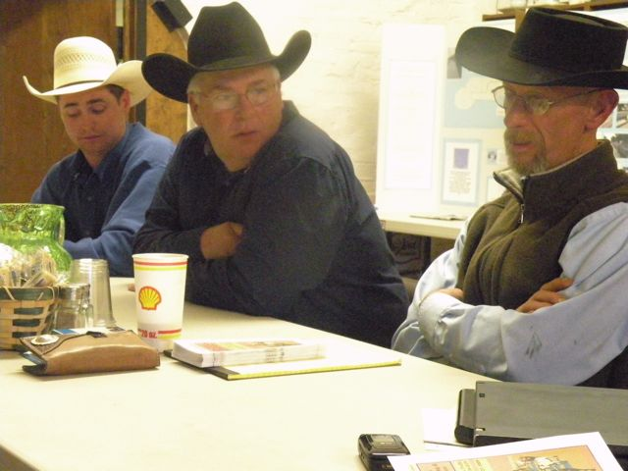
At the same time, people who have no direct connection to agriculture have moved into the area in recent years. Farmers and ranchers are pretty practical people. They think in terms of functionality. If something breaks, they might just hold things together with baling wire and call it good. They’re used to a few rough edges in their communities.
The presence of the Idaho School for the Deaf and the Blind, Gooding Memorial Hospital and Walker Center have added a cadre of educated service professionals to this otherwise ag-based community. These service professionals and their spouses are going to be more focused on quality of life and the amenities that a community offers. Additionally, these institutions bring out-of-town visitors to Gooding, who are forming first impressions based on appearances. Taking care of appearance and continuing to develop amenities is going to help Gooding be the kind of town that attracts skilled workers and employers and keeps retirees, visitors and commuters happy. This will also help Gooding become the kind of community that young people will want to return to as adults.
Cultural Diversity
Gooding’s cultural diversity was also a major topic. The community has significant populations of Basques, Portuguese, Peruvians and Hispanics. It seemed the degree to which a group was thought of as fully integrated into the community was in part a function of how long they’ve been present. For example, the Basque culture is woven into the community fabric. The Basque Picnic is an event in which the entire community participates. On the other hand, there were comments and perceptions that the Latin cultures, being more recent arrivals, don’t have the same level of formal interaction with the other more established groups.
Until relatively recently, Gooding was accustomed to having Latino residents on a seasonal basis, but that is changing. Latinos are moving into Gooding permanently, getting full-time jobs, buying houses and slowly entering the middle class. Some in the majority culture expressed a perception that Latinos don’t want to socialize with anyone but each other and have little to no interest in learning English.
Others told a different story. For example, it was also said the reason more Latinos didn’t volunteer at the schools is because they were shy and embarrassed about their perceived lack of formal education and about not knowing the language. Those teaching English as a Second Language classes said they are always full. The Latino community may not know culturally how to go about getting involved in the schools or in the greater community, but that doesn’t necessarily mean they don’t want to be involved.
Building bridges across cultures is vital to creating a safe and inclusive community where all feel appreciated and accepted. Gooding cannot afford to be a community of 2,400 Anglos living next to 800 Latinos. The full population is needed to keep many local businesses open and thriving. Latino purchasing power has been growing much faster than average in recent years. It is in everyone’s best interest to build a community that functions across cultural differences.
Youth
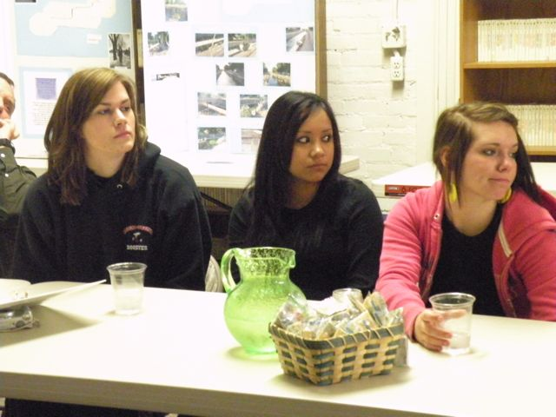
People of all ages talked about the qualities in Gooding that make it a great town in which to raise a family. The high school students participating in the review were happy to have grown up in Gooding. Community leaders and parents can be proud that a high number said they intended to either live in Gooding after graduation or return to Gooding after experiencing life elsewhere for a period of time. They expressed appreciation for the community’s historical structures, parks and its friendliness. They valued community service and seemed open to additional opportunities for service were they are presented. In the next breath, they expressed the time-honored refrain of the teenager: “there’s nothing to do in Gooding” or “there’s not enough to do outside of school.” Youth also expressed a desire for more local part-time job opportunities.
Young people expressed a perception that the community’s youth pregnancy rate is high, though this could not be verified with state statistics. Substance abuse is rising with marijuana and alcohol being reported by students as easy to get.
The North Valley Academy Charter School and its relationship with the Gooding School District was by far the most frequently raised youth-related issue. Many expressed their perception that everyone in town has an opinion and that it was THE hot-button issue. Some went so far as to say it’s dividing the town’s residents. Students discussed bullying that happens on busses ridden by both charter school and regular school district students. Charter school kids are easily identified because of the school’s dress code. Students from the two high schools also said parents were driving the conflict. One student used the words “ridiculous” and “out of hand” to describe his take on the situation.
Our conversation with school leaders suggested the relations between the charter school and the school district are becoming somewhat more cooperative than they were this past winter. The passion with which school leaders and residents talk about the issue reflects the priority the community places on its responsibility to prepare youth to be productive adults, parents and leaders in the 21st Century. Continued civil discourse that respects the interests of each group is the key to moving forward. While each side has legitimate self-interests, each side must also be sensitive that its actions may have profound impacts on the other. All have an interest in sustaining a vibrant and successful education system in Gooding.
Citizen Engagement
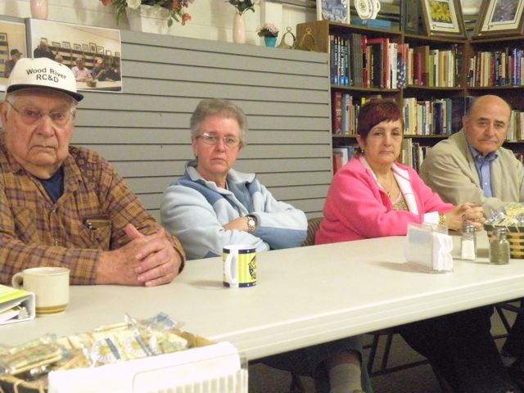
Citizen engagement refers to how the community comes together to build consensus, make decisions and act to achieve goals. Relationships between city hall, businesses, residents and community-based organizations are part of citizen engagement. In approaching Gooding citizens and leaders, focus area team members asked themselves if people in Gooding are accurately informed about community affairs and feel they can play a meaningful role in improving the community. Many communities struggle with such questions.
People expressed discouragement that more doesn’t get done in Gooding. The same people step up and the others stay seated. It was said that neighbors tend to rally around neighbors, but the community as a whole struggles to come together to find solid solutions to larger problems. With competition rising for community development grant funding and funding at all levels staying flat at best, it has never been more important to show funding agencies and organizations that the community has involved all relevant stakeholders in a collaborative fashion in the development of community projects.
The community has every reason to be proud of several significant accomplishments. The completion of the outdoor swimming pool project four years ago is just one example. Donated materials and labor allowed the pool to be built for $275,000 rather than the $400,000 to $500,000 typical cost of a pool this size. The observations, recommendations and resources in this report will help Gooding take advantage of opportunities to continue to complete projects by engaging the community in this way.

Physical Amenities
Citizens repeatedly expressed appreciation for the community’s historical and physical assets. These include:
- The CCC-built Little Wood River Canal and Wall
- The rodeo and fair grounds
- The downtown and, in particular, the Schubert Theater, Lincoln Inn, Sally’s and Cook’s Food Town among others
- The Idaho School for the Deaf and the Blind
- The various parks in the community
- Home and other structures built with lava rock
- The airport
There is one other aspect of Gooding’s identity that relates to its physical qualities. There is plenty of evidence that Gooding residents take pride in taking care of their homes and properties. While it didn’t come up as much in conversation during the community review, many respondents to the pre-review survey voiced concern about residential and commercial properties being taken over by weeds, dilapidated vehicles and other refuse.

Community Identity Observations, Recommendations and Resources

OBSERVATION 1: The qualities that make Gooding a great place to raise kids and grandkids are a significant part of the community’s identity. Continue to reinforce and expand these qualities.
Recommendations
- Enlist service and other organizations to create additional opportunities for youth to be mentored by caring, responsible adults.
- Engage youth, parents and other residents in efforts to develop youth-oriented amenities and programs.
- Continue to look for ways to include youth in government and community organizations. The ongoing creation of the Youth Advisory Council is an excellent start.
- Continue to develop programs and activities for youth through the Fifth Day Coalition to prepare students and the community for the change to a four-day school week.
Resources
- The Association of Idaho Cities’ Youth Engagement Resources is an excellent collection of available resources to involve youth in community decision-making and strengthen youth and their families, www.idahocities.org/index, (208) 344-8594.
- Mandy Decastro at the city association is an excellent source for advice regarding creating a Youth Advisory Council, MDecastro@idahocities.org. Cities that have created successful Youth Advisory Councils include Caldwell, Rexburg, Meridian and Eagle.
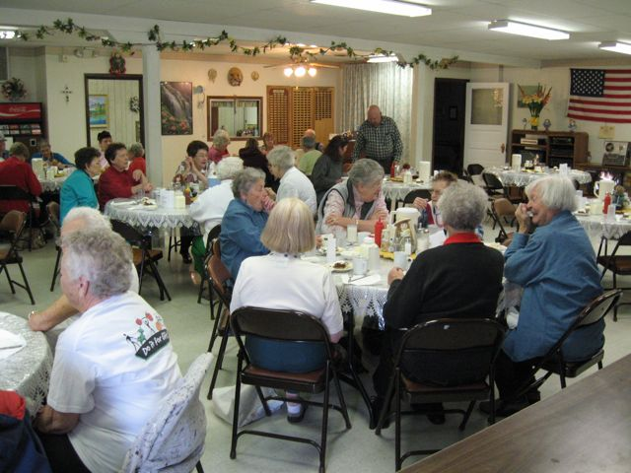
- Search Institute is an independent national nonprofit organization that provides leadership, knowledge and resources to promote healthy children, youth and communities. The institute is most known for its 40 Development Assets, which are positive experiences and personal qualities that young people aged 12 to 18 need to grow up healthy, caring and responsible, www.search-institute.org.
- Missoula Children’s Theater, www.mctinc.org, tour@mctinc.org, (406) 728-1911.
- Idaho Shakespeare Festival has a youth program that was formerly the Idaho Theater for Youth, http://www.idahoshakespeare.org/community.html, (208) 429-9908, ext. 3.
- The Cabin, formerly Log Cabin Literary Center has a Mentoring Young Writers in the Classroom program, http://thecabinidaho.org.wits.htm, (208) 331-8000.
- “The Station” Youth Recreation Center in Soda Springs is a successful, award-winning, volunteer-run youth center housed in the former police station, information available though the Soda Springs City Hall, (208) 547-2600.
- Idaho Department of Commerce Community Development Block Grant Program, http://commerce.idaho.gov/communities/block-grants.aspx, Dennis Porter, manager, dennis.porter@commerce.idaho.gov, (208) 334-2470. Porter and his team have recently helped communities including Deary, Blanchard, Worley and Blaine County explore interest in building community centers and will be able to provide local contact information as well as funding options. The program has also funded Boys and Girls Clubs in Lapwai and Garden City.
- The Tony Hawk Foundation has awarded grants for the construction of skate parks in Buhl, McCall and New Meadows, http://www.tonyhawkfoundation.org/grant_application.asp.
- The National League of Cities has resources for involving youth in the community, www.nlc.org/IYEF.
- National Safety Council has grants that promote safety and health among youth including the possible development of a safe greenbelt or recreational/educational trail, www.nsc.org/youthsafety.
- Paul G. Allen Foundation provides funding opportunities for investment in youth engagement in their communities, www.pgafoundations.com.
- Youth Venture has information about using youth for community needs and helpig youth create their own “ventures” by providing seed money, www.youthventure.org.
- The Idaho State Department of Education Web site on rural education includes extensive information about four-day school weeks, http://www.sde.idaho.gov/site/ruraleducation/.
OBSERVATION 2: Gooding’s sense of community can grow even stronger by embracing its ethnic diversity in the way that the community has come to embrace the Deaf and Blind School and by building on the existing strong connection between the community and the Idaho School for the Deaf and the Blind.
Recommendations
- Seek out additional opportunities to develop deeper connections between the school’s leadership, students and families and the community at large. One example would be to develop a program to enable students to experience direct contact with horses and the community’s western heritage.
- Create a community project to share and document the ethnic heritage, family histories and customs of Gooding residents.
- Use formal and informal communication networks such as churches, schools, service organizations and employers to make sure people in all groups in the community are aware of opportunities to offer their skills and experience in the completion of community projects, as Observation 3 suggests.
- Recruit people to existing boards, commissions and committees so they represent the community’s diversity.
- Create a human relations advisory committee that would seek and provide input on ways for the city and county to make Gooding a welcoming home for Latinos and other ethnic groups.
Resources
- Idaho History Center, Kathy Hodges, oral historian, Kathy.hodges@ishs.idaho.gov, (208) 334-3863,.
- ”Changing Faces, Changing Communities” is a publication written by Everyday Democracy to help communities face the challenges and meet the opportunities raised by the arrival of newcomers including pointers on how to involve public officials, http://www.everyday-democracy.org/en/Resource.23.aspx.
- Idaho Human Rights Education Center offers lesson plans and reading lists to help teachers in communities with the diversity of Gooding, http://www.idaho-humanrights.org/Education/education.html, info@Idaho-humanrights.org, (208) 345-0304.
- Idaho Inclusiveness Coalition is a non-profit organization formed in 1999 to develop and implement strategies for creating inclusive communities in Idaho, http://www.idahoincludes.org/, info@idahoincludes.org.
- Idaho Public Television’s Web site includes a directory of organizations and agencies across Idaho working on diversity-related issues, http://idahoptv.org/outreach/diversity/directory.html. It also includes narrative examples of human rights and diversity-related actions in Idaho, http://idahoptv.org/outreach/diversity/idcmsns.html.
- Gloria Galan, Latina community leader and former member of Twin Falls City Council, (208) 734-8297.
- Gladys Esquibel, Burley area Latina community leader, (208) 878-5104.
- Caminemos Juntos – Let’s Walk Together – is a non-profit organization in Lincoln County formed to bring together Latinos, organize family friendly activities and organize volunteers. It is now open to people of all cultures in an effort to bridge cultural divides in the community. Delores Vega, (208) 421-2705 or Manuel Rodriguez, (208) 721-7019.
- The Alabama Institute for Deaf and Blind’s Marianna Greene Henry Special Equestrian Arena may be a source of information and inspiration regarding the use of horses with Idaho School for the Deaf and the Blind students, http://www.aidb.org/, (256) 761-3200.
- The Idaho Community Action Network conducts a number of workshops and training sessions on farm worker and immigration issues. http://idahocan.org/, Leo Morales, (866) 385‐9146.
- Center for Community and Justice, which works with communities to address education and health care issues, may be able to offer cultural awareness training to both the Hispanic and Anglo communities, http://comunidadyjusticia.org/index.html, Sam Byrd, (208) 378‐1368.
- The city of Caldwell sponsors an annual Farm Worker Appreciation Day, Estella Zamora, (208) 880‐2405.
- The Jesuit Volunteer Corps program is a national faith-based volunteer organization that places recent college graduates with agencies and community organizations working on poverty and similar issues, www.jvcnorthwest.org, Emily Jendzejec, area director Northwest, (503) 335-8202.
- The United Way of South Central Idaho is offering training sessions and networking opportunities regarding various aspects of non-profit organizational development and service delivery. Patricia Hansen, Executive Director, director@unitedwayscid.org, (208) 733-4922.
OBSERVATION 3: Using formal and informal communication to educate, solicit feedback from and enlist the help of citizens in community projects would promote community self-sufficiency, build trust and develop new leadership. Gooding citizens are asking to be engaged in this way.
Recommendations
- Form study circles comprised of residents to openly and creatively discuss community issues as needed. Examples of projects that would make use of and expand the value residents place on neighbors supporting neighbors include:
  - The Little Wood River
  - A Clean-Up Gooding and/or Paint the Town day
  - Enhancing and beautifying downtown
  - Fixing and building new sidewalks
  - Improving gardens; creating a community garden
  - Renovating the Schubert Theater (see Appendix E for details)
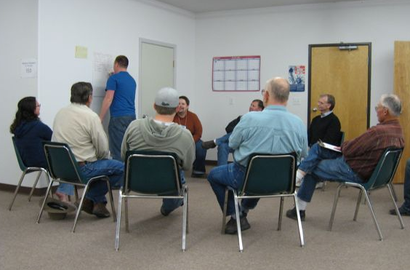
- Expand use of the city’s Web site to convey community information and publicize opportunities for citizen involvement.
- Develop a local “currency” or barter program citizens can use to trade needed skills and services.
- Create one or more community bulletin boards.
- Create an informal group of citizens representing the major ethnic and cultural groups to generate project ideas to promote intercultural understanding and appreciation. This committee could be ad hoc or permanent.
- Proivide community mediation training to interested leaders and residents so they, in turn, help build consensus between divergent interests.
Resources
- Everyday Democracy, formerly Study Circles Resource Center, http://www.everyday-democracy.org/en/index.aspx. Kuna residents have successfully used study circles for many years. Zella Johnson, zeltext@msn.com, (208) 871-0696.
- The University of Idaho’s Horizons Program has used study circles in many southern and southeastern Idaho communities, http://extension.ag.uidaho.edu/horizons/, Barb Petty, bpetty@uidaho.edu, (208) 523-4007.
- Caldwell’s online community bulletin board includes a community calendar, a list of places to go and things to do and a list of community businesses, www.aboutcaldwell.com/index.html.
- The city of Rexburg has an excellent monthly community newsletter on the city’s homepage. Past issues are also available via archive. http://rexburg.org, (208) 359-3020.
- Boise has an effective Mayor’s Hotline, www.cityofboise.org/Mayor/Hotline/page 876.aspx, Boise mayor’s office, (208) 384-4422.
- Lincoln County Chatter Blog is an online source of information and opinion sharing regarding community affairs in Lincoln County, www.lincolncountychatter.blogspot.com.
- “The World Café: Shaping Our Futures Through Conversations That Matter” by Juanita Brown with David Issacs, Berrett-Koehler Publishers, 2005, outlines an innovative approach to discovering collective wisdom through open civic dialogue, www.theworldcafe.com.
- “Reframing Public Participation: Strategies for the 21st Century” published in “Planning Theory and Practice,” Vol. 5. No. 4, December 2004, makes the case that legally required participation methods in the U.S. not only do not meet most basic goals for public participation, but they are also counterproductive, causing mistrust, www.csus.edu/ccp/publications/Reframing_Public_Participation_Final.pdf.
- “Governments are From Saturn……Citizens are from Jupiter: Strategies for Reconnecting Citizens and Government” published June 1998 by the Municipal Research and Services Center in Washington State University is full of strategies the city could use to reconnect with citizens. Contact information for all strategies is provided http://www.mrsc.org/Publications/srcgtxt.pdf.
- “The Great Good Place: Cafes, Coffee Shops, Bookstores, Bars, Hair Salons, and Other Hangouts at the Heart of a Community” by Ray Oldenburg describes the importance of gathering places within communities. The book and its author are described on the Web site of the Project for Public Spaces, http://www.pps.org/info/placemakingtools/placemakers/roldenburg.
- Idaho Nonprofit Center, http://www.idahononprofits.org, Lynn Hoffmann, executive director, lhoffmann@idahononprofits.org, (208) 424-2229.
- “Fostering Dialogue Across Divides: A Nuts and Bolts Guide from the Public Conversations Project” is an excellent 2006 publication available to download or purchase, http://www.publicconversations.org/node/99.
- The Lincoln County Community Justice Coalition develops and coordinates capacities related to restorative justice, a community-integrated approach to probation programs and law enforcement generally in Lincoln County. The Coalition also seeks to educate the public through training sessions, events, newsletters and flyers about current issues including substance abuse, regional gangs and conflict resolution/mediation and to use methods and best practices to help victims of crime through their ordeals as well as to facilitate community discussions about hot-button issues. Magistrate Mark Ingram, julieingram@cableone.net, (208) 886-2466.
- Consensus Building Institute is a Cambridge, Mass.-based organization that has worked with hundreds of groups to build consensus, resolve conflict and produce mutually beneficial agreements. It offers training and direct consensus building services. Its new online course on resolving land use disputes is at http://www.cbuilding.org/2007/08/28/consensus-building-institute-presents-online-course/.
- Leadership Idaho Agriculture, a leadership development program for leaders in agriculture and in rural communities, http://www.leadershipidahoag.org/, Rick Waitley, (208) 888-0988.
- Northwest Community Development Institute, a leadership development program for community and economic development leaders, https://secure.meetingsystems.com/nwcdi/, Gloria Mabbutt, Gloria.mabbutt@commerce.idaho.gov, (208) 334-2650, ext. 2139.
- Information about creating a community barter network is at http://www.ehow.com/how_4887994_create-local-online-barter-network.html.
- Led by a local church, a successful community barter system has been created in Brewster, Mass., and is discussed in an article, http://www.wickedlocal.com/brewster/archive/x1397979015.
OBSERVATION 4: Gooding’s western and agricultural heritage is another important element of the community’s identity. Continue to celebrate and publicize this heritage.
Recommendations
- Support the development of a permanent structure to house the Cowboy Hall of Fame. Further, the Visiting Team recommends priority be given to identifying an existing building with historic value to house the hall.
- Through marketing and infrastructure improvements, support the development of value-added agricultural and western heritage products in the area.
- Encourage local growers and dairy operators to work together to develop local farm tours.
- Develop a permanent public art project or program to celebrate Gooding’s western and agricultural heritage.
- Consider reforming the Gooding Grange.
Resources
- Idaho Ag in the Classroom, http://www.idahoaitc.org/index.html, Rick Waitley, state director, rcwaitley@spro.net, (208) 888-0988.
- Farmers’ Markets and AgriTourism, Idaho State Department of Agriculture, Lacey Menasco, lmenasco@agri.idaho.gov.
- Idaho’s Bounty is a group devoted to connecting sustainable farmers with consumers, http://www.idahosbounty.org/, James Reed is the Magic Valley coordinator, jreed@idahosbounty.org.
- Idaho State Grange will help expand existing granges and revive others, Donald Billmire, master, Idaho State Grange, idahostategrange@qwestoffice.net.
- Idaho Commission for the Arts provides grants and other resources to local organizations, Michelle Coleman, community development director, michelle.coleman@arts.idaho.gov.
- See the economic development focus area for additional resource related to developing value-added agricultural products.

Economic Development

Community Concerns and Comments
Economic development includes supporting the growth of existing businesses, assisting current residents who want to start a new business and attracting new businesses to the community.
The economic development focus area team met with six stakeholder groups during the community review. The community concerns and comments fall under the following themes.
Desire for More andBetter Jobs
Gooding residents and leaders would like to see increases in the availability and quality of local jobs. Business owners told us that professionals have turned down opportunities to work and live in Gooding because suitable employment opportunities were not available for spouses. Specific goods and services residents would like to see more of include hotel and motel accommodations, entertainment options and overall quality and variety of goods in retail stores.
Little Wood River Canal and Floodplain
“The river” was the most frequent response Gooding business leaders and residents gave when asked to identify what they thought was the number one economic development issue in the community. The river wall and the designated floodplain came up repeatedly with respect to economic development but also in the context of infrastructure and community identity.
The floodplain was a concern because development and insurance are more expensive in the 100-year floodplain as designated by the Federal Emergency Management Agency in 1984.
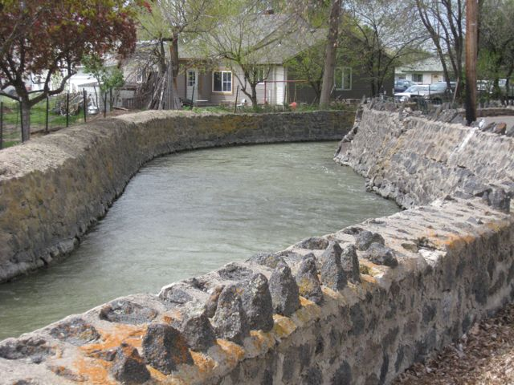
The Visiting Team learned that the 3.6- mile Little Wood River retaining wall was built with hand hewn and laid basalt in 1935 by the Civilian Conservation Corps. It is eligible for the National Register of Historic Places for its association with a New Deal Era water management project. The community’s bridges spanning the canal also have architectural qualities worthy of protection.
Everyone involved in the review expressed at least some desire to have recreational opportunities along the river. Most spoke in terms of having a pathway or interpretive walkway along the river. A few people were creative and suggested ways people could start playing on the river such as floating on inner tubes or in kayaks.
Marketing Beyond Gooding City Limits
In conversations about economic development, the team began to realize that potential business partners, prospective residents and tourists outside the community don’t have access to information about the existing businesses, infrastructure, excellent recreational amenities and annual community events offered in Gooding and surrounding areas.
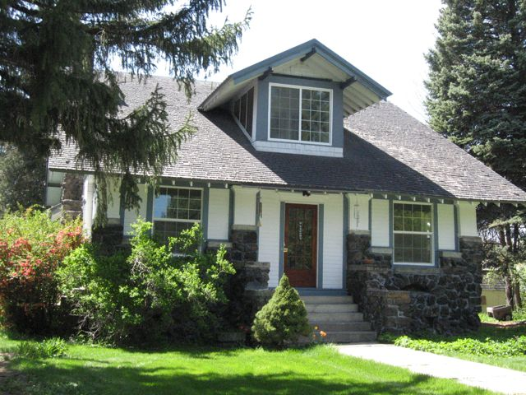
Housing and Other Amenities Desired by Prospective New Residents
Gooding’s housing stock is dominated by older homes that lack some of the amenities and the energy efficiency found in newer construction, complicating efforts to recruit highly skilled employees to the area. It is also important to note historic housing stock can often increase in value and add to a community’s sense of place. The same applies to entertainment, cultural and education opportunities.
Economic development assets Gooding residents and business owners are particularly proud of include:
- The soon-to-be completed hospital
- Access to rail and road-based freight transportation
- The airport and its ability to accommodate small jets
- The industrial park
- The dairy industry
- Idaho School for the Deaf and the Blind
- The Walker Center
- Proximity to public lands and major federal installations such as the Idaho National Laboratory and Mountain Home Air Force Base
- Relatively healthy downtown with its historic structures, especially the Schubert Theater

Economic Development Observations, Recommendations and Resources

OBSERVATION 1: Prospective new employers, new customers and economic development agencies from outside the immediate Gooding area generally aren’t aware of the community’s existing businesses, available real estate, services and amenities.
Recommendations
- Gooding needs to create a business directory to foster business attraction by making potential new businesses aware of the services, sub-contractors and suppliers available in the community. To share costs, Gooding might want to partner with the cities of Wendell, Hagerman and Bliss in creating this directory. It may be possible to sell ad space in the directory to help fund updates and future printings.
- Gooding should develop a one-stop-shop city Web site. This Web site should, at the very least, contain an online business directory, a community profile highlighting information important to the business community such as infrastructure capacity and demographic information, contact information for the Rural Magic Valley Economic Development Association, city ordinances and procedures, recreational opportunities and community events. Such a directory might be thought of as a “virtual business center.”
- Local real estate agents should be encouraged to place available commercial and industrial properties and land on Idaho’s Gem State Prospector Web site. This Web site is free and combines the property listing with maps and demographic statistics that interest companies looking for new locations.
Resources
- USDA’s Rural Business Enterprise Program has funded the creation of business directories for communities across Idaho, http://www.rurdev.usda.gov/id/rbs.htm. Randy Wheatley, randy.wheatley@id.usda.gov, (208) 436-0116.
- The Lost Rivers Economic Development Organization in eastern Idaho, with help from USDA Rural Development, created a regional business directory that could serve as a model for a Gooding directory, Michelle Holt, lred@atcnet.net, (208) 527-3060.
- The city of Jerome has a Web site that combines city, community and economic development information, http://www.ci.jerome.id.us/, (208) 324-8189.
- The state of Idaho’s Travel Council Grant program can help build local and regional Web sites promoting tourism and hospitality businesses. These funds might help leverage other resources or cost share a city-economic development Web site, http://www.commerce.idaho.gov/travel/grant-program/. Cathy Bourner, cathy.bourner@commerce.idaho.gov, (208) 334-2470.
- Gem State Prospector, Idaho Department of Commerce, http://gemstateprospector.com, Jerry Miller, jerry.miller@commerce.idaho.gov, (208) 334-2470, ext 2143.
- Lincoln County Resource Guide/Website Group, http://www.lccrossroads.org/.
OBSERVATION 2: Gooding’s existing floodplain, federally delineated in 1984, makes property development and ownership more expensive than in neighboring cities, putting the community at a competitive disadvantage.
Recommendations
- The city should investigate options for obtaining a flood map revision from the Federal Emergency Management Agency. Revising the flood map covering the community may reduce the size of the floodplain footprint, thereby reducing insurance cost to property owners and dismantling a barrier to bringing new housing and other development to the community.
- Clearly and fully document the flood control measures and all other factors that give the city reason to believe the actual floodplain is smaller than shown on the 1984 map.
Resources
- FEMA Map Assistance Center, http://www.fema.gov/plan/prevent/fhm/fmc_main.shtm, and Map Service Center, http://msc.fema.gov, (877) 336-2627.
- Mary McGown, Floodplain Coordinator, Idaho Department of Water Resources, mmcgown@idwr.state.id.us, (208) 287-4928.
- Work with the U.S. Army Corps of Engineers’ Walla Walla District floodplain mapping program, Tracy Schwarz, tracy.schwarz@usace.army.mil, (509) 527-7522.
- Mitch Silvers, office of Senator Mike Crapo in Lewiston, has been involved in floodplain delineation issues in Caldwell and Kellogg/Silver Valley areas, mitch_silvers@crapo.senate.gov, (208) 743-1492.
- Idaho Bureau of Homeland Security, David Jackson, Mitigation Program Manager, (208) 422-3047.
OBSERVATION 3: Some employers are finding it difficult to recruit and retain qualified employees, while some highly skilled workers are choosing not to relocate to Gooding due to a real or perceived lack of professional employment opportunities for spouses and other factors such as education and housing.
Recommendations
- Community input should be solicited to help determine the future of the soon-to-be vacant hospital site. Some ideas for the reuse include a mental health clinic, assisted living services, a College of Southern Idaho satellite campus with an emphasis on medical and veterinary courses, an institute for the research and development of assistance devices for hearing- and sight-impaired individuals and a training center for service or assistance animals. Assuming that the facility remains in public or non-profit ownership, repairs and enhancements to the old hospital may be eligible for either the Idaho Gem Grant or Idaho Community Development Block Grant programs. A planning grant for adaptive re-use may also be possible through USDA Rural Development’s Rural Business Opportunity Grant program.
- The Gooding Chamber of Commerce should broaden its focus and help local businesses connect with training and resources. This might be accomplished by hosting luncheons or “brown baggers” with speakers on topics of benefit to both retail and non-retail establishments. Since businesses in both Gooding and nearby Wendell serve customers in the other’s community, it might be worth creating a partnership between the two chambers to cosponsor business training opportunities.
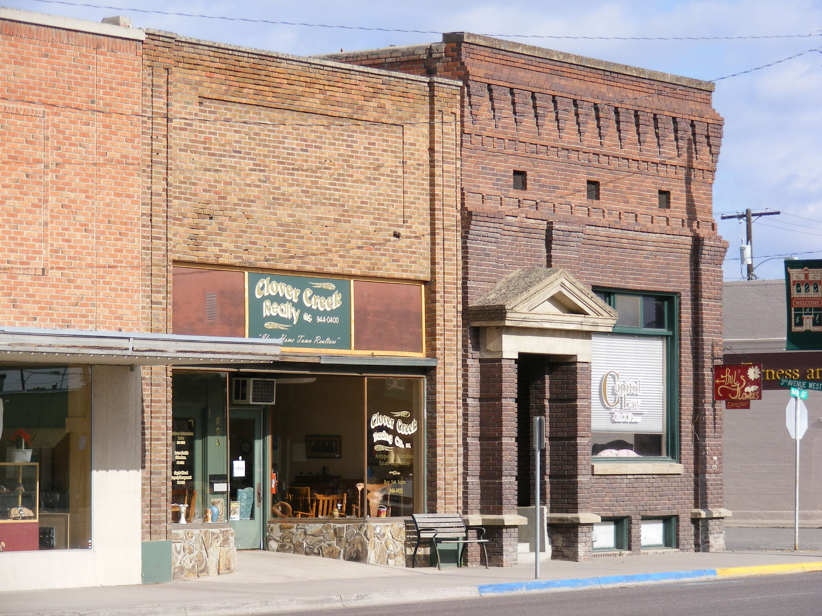
- Gooding’s business community should look for ways to provide students with work skills and practical experience. This might take the form of an internship program that exposes students to the skills and training they will need to obtain to succeed in the workplace. At the same time, a mentoring program may help local businesses fill the skill gap. A junior entrepreneur program such as the Rural Enterprise Action Learning program could go a long way to fostering future leaders and new businesses. A number of rural school districts in Idaho have fostered entrepreneurship through school-based enterprises. Creating practical learning opportunities will help raise the perceived quality of the school system.
- While market forces will determine the pace of new housing development, there are things the city could do to promote the creation of contemporary housing. First, the city should make its planning and building regulations user friendly. This might include the creation of a checklist to help persons who are looking for permits and approvals. Another step in this direction would be to make all city ordinances available on the Internet. Third, the city should consider offering incentives to the builders of “green buildings.” Incentives could take the form of discounted permits or connection fees. The benefit to the city might be in the form of higher tax revenues due to the premium values associated with “green construction” as well as savings derived from conserving city services. Historic housing can also be made more sustainable without losing the important characteristics which give it value.
- Gooding business should be encouraged to pursue government contracting opportunities. The city or chamber could sponsor a government contracting training session. The city should explore the possibility of becoming an Historically Underutilized Business Zone through the U.S. Small Business Administration. Businesses located in a HUB zone have an inside track obtaining government contracts.
Resources
- A number of chambers of commerce across Idaho provide training opportunities for business. The Boise chamber sponsors resource meetings where businesses are introduced to the services offered by agencies like the Idaho Small Business Development Center, Idaho Department of Commerce and Small Business Administration, http://www.boisechamber.org, Jason Schultz, jschultz@boisechamber.org, (208) 472-5217.
- Rural Development Initiatives is a Eugene, Ore.-based nonprofit organization that helps towns and rural partnerships develop and diversify their economies by creating inclusive, long-term strategies and identifying and managing crucial projects. It conducts community training sessions on leadership, effective organizations and other topics in both English and Spanish. Its work is focused in Oregon but also reaches six western states including Idaho and British Columbia, http://www.rdiinc.org/, Noelle Colby-Rotell, nrotell@rdiinc.org, (208) 954-9564. Also, Visiting Team member Dick Gardner is an Idaho-based contract trainer for the organization.
- The Rural Development Initiative’s Web site tells the Lincoln County, Ore., success story of the youth entrepreneurship project. Students formed the KayakShack business with the help from their school and the Connecting Oregon for Rural Entrepreneurship) project, www.rdiinc.org.
- The Kellogg School District operates a school-to-work program that offers job mentoring and vocational training, http://www.ksd391.org/stw/. Sandra Pommerening, sandra.pommerening@Tksd391.org, (208) 784-1348.
- Clearwater County Economic Development, in cooperation with the Orofino School District, offers entrepreneur training in the high school, http://www.clearwatercounty.org/?EconomicDevelopment. Chris St Germaine, cceds@orofino-id.com, (208) 476-9829.
- The city of Eagle Web site is a very good example of a customer-friendly way to explain city regulations, http://www.cityofeagle.com/.
- Other cities that have excellent online citizen’s guides for various permitting processes and development activities including Caldwell and Coeur d’Alene, http://cityofcaldwell.com/page/33550/, (208) 455-3021 and http://coeurdaleneidaho.org, (208) 769-2240.
- The Environmental Protection Agency maintains a list of grants and incentives used by cities to promote green building construction, http://www.epa.gov/greenbuilding/tools/funding.htm.
- The Idaho Office of Energy Resources maintains a good list of “Green Building” resources and incentives, http://www.energy.idaho.gov/financialassistance/, Terry Hoebelheinrich, (208) 287-4899.
- Preservation Idaho offers tips to make historic homes more sustainable, http://www.preservationnation.org/issues/sustainability/green-home-tips.html.
- The Idaho Department of Commerce Idaho Business Networks helps businesses pursue government contracting opportunities, http://www.commerce.idaho.gov/business/government-contracting.aspx. Sundi Neely, sundi.neely@commerce.idaho.gov, (208) 334-2470.
- HUB Zone Certification, https://eweb1sp.sba.gov/hubzone/internet/, Larry Demirelli, larry.demirelli@sba.gov, (208) 334-9004.
- Idaho Community Development Block Grant can fund hospital redevelopment, http://www.commerce.idaho.gov/communities/block-grants.aspx, Pat Madarieta, pat.madarieta@commerce.idaho.gov.
- Idaho Gem Grant program for hospital redevelopment, http://www.commerce.idaho.gov/communities/idaho-gem-grants.aspx, Jerry Miller, jerry.miller@commerce.idaho.gov, (208) 334-2470, ext. 2143.
- The U.S. Department of Housing and Urban Development’s Federal Housing Administration’s section 242 program can help communities finance hospital construction and improvement projects, http://www.hud.gov/offices/hsg/hsgmove/hotm0515.cfm. Jerry Royster, (208) 334-1088, ext. 3017.
- The Idaho Health Facilities Authority offers low interest loans for health care facilities, http://www.idhfa.org/. Shelley Shannon, (208) 342-8772.
- USDA’s Community Facilities Program offers low-interest loans for the construction of health care and other public facilities, http://www.rurdev.usda.gov/id/wwgrant.pdf. Becky Dean, becky.dean@id.usda.gov, (208) 436-0116.
- Southern Idaho Economic Development, http://www.southernidaho.org/main.asp, Jan Rodgers, executive director, janrsiedo@aol.com, (208) 324-7408.
OBSERVATION 4: The development of publicly and privately-owned amenities combined with additional marketing would generate income by helping Gooding become a hub of tourist activities.
Recommendations
- Gooding should develop both online and printed tourism marketing materials. A “virtual visitor’s center” on a city or economic development Web site would go a long way toward letting the outside world know about everything Gooding has to offer. Printed materials such as a brochure could be strategically distributed to big city hotels, welcome centers and other visitor centers across southern Idaho.
- Develop a visitor’s kiosk. The kiosk could contain panels highlighting the area’s history as well as an information rack for brochures and business advertising. An ideal location for the kiosk is the northeast corner of the intersection of State Highway 46 and U.S. Highway 26.
- Study the feasibility of a new full-service motel. The question isn’t whether Gooding would be served by a contemporary, nationally-branded motel but whether such a facility could generate enough revenue to make business sense. Ideally the businesses that could benefit from a new motel -- the fairgrounds, Walker Center, Idaho School for the Deaf and the Blind and restaurants -- should form a partnership to commence a motel feasibility study.
- Both on- and off-river activities are big business in Idaho. The community should look for ways to make the Wood River accessible to the casual user. Accessibility might take the form of a river walk with interpretive signs, benches or “put ins” and “take outs” for floating.
- The Gooding County fairgrounds are ideally suited to host concerts and festivals. The ability to accommodate 3,000 spectators may be attractive to smaller national and regional touring acts.
- The success of Ballard Cheese as both a producer of artisan cheeses and as a visitor attraction highlights the potential that specialty food production holds for Gooding County. The creation of a countywide “Artisan Food and Wine Trail” could be a tourism hit. Establishing the trail would entail creating of a brochure and web page with maps, directions and hours of operation. Additionally, signs promoting the trail could be placed along the major highways.
Resources
- The Idaho Department of Commerce has programs to support tourism development, http://commerce.idaho.gov/travel/ including the Idaho Travel Council Grant Program that provides funding for the creation of visitor-oriented Web sites and brochures. Cathy Bourner, cathy.bourner@commerce.idaho.gov.
- Idaho Travel Grant Program, http://www.commerce.idaho.gov/travel/grant-program/.
- USDA’s Rural Business Enterprise Grant Program may be able to provide funding for the creation of marketing materials and the construction of a visitor’s kiosk, http://www.rurdev.usda.gov/id/rbs.htm, Randy Wheatley, randy.wheatley@id.usda.gov, (208) 436-0116.
- The Kooskia Chamber of Commerce hosts a Web site targeted for both economic development and tourism. On the Web site is a picture of its visitor’s kiosk, Kooskia Chamber of Commerce, http://www.kooskia.com/, kooskiachamber@qroidaho.net, (208) 926-4362.
- The city of St. Maries built a visitor’s kiosk with a grant from the U.S. Forest Service as a demonstration project for small diameter wood, Kim Schwanz, Timber Plus, timberplus@smgazette.com, (208) 245-2239.
- USDA’s Rural Business Enterprise Program has funded a number of lodging feasibility studies across Idaho, http://www.rurdev.usda.gov/id/rbs.htm, Randy Wheatley, randy.wheatley@id.usda.gov, (208) 436-0116.
- Two Degrees Northwest is a cultural tourism effort based in north central Idaho and southwestern Washington coordinated by the University of Idaho Extension, http://www.2dnw.org/, Lori Higgins, director, Higgins@uidaho.edu, (208) 885-9717.
- A number of Idaho’s smaller rural communities have trail systems that might serve as a model for creating a river walk in Gooding including St. Anthony, which created a trail system along the Henry’s Fork of the Snake River,city of St. Anthony, city@cityofstanthony.org, (208) 624-3494.
- The Conservation Fund in cooperation with Kodak Corp. offers grants for the creation and improvement of trails and walkways, http://www.conservationfund.org/kodak_awards
- The non-profit organization Bikes Belong offers grants to help communities develop trails, http://www.bikesbelong.org/grants.
- One of the best ways to attract concerts and other events is to establish a relationship with event promoters such as Bravo Entertainment, Mark Dinerstein, senior talent buyer, mark@knittingfactory.com , (208) 343-8883 ext 107.
- The Boise-based International Events and Festival Association may be able offer help and advice on attracting events and festivals to the Gooding Fairgrounds, Http://www.ifea.com/, (208) 433-0950.
- The Idaho Department of Agriculture offers a free handbook entitled Starting a Specialty Foods Business, which is available free from the department’s Web site, http://www.agri.state.id.us/Categories/Marketing/Documents/specialtyfoodbook.pdf.
- A North Carolina-based organization called Handmade in America may serve as a model for creating a specialty food trail, anf ehile Handmade is built around the arts, many of its ideas and resources could be easily applied to specialty foods, http://www.handmadeinamerica.org/. Geraldine Plato, gplato@handmadeinamerica.org, (828) 252-0121.
- USDA Value Added Producer Grant program provides funding to help eligible independent producers of agricultural commodities, agricultural producer groups, farmer and rancher cooperatives and majority-controlled producer-based business ventures develop business plans and strategies to create viable marketing opportunities. Grants facilitate greater participation in emerging markets and new markets for value-added products, http://www.rurdev.usda.gov/rbs/coops/vadg.htm, Randy Wheatley, randy.wheatley@id.usda.gov, (208) 436-0116.
- Idaho Department of Agriculture’s Idaho Preferred® Program, www.idahopreferred.com, and Marketing Division, http://www.idahoag.us/Categories/Marketing/indexMarketing.php, are great resources for marketing local agricultural products.
- Southern Idaho Tourism, Debbie Dane, executive director, ddane@csi.edu, (208) 732-5569.
- Idaho State Parks and Recreation offers grants for recreation projects, particularly if they are multipurpose and attract multiple audiences, http://parksandrecreation.idaho.gov/aboutus/grants.aspx.
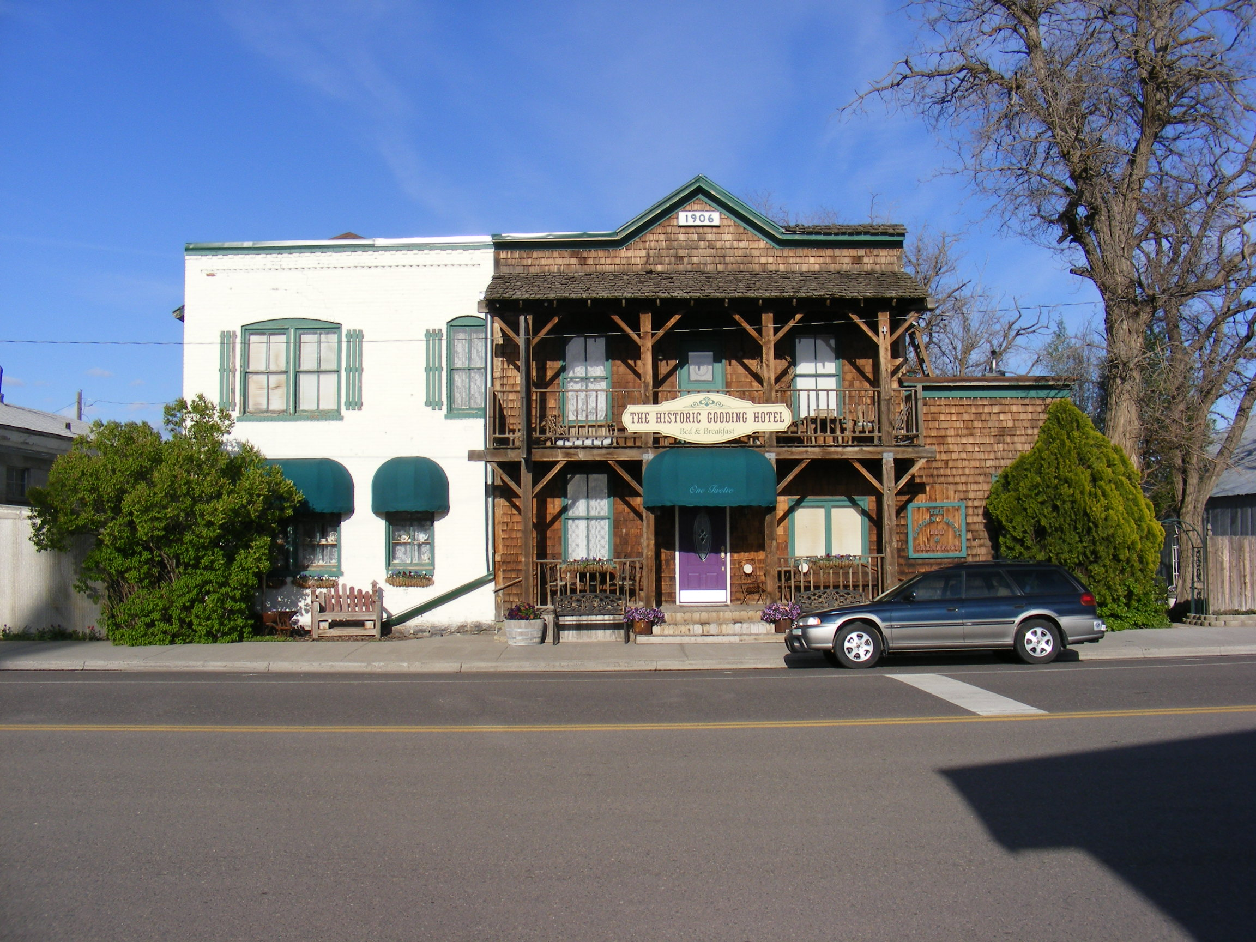
OBSERVATION 5: Downtown Gooding has many historic buildings. The gem in the crown is the historic Schubert Theater. Its restoration would create a destination for lectures, plays and live performances. While most of the storefronts along State Highway 46 are occupied, there appear to be several vacant properties one block to the east and west of the state highway. Some downtowns have attempted to create a consistent, unified “theme” with mixed results. The Visiting Team recommends that Gooding’s “theme” should not involve the creation of something that isn’t part of the city’s history or current identity. It should be based on the history embodied by your own unique historic structures. Off Main Street the Visiting Team heard a lot of discussion from the business community about inconsistent code enforcement and a need for beautification.
Recommendations
- The city of Gooding should commission a downtown revitalization study to look at improvements, generate cost estimates and gather community input and support for downtown improvements.
- Gooding should look towards creating Idaho’s first “green” downtown with solar-powered street lighting and a revolving loan fund to help building owners leverage incentives for improving energy efficiency depending on technology and its connection to the grid. Solar-powered streetlights during the summer months could generate revenue through net metering. Recycling bins and benches constructed from recycled materials could add to the ambiance of the green downtown.
- At the very least, Gooding should create a walking tour highlighting its history and significant historic buildings. The installation of locally created public art would be a nice additional touch.
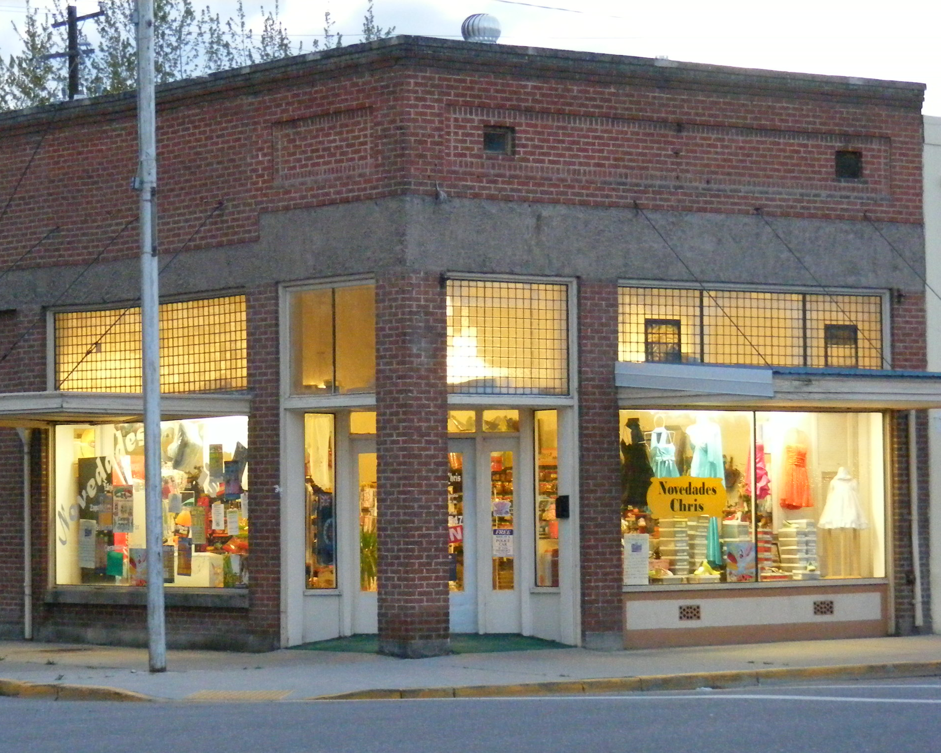
- During the summer months the community should consider bringing more events to the downtown. Art shows, farmers’ markets, car shows, geocaching , and a street dance are just a few examples of events that could boost traffic and attract visitors to the community.
- The city should organize volunteers to help clean up the community. Volunteers could be deployed to assist disabled and elderly residents rake, paint, and complete minor repairs.
- A community beautification cooperative could be created. It would divert donations otherwise directed to youth groups and sports teams into a consolidated fund whose custodians would then offer designated projects at a specified price to youth groups and sports teams that could perform these community services to receive money from the fund.
- Becoming a Certified Local Government will give the city access to expert technical advice from the State Historic Preservation Office, the National Park Service, the National Trust for Historic Preservation and the National Main Street Center. It will also make the community eligible for funding from these same agencies and organizations.
- The community should support the renovation and re-opening of the Schubert Theater. (See Appendix E)
- If one does not currently exist, Gooding could establish a community service requirement in the middle and high schools, perhaps in conjunction with the Fifth Day program.
- Well-kept and improved properties could be recognized. This could take the form of an award for best looking property or most improved property, for example.
- Building safety codes should be aggressively and consistently enforced against those violators who habitually fail to cooperate with community beautification standards.
- An attractive entryway with trees and signage should be created on the south side of Gooding at the intersection of U.S. Highway 26 and Idaho Highway 46.
Resources
- USDA’s Rural Business Enterprise Grant Program may be able to fund a downtown revitalization study, http://www.rurdev.usda.gov/id/rbs.htm, Randy Wheatley, randy.wheatley@id.usda.gov, (208) 436-0116.
- The Idaho Gem Grant program can help fund downtown revitalization initiatives, http://www.commerce.idaho.gov/communities/idaho-gem-grants.aspx, Jerry Miller, jerry.miller@commerce.idaho.gov, (208) 334-2470 ext 2143.
- Once a revitalization plan is in place, Idaho Community Development Block Grant funds may be used for capital improvements, http://www.commerce.idaho.gov/communities/block-grants.aspx, Pat Madarieta, pat.madarieta@commerce.idaho.gov, (208) 334-2470.
- Idaho Power offers energy audits and a grant program that could help implement a downtown revitalization project, http://www.idahopower.com/energycenter/energyefficiency/programsSummary.htm, http://www.idahopower.com/NewsCommunity/Community/Involvement/default.cfm, Dan Olmstead, dolmstead@idahopower.com, (208) 324-3442.
- Information about becoming a Certified Local Government is available at http://nps.gov/history/hps/clg and through the Idaho State Historic Preservation Office, http://www.idahohistory.net/shpo.html. As the statewide CLG coordinator, Anne Swanson at the State Historic Preservation Office can answer any questions, Ann.Swanson@ishs.idaho.gov, (208) 334-3861 ext 104. A booklet about how to become a CLG is at http://www.idahohistory.net/CLG_PROGRAM_BOOKLET.pdf.
- Idaho Heritage Trust can conduct research for historic preservation funding and resources, Gaetha Pace, Gaetha@mindspring.com, (208) 549-1778.
- Preservation Idaho, www.preservationidaho.org/index.shtml, info@preservationidaho.org, (208) 424-5111.
- The Federal Historic Preservation Tax Incentives program can assist with the restoration of the Schubert Theater, http://www.nps.gov/history/hps/tps/tax/index.htm.
- The National Trust for Historic Preservation and its National Trust Preservation Fund, http://www.preservationnation.org/resources/find-funding.
- Jerry Myers, Pocatello-based Myers-Anderson Architects, has extensive experience with the federal tax credit/incentives program, (208) 232-3741
- The Wilson Theater in Rupert is an excellent example of a historic community theater restored by a multi-year community effort. Chris Jackson, (208) 436-2787.
- University of Idaho College of Art and Architecture. Wendy McClure, wmcclure@uidaho.edu and Rula Awwad Rafferty, rulaa@uidaho.edu, are two faculty members who frequently work with communities on community design and downtown revitalization issues.
- Boise Neighborhood Housing Services sponsors both “Rake up Boise” and “Paint the Town” programs for low income and disabled residents, http://www.nhsid.org/. Lynn Cundick, (208) 343-4065.
- Idaho Department of Lands Community Forestry Program assists communities with tree planting and beautification projects, http://www.idl.idaho.gov/bureau/community_forestry/contacts/index. David Stephenson, community forest coordinator, (208) 666-8621.
- The Arbor Day Foundation is the home of the “Tree City USA” program under which 23 Idaho cities received assistance and recognition, http://www.arborday.org/programs/treeCityUSA/index.cfm.
- The Idaho Commission on the Arts grants are available to promote art activities in rural communities, http://arts.idaho.gov.
- USDA 504 Housing Program to help low-income residents with home repairs and weatherization, http://www.rurdev.usda.gov/rhs/sfh/brief_repairgrant.htm, USDA Rural Development Housing Programs, Twin Falls Service Center, (208) 436-0116.
- The Accessibility Improvement Program can help pay to make homes handicapped accessible, http://www.idaholifecenter.org/, Mickey Palmer, (208) 232-2747.
- Rural Roots, a nonprofit organization, and Idaho Department of Agriculture can provide information about creating and managing farmers’ markets, www.ruralroots.org, (208) 883-3462 and http://www.agri.state.id.us/Categories/Marketing/FMmarketing.php, (208) 332-8500.
- Lincoln County Crossroads Farmers’ Market, Patty Nance (208) 731-2659 or (208) 544-2480.
- The city of Nampa created a revolving loan fund for restoring building facades in its historic downtown, http://ci.nampa.id.us/downloads/30/FA%C3%87ADE%20IMPROVEMENT%20PROGRAM.doc.
- Star and Kuna each have walking tour brochures, http://www.adaweb.net/Portals/0/HPC/Documents/StarWalkingTour2005.pdf and http://www.adaweb.net/Portals/0/HPC/Documents/kuna.pdf.
- Lincoln County Historical Society, lincolncountyhistorical@sfly.com.

Infrastructure

Community Concerns and Comments
Many Gooding residents shared their opinions about infrastructure, which includes the city’s culinary and irrigation water systems, sewer system, streets and sidewalks, airport and the Little Wood River Canal. In both conversation and the pre-review survey, most infrastructure-related concerns and comments were about either the irrigation system or the Little Wood River Canal. Sidewalks and pathways, or the lack thereof, were also on citizens’ minds.
Irrigation System
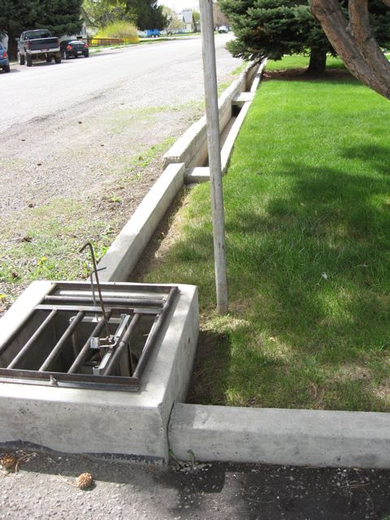
The irrigation system has been the subject of considerable debate for some time. City leaders called itthe infrastructure issue citizens are most concerned about. The city is now conducting a study to identify alternatives and costs to deal with the obsolete, inefficient system. Citizens expressed frustration with the flooding of basements that has occurred. Many felt it was unfair to be assessed a fee for irrigation water they cannot use due to topography changes or other factors. Conversely, there may be a perception that some residents are receiving, but not paying for, irrigation water.
From the city’s perspective, operating the existing system requires excessive maintenance. It is increasingly difficult to train and retain ditch riders. City staff have been diverted from primary responsibilities for streets, water and sewer to keep the irrigation system functioning.
Little Wood River Canal
The major concern about the Little Wood River Canal can be expressed in one word: safety. Gooding residents clearly see the urgency of the situation and question why more progress has not been made after years of discussion. That said, the Visiting Team did learn the Idaho congressional delegation was successful in including $1 million for preliminary alternative analysis and related environmental work in proposed legislation, though it has not yet been passed by Congress.
Streets and Sidewalks
Overall, public satisfaction with the street system seems favorable. To its credit, the city has a street maintenance schedule although material costs have risen dramatically in recent years. Community leaders anticipate that development activity in the vicinity of the U.S. Highway 26/Idaho Highway 46 junction will continue to increase. They expressed interest in studying ways to modify the intersection to safely accommodate that increase in vehicle and pedestrian traffic.
Citizen support for improving existing sidewalks and building new ones is strong. A few people mentioned that in recent years there have been accidents involving young people being hit by cars while crossing Main Street. Enthusiasm was often expressed for the idea of a combination bike and walking pathway in conjunction with a rebuilt or rehabilitated Little Wood River Canal. At the same time, the extent to which property owners would actually be willing to pay for a more walkable community is not known.
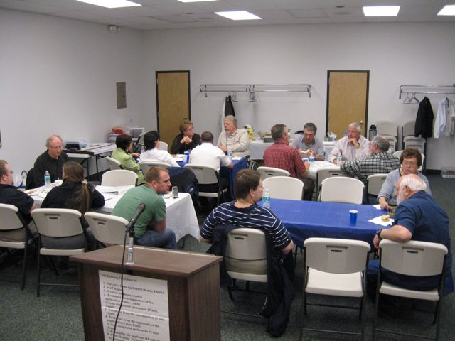
Culinary Water and Wastewater Treatment Systems
No significant public concern about either culinary water or sewer treatment was noted. Both of these systems seem to be operating well, with needed modest improvements and state permitting requirements being addressed according to schedule by the city.
Airport
Comments regarding the airport primarily came from community leaders and economic development professionals. Both said the airport is seeing increased use by Sun Valley area visitors and residents who are taking advantage of the airport’s ability to accommodate small jets. They also said the airport makes bringing prospective employers to the area for tours convenient and efficient.
Other Infrastructure
Other public or quasi-public facilities appreciated most often by citizens include the golf course, library, fairgrounds, parks, new outdoor swimming pool, Walker Center auditorium, indoor pool at the Idaho School for the Deaf and the Blind and the schools.

Infrastructure Observations, Recommendations and Resources

OBSERVATION 1: Addressing problems with the flood irrigation system should continue to be a high priority.
Recommendations
- Look at alternatives to fixing the existing irrigation system. The team feels rehabilitating the existing irrigation system would NOT be an effective alternative because of the initial cost and ongoing operation and maintenance costs.
- Conduct a high quality education and public involvement effort to help residents understand the present situation, gauge what they think of the options and build consensus around an action plan.
- Make sure the cost of building and especially operating the new irrigation system is determined equitably. Many residents expressed frustration about perceived inequities in funding the existing system, primarily that some residents currently paying for the irrigation system cannot access the water.
- Ensure that the city has the option to convert the surface water it currently uses for irrigation to a secure ground water right for its future potable water supply.

Resources

- Rural Community Assistance Corporation, Jim Phillips, jphillips@rcac.org, (208) 855-2310.
- USDA Rural Development, http://www.rurdev.usda.gov/id/rbs.htm. Randy Wheatley, randy.wheatley@id.usda.gov, (208) 436-0116.
- Idaho Water Resource Board Financial Program, http://www.idwr.idaho.gov/waterboard/Financial%20program/financial.htm. Stuart VanGreuningen, stuart.vangreuningen@idwr.idaho.gov, (208) 287-4905.
- Idaho Department of Environmental Quality, Twin Falls, Greg Misbach, gregory.misbach@deq.idaho.gov, (208) 733-5380 ext. 118.
- USDA Rural Development, Twin Falls, Robert Lanford, robert@id.usda.gov, (208) 733-5380 ext. 118.
- Susan Riddle, Community and Economic Development grant writer in Twin Falls, smriddle@cableone.net, (208) 736-7650.
- Region IV Development Association, Twin Falls, Carleen Herring, carleen@rivda.org, (208) 732-5727 ext. 3010.
- The city of Nampa has a pressurized irrigation system, Superintendent Fred Snodderly, snoderlyf@cityofnampa.us, (208) 468-5502.
OBSERVATION 2: The deteriorating condition of the Little Wood River Canal walls must be addressed to protect private property, public health and safety.
Recommendations
- Consider creating a flood protection district to help fund the canal project.
- Conduct a community design session or similar effort to generate ideas and gauge public support for different scenarios for the design and use of the canal. Such scenarios should include enhancing the river as a community amenity.
- Recognize the wall and bridges have architectural, cultural and historic significance and create a community project to document the historic canal using photos, video and oral history.
- If canal walls are ultimately going to be replaced with new materials rather than rehabilitated using existing materials, consider ways one or more small portions of the original wall can remain in place or be developed into permanent public art, a monument or public structure that incorporates the original wall material.

Resources

- The National Fish and Wildlife Foundation provides small grants to stimulate the planning and design of greenways in communities, www.nfwf.org or www.conservationfund.org.
- The Idaho Transportation Department has a bicycle and pedestrian coordinator who could provide advice and technical assistance towards the creation of a river walkway, http://itd.idaho.gov/bike_ped/. Mark McNeese, mark.mcneese@itd.idaho.gov , (208) 334-8272,
- U.S. Army Corps of Engineers, Boise office, http://www.nww.usace.army.mil/boise/outreach.html, Boise office, Boise.Office@usace.army.mil, (208) 345-2064.
- The city of Caldwell partnered with agencies and organizations to “daylight” Indian Creek, making it the centerpiece of the downtown area, http://www.caldwellonline.org/Indian_Creek.htm, Dennis Cannon, city of Caldwell redevelopment coordinator, dcannon@ci.caldwell.id.us, (208) 455-4736.
- Cascade Whitewater Park, Cascade Mayor Dick Carter, info@fcwwp.org, (208) 382-4279. The supporting nonprofit organization is called Friends of Cascade Whitewater Park. Whitewater parks are also being pursued in Boise and Riggins.
- The National Recreation and Park Association’s Web site contains information about creating a whitewater park, http://www.nrpa.org/content/default.aspx?documentId=3611.
- See historic preservation-related resources under ‘Community Identity’ report.
OBSERVATION 3: There is significant community support to rebuild existing deteriorated sidewalks and to build new sidewalks to increase Gooding’s overall walkability and the pedestrian safety of students, residents and visitors.
Recommendations
- Use volunteers to conduct an assessment or survey of residents to identify sidewalk conditions and needs citywide. This would result in the identification of high, medium and low priority projects.
- Pursue available funding sources for sidewalk construction and re-construction including crosswalk improvements.

Resources

- Safe Routes to School program, Idaho Transportation Department, http://itd.idaho.gov/SR2S/home.htm, Jo O’Connor, Jo.OConnor@itd.idaho,gov, (208) 334-4475.
- Mark McNeese, Idaho Transportation Department bicycle and pedestrian coordinator, mmcneese@itd.state.id.us, (208) 334-8272.
- Molly O’Reilly, volunteer, has conducted a sidewalk inventory in her community of Sandpoint, (208) 255-7336.
- International Walk to School Day, www.walktoschool.org.
- National Center for Safe Routes to School, www.saferoutesinfo.org, (919) 962-7412.
OBSERVATION 4: With the construction of the new hospital and other current and anticipated traffic-generating development in the immediate area, long-term traffic flow and vehicle and pedestrian safety concerns at the U.S. Highway 26/Idaho Highway 46 junction should be addressed. This is particularly important if the city wishes to encourage additional development at this location.
Recommendations
- Unless it has already been addressed through the city’s comprehensive plan, initiate community discussion about the desirability of additional development near the junction. The community should recognize that some of the future development at the intersection may involve relocation an existing business on Main Street or from the industrial area east of the fairgrounds.
- Work with the Idaho Transportation Department to establish projected average daily traffic counts at the intersection given ongoing and anticipated development in the immediate area.
- To the extent possible, project the number of new jobs that will be created by ongoing and anticipated development near the intersection.
- Use traffic count projections to re-initiate communication with the Transportation Department’s District 4 on traffic flow and vehicle and pedestrian safety issues and confirm that the district will support improvements to the intersection provided funding sources are identified by the city or county.
- Given projected traffic levels and pedestrian activity in the area, identify viable design alternatives for the intersection. These alternatives should include a roundabout and full signalization.
- Establish a phased project timeline and pursue available funding for the preferred design solution.

Resources

- Idaho Department of Commerce, Rural Community Development Block Grant Program, Pat Madarieta, pat.madarieta@commerce.idaho.gov, (208) 334-2650 ext 2144.
- Local Highway Technical Assistance Council, Lance Holmstrom, lholmstromg@lhtac.org, (208) 344-0565.
- Kevin Sablan, traffic engineer, Idaho Transportation Department, Kevin.sablan@itd.idaho.gov, (208) 334-8340.
- “Roundabout Application Guidelines of Ada County” commissioned by the Ada County Highway District includes research of existing best practices nationwide, siting and design guidelines, cost comparisons between roundabout versus signalized intersections and future disability issues, http://www.achd.ada.id.us/PDF/Departments/Traffic/Draft_Report_14Mar07.pdf, Ada County Highway District, (208) 387-6100.
- “Main Street: When a Highway Runs Through It” was published in 1999 by the Oregon Department of Transportation to educate communities about pedestrian safety and community design associated with highways within city limits, http://www.contextsensitivesolutions.org/content/reading/main-street/resources/main-street-when-a-highway/.
- Legislation passed by the Idaho Legislature in recent years allows developers to receive sales tax rebates if they privately fund approved transportation projects, http://www.legislature.idaho.gov/legislation/2009/H0119.htm.
Part III: Final Thoughts

With this third and final section of the report, the Visiting Team offers the city of Gooding final insights and suggested next steps for each of the focus areas. We also leave you with more specific information and resources pertaining to:
- Community strategic planning
- Conflict resolution

Community Identity
Residents enjoy and value Gooding’s identity as a friendly and safe small town with a high priority on its youth. These appealing qualities may help explain the perception that a sizeable number of people live in Gooding County but commute to nearby counties. This perception is supported by 2000 census data. As shown in the table below, 26 percent of Gooding County’s labor force in the year 2000 actually worked in other counties. The table does not include an additional 73 Gooding County residents who worked in Cassia, Elmore or Minidoka counties.
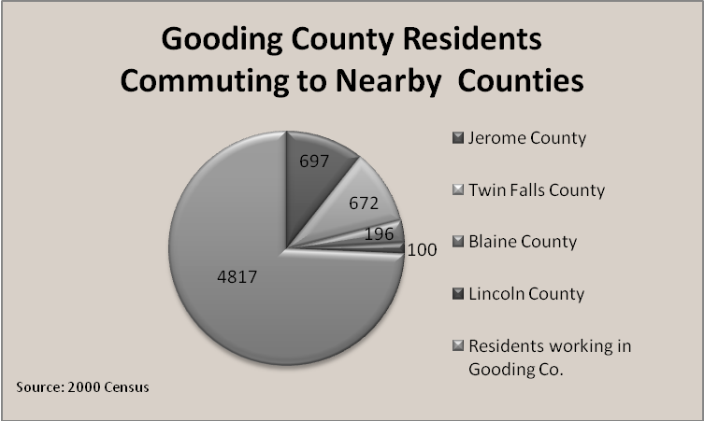

In addition to the small town character and emphasis on young people, much was said about Gooding’s western agricultural heritage and diversity. Citizens also spoke of their desire to be informed about and engaged in public decision making and related community and economic development projects. Finally, many residents are proud that Gooding is the home of the Idaho School for the Deaf and the Blind.
The Visiting Team’s recommendations related to community identity encourage Gooding to build on those amenities and qualities that citizens value most as opposed to creating something that doesn’t currently exist. Specifically, recommendations focus on making Gooding an even better place in which to raise kids, celebrating its diversity and western agricultural heritage and engaging citizens more fully.

Economic Development
As in many rural communities, Gooding residents and leaders desire more and better employment opportunities. Achieving this goal involves continuing to support the development of the area’s traditional agricultural sector while also developing cultural, recreational and educational opportunities sought by potential employers and skilled workers in non-agricultural professions.
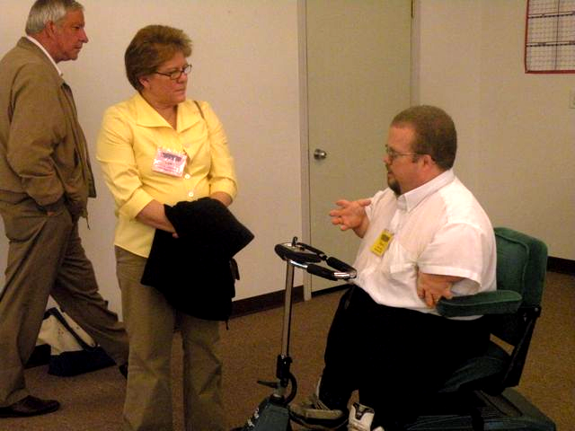
The Visiting Team’s recommendations related to economic development encourage the city of Gooding to tap into opportunities to market the community throughout the region and state; take steps to lower existing barriers to new residential and commercial development and redevelopment; protect property, health and safety by continuing to press for rehabilitation or reconstruction of the Little Wood River Canal; create new ways for existing businesses to connect with and support each other and invest in the community’s relatively intact downtown by encouraging revitalization.

Infrastructure
The verbal and written information reviewed by the Visiting Team showed the city’s infrastructure is being appropriately managed. As evidenced by a public meeting in mid-May, the city is making progress on the one aspect of infrastructure that has obvious and immediate needs -- the irrigation system. While it came up in all three focus areas, the Infrastructure section of this report addresses the Little Wood River Canal in greatest detail. With both the irrigation system and the canal, the city should continue engaging residents as much as possible so they play a part in identifying and supporting the preferred actions. In addition to the irrigation system and canal, the Visiting Team also noted support in the community for projects that make the community more walkable and bikable.

What Next?
Gooding’s interest in hosting a community review is a clear expression of the community’s desire to increase its stability and resiliency in today’s challenging times. The city took the next step in its community review application to the Idaho Rural Partnership by expressing one of four desirable outcomes: “A strategic plan based on the community review that addresses the issues, ideas and options indentified in the review that will guide the city in the direction it has identified.”
The process of creating a strategic plan is itself an ideal opportunity to begin implementing some of the recommendations in this report such as two-way communication between city leadership and residents and efforts to ensure citizen participating in community development efforts reflect Gooding’s demographics.
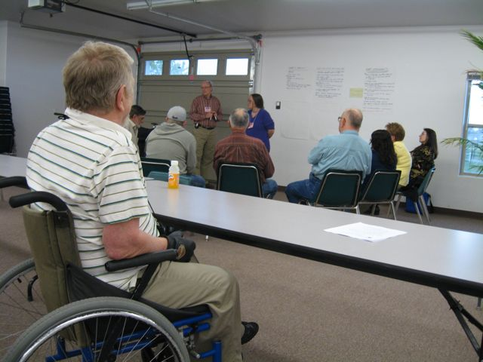
The Visiting Team would like to conclude this report with thoughts and suggestions related to strategic planning in hopes that they might help the city complete its stated objective of using this report as a basis for completing such a plan. Some communities use the term strategic plan while others prefer action plan. For the purposes of this report, both terms refer to a public process and resulting document that identifies and prioritizes opportunities to ensure a community’s social, economic and environmental well-being over the long term so future residents have access to the same quality of life enjoyed at present.
The adoption of a plan is often thought of as the end of a planning process. This is understandable, given the significant time and energy required to complete a plan. The Visiting Team invites Gooding to think about its strategic plan from a different perspective -- one in which plan adoption is the beginning, not the end, of the planning process. After all, the true measure of any plan’s success is determined by the participation in its implementation. The question to ask from the outset is, “What kind of strategic planning process increases the likelihood that citizens and leaders of Gooding remain engaged in implementation over the long term?”

Conventional Strategic Planning
Strategic planning in the context of community and economic development evolves with the rest of society. Conventionally, strategic planning has been more focused on uncovering local problems, resource constraints, deficiencies and unmet needs. Actions to address the problems are then identified. At the end of such a process, participants can easily view their community as a place full of problems and needs, most of which require the help of outsiders to resolve. In this scenario the outsiders can become viewed as the agents of change, rather than the residents. Reinforced over time, this approach can have a disempowering effect.
The result is that residents can become apathetic, disengaging from the process soon after adoption of the plan. Worse yet, some planning processes do not engage citizens in the first place, resulting in a plan that few people even know exists. Subsequent funding requests connected to the plan cannot demonstrate the kind of broad local support necessary to stand out from the multitude of requests from other communities. These consequences are motivating a shift away from problem-oriented methods toward processes that build on past community achievements, existing strengths and local skills. By encouraging the creation of positive, affirmative images, these processes tend to produce desired change more quickly. They go beyond mere participation by cultivating inspiration.

A Better Way
Asset-Based Community Development and Appreciative Inquiry are two paradigms that have emerged over the last 15 to 20 years to inspire residents or members of an organization through processes that use the best of what already exists to construct a vision of what the community might be if it identifies its strengths, then improves or intensifies them. Both paradigms share a belief that momentum for change requires positive thinking and social bonding. Both recognize people and communities tend to move in the direction of the stories they tell about who they are and who they can be. Hundreds of interviews about the qualities that contributed to past and current successes will lead a community in a much more positive direction than hundreds of interviews about past poor participation and projects that failed to achieve their potential.
Asset-Based Community Development
There are both deficiencies and capacities in every community. As described above, the basic premise of Asset-Based Community Development is that a capacity-focused approach is more likely to empower the community and mobilize citizens to create positive and meaningful change from within. It was pioneered by John McKnight and John Kretzmann of the Institute of Policy Research at Northwestern University.
This approach categorizes a community’s assets into five categories:
- Individuals – By recognizing the power of individuals, people can take ownership of the community development process.
- Local associations – These can be formal such as existing organizations or informal such as families or groups of friends. Identifying both is important.
- Local institutions – These include government agencies, businesses and schools, for example. Identifying each institution’s resources helps establish and reinforce a sense of civic responsibility.
- Physical assets – These include infrastructure and other publicly and privately owned amenities.
- Local economy – This includes data quantifying and qualifying the types of employment in the community and related emerging opportunities.
After the initial inventory of the assets above, this approach involves the following five-step process:
- Mapping completely the capacities and assets of individuals, local associations and institutions.
- Building relationships among local assets for mutually beneficial problem solving within the community.
- Mobilizing the community's assets fully for economic development and information sharing purposes.
- Convening a broadly representative group for the purposes of building a community vision and plan.
- Leveraging activities, investments and resources from outside the community to support asset-based, locally defined development.

Resources Related to Asset-Based Community Development

- “Building Communities from the Inside Out: A Path Toward Finding and Mobilizing a Community's Assets” by John McKnight and John Kretzmann, 1993.
- The publication above and many other related resources are available at the Web site of The Asset-Based Community Development Institute, www.abcdinstitute.org.
Appreciative Inquiry
Appreciative Inquiry’s evolvedfrom organizational development though it is increasingly being adapted to community development. It was developed in the mid 1980s andearly 1990s by David Cooperrider and colleagues at the Department of Organizational Behavior at Case Western Reserve University. It is based on the theory that positive change comes from focusing on the peak experiences and successes of the past. The connection between Appreciative Inquiry and community development is natural. It is a highly inclusive process in which community members take responsibility for generating and gathering information usually through interviews and broader forms of group storytelling. Some think of Appreciative Inquiry as not so much a tool or methodology as an attitude or approach.
Appreciative Inquiry typically uses a process referred to as the 4D model. The 4 Ds are:
- Discover – Residents are encouraged to gather stories and insights from each other about what has made the community successful in the past, the conditions that made these successes possible such asleadership, relationships, communication and events. By highlighting what is strong and vibrant about a community, it will continue to move in that direction.
- Dream – Residents explore how past experiences can apply to the community’s future. They imagine what could be for the community.
- Design – The actual development of the plan that describes how the ideal complement of past success and future possibilities would manifest itself.
- Deliver – People create the mechanisms and reinforce existing capacities to make the dream a long-term reality.
Resources Related to Appreciative Inquiry

- “A Positive Revolution in Change: Appreciative Inquiry” by David Cooperrider and Diana Whitney, Case Western Reserve University, 1999.
- The document above and many other resources related to AI are found at the Appreciative Inquiry Commons Web site, http://appreciativeinquiry.case.edu/.
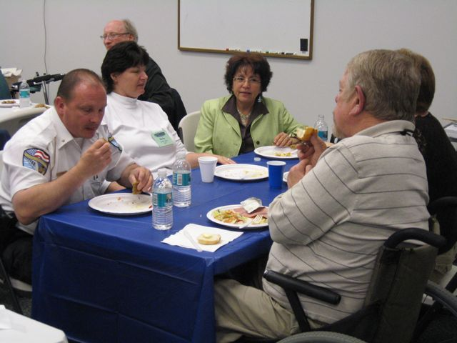
In both Asset-Based Community Development and Appreciative Inquiry, residents participate in opportunities to appreciate their value to the community, encouraging them to feel more connected to other residents and to the success of the community. With this connection comes an increased level of personal responsibility. As noted earlier, Asset-Based Community Development has been frequently applied in broad, more complex community development initiatives. Appreciative Inquiry initially came from the organizational development world and is only recently being adapted to community development.
Embarking on a strategic planning process does not require the city to choose Asset-Based Community Development, Appreciative Inquiry or any other singlemethod. These are not mutually exclusive. Both are capacity building in nature. They are complementary and combinable. The Visiting Team encourages the city to develop an adaptive process that integrates elements of both.

Why it Matters
Public resources such as grant funding from outside the community are typically needed to accomplish larger scale community and economic development goals. As all Idaho cities know firsthand, the amount of funding is finite while the needs and competition for funding are ever increasing. Funding applications that result from the kind of empowering, affirming and inclusive strategic planning process will rise to the top above requests from other communities that don’t benefit from the same level of broad support at the local level. In other words, using an inspiring planning process will mobilize resources from within the community AND generate support from outside the community.

Community Conflict Resolution
Every person, family, organization and community experiences conflict resulting from differences in values and perception. Conflicts can become difficult to resolve when feelings such as fear and anger are present.
As stated previously in this report, many residents and community leaders expressed strong opinions and emotions regarding the North Valley Academy Charter School and its real or potential impact on the Gooding School District and the community in general. Still, it is important to note that past and current areas of concern or disagreement in Gooding are no more severe or prevalent than in other Idaho communities.
The resolution of conflict can be challenging, especially if emotions are involved -- which they often are. Whether the conflict involves two people or large groups, it often helps to reflect on these related questions:
- What is at risk if this conflict continues unresolved? What is the conflict costing our community and the individuals involved?
- What is at risk if we work to resolve the conflict or reach agreements? What is it about the resolution process or its outcome that we fear? After all, there must be something we are afraid to risk. If there wasn’t, the conflict would have been resolved long ago.

True, both options may appear equally unappealing. These questions help us see that choosing not to act and not to engage with the person or organization with which we are in conflict means we accept the costs of the status quo. Is choosing not to act the healthiest, most responsible choice we can make? Individuals or organizations often work to resolve conflict when they realize the risk of the status quo is greater than the risk of working to reach agreement.

Sources of Conflict
Community conflicts arise from differences in needs or interests perceived on three levels:

- Substance -- Parties have poor or biased information, are interpreting the same information differently or have taken mutually exclusive positions.

- Process -- Stakeholders or individuals feel a decision-making process has been unfair, biased or left out key groups.

- People -- Individuals are in conflict because there is mistrust, suspicion and misperception. Interpersonal communications may be inadequate or misleading.

Many community conflicts involve more than one source.

Keys to Successful Community Conflict Resolution

The likelihood of resolution is greatly increased when we:

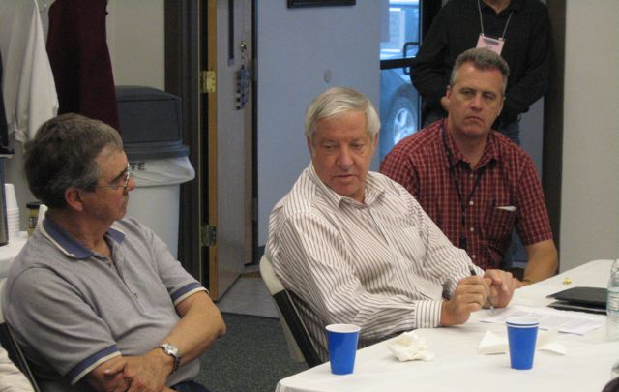
- Establish communication agreements among the parties. Such agreements may address, for example, confidentiality.
- Communicate in ways that connect people as human beings and residents of the same community.
- Abandon the goal of getting other people to do what we want in favor of focusing on creating the conditions whereby everyone’s interests or needs will be met. This produces a setting in which all involved trust that their needs and values will be respectfully addressed.
- Loosen our grip on our positions in favor of making sure the other party or parties understand our interests.
- Look for the root cause of the situation below the surface. Sometimes these causes can be individual in nature, rather than organization-based.
- Encourage the use of active listening to make sure the person speaking is being accurately understood by those listening.
- Take ownership for our judgments or assessments separately from objective information about which no one could disagree. Failing to take responsibility for our judgments, assessments and feelings creates distance between people, thereby decreasing the potential for successful resolution.
- Make sure all needs and interests are understood before potential solutions are discussed.
- Make requests clearly using words that express what we want rather than what we don’t want.
Resources related to community conflict resolution are found in the ‘Community Identity’ section of this report.

Appendices

Gooding Community Survey Results

Visiting Team Member Biographies and Contact Information

Mayor’s Column in Toponis Times, April 28, 2009

Gooding Community Review Detailed Itinerary

Write-up concerning restoration of the Schubert Theater by Visiting Team member Dan Everhart

Appendix A: Gooding Community Survey Results
Community Review Survey—

We Need Your Input! Please Return by April 20th.
This survey can also be completed online at www.irp.idaho.gov.
First, we would like to know a little bit about who has completed our survey. Please complete the following items before returning the survey to us.
Gender: 3 no answer _65____ Male _80___ Female Age: average 52.5
Ethnicity: Native American – 2 Anglo/white/caucasion – 118 Asian American – 1 Basque – 1 Hispanic – 2
Years Lived in the Community: _Average 26.3
Where do you currently live? 125_ In Gooding _19__ Other Area in Gooding County
Do you commute to work in another city or town? _25__ Yes 118___ No
If yes, to what city or town to you commute to work in? __
Bliss 2; Boise 1; Hagerman 1; Wendell 1; Jerome 4; Buhl 1; Castleford 1; Ketchum area 2; Mountain Home 1; Shoshone 3; Twin Falls 6
Listed on the next several pages are 75 community features and resources. Please rate your perception of the quality of these features in your community. Please be absolutely honest in your answer, as it is important to know exactly how you feel. If you don’t have an opinion about it, simply do not respond to that item.

Item | Community Feature | Quality Rating “1-very poor” to “7-very good”
Transportation and Roads
1. | City Streets and Roads | 4.41
2. | Airport | 5.06
3. | Traffic Conditions | 5.06
4. | Parking Downtown | 4.35
6. | Bicycle and Pedestrian Access | 3.94
Community Protection
7. | Police Protection | 5.21
8. | Crime Prevention Programs | 4.53
9. | Fire Protection | 5.86
10. | Building Code Enforcement & Inspection | 4.59
Water/Wastewater Resources
11. | Water Supply | 5.28
12. | Water Quality | 5.04
13. | Sewage Collection and Disposal | 5.65
14. | Flood Control Measures | 4.76
Parks & Recreation
15. | Community Parks and Playgrounds | 4.73
16. | Sufficient Planning for Future Recreational Facilities | 3.31
17. | Recreation for Children 12 and under | 3.48
18. | Recreation for Teenagers | 2.63
19. | Recreation for Adults | 3.01
Local Leadership
20. | Responsiveness of Local Government | 4.06
21. | Cooperation Among Local Government and Civic Groups | 4.25
22. | Community Involvement in Decision Making | 3.73
23. | Cooperation between City and County | 4.02
24. | Effective Community Leadership | 4.18
25. | Long-Range Planning | 3.66
26. | Planning and Zoning of Real Property | 3.90
Educational Resources
27. | Quality of City Library | 5.67
28. | Local Arts and Cultural Opportunities | 3.01
29. | Condition of School Buildings | 4.88
30. | Quality of Elementary Education | 4.88
32. | Quality of Junior High Education | 4.69
33. | Quality of High School Education | 4.46
34. | Vocational Education - Job Training Opportunities | 3.74
35. | Higher Education Opportunities | 4.09
Health Resources
36. | Ambulance Service | 5.6
37. | Availability of Emergency Care | 5.57
38. | Access to Hospital(s) | 5.87
39. | Availability of Doctors | 5.66
40. | Availability of Mental Health Care | 3.86
Housing
41. | Availability of Homes to Purchase | 4.78
42. | Condition of Homes Available | 3.9
43. | Availability of Rental Housing Options | 3.71
44. | Condition of Rental Housing | 3.44
45. | Availability of Affordable Income Housing Options | 3.61
46. | Condition of Affordable Income Housing Options | 3.69
Community Appearance
47. | Appearance of Downtown | 4.73
48. | Appearance of Public Buildings | 4.96
49. | Appearance of Neighborhoods | 4.01
50. | Appearance of Gateways into Community | 3.87
Social Climate
51. | Friendliness of Residents | 5.31
52. | Progressive Community Spirit | 4.30
53. | Welcome Given to Newcomers | 4.29
54. | Acceptance of Minorities | 4.30
55. | Involvement of Churches in Community | 5.22
Jobs and Industry
56. | Availability of Local Jobs | 3.06
57. | Quality of Available Local Jobs | 3.15
58. | Variety of Local Industry | 3.16
59. | Business Involvement with Community | 4.13
Local Goods and Services
60. | Variety & Quality of Goods in Stores | 4.15
61. | Number of Places to Eat Out | 4.55
62. | Quality of Places to Eat Out | 4.50
63. | Accessibility of Community for People With Disabilities | 4.54
64. | Availability of Day Care for Children | 4.34
65. | Availability of Senior Programs | 4.78
66. | Availability of Drug and Alcohol Treatment Programs | 5.69
67. | Banking and Financial Services | 5.77
68. | Local Newspaper Service | 3.52
69. | Hotel and Motel Accommodations | 2.70
70. | High Speed Internet Access & Quality | 4.81
71. | Entertainment Options | 2.10
72. | Garbage Collection and Disposal | 5.48
Overall Perceptions
73. | Overall Community Quality | 4.79
74. | City staff response to challenges in Gooding | 4.26
75. | Usability and helpfulness of city website www.goodingidaho.org | 3.86

Finally, we would like to know your perceptions—in your own words—about what is great about the city of Gooding and how you would like to see it improve. Please share your thoughts on these issues with us.
What are the strengths and assets that make the city of Gooding a special place to work, live, play and raise a family?
- Everybody is close for the most part and watches out for each other. Schools are good.
- good people, good public services, attractive communty, excellent schools, good infrastructure
- Small town atmosphere
- Good people. Clean town.
- Healthcare availability, clean city, sage neighborhoods, central location for outdoor activities.
- Small town atmosphere is great. The local Police department is very responsive and helpful with residents. The chief of police is doing his job right. Keep him.
- Relatively safe feeling, attractive downtown, quality schools and public offices, relaxed atmosphere
- It is a pretty community with lots of trees and recreational opportunities.
- Close to stores, schools, etc.
- It's a peaceful and secure place to live
- The new hospital, the North Valley Academy, the upgraded rodeo grounds and Cowboy Hall of Fame & annual Reunion, the Basque Center
- Gooding is more of a retirement town right now. IT has no strenghts except maybe not a lot of crime.
- Small community. Great place to rasie kids without the crime/gang violance.
- The small town does seem safer than the crime that hits larger communities. There are families moving in from other areas that will help with versatility.
- The small town atmosphere, where you know people and people are mostly friendly.
- NIce peaceful, clean town, good farming, agriculture
- Familiarity in the community in that you know most if not all of your neighbors and they know you so your children, property, etc. has kind of a community parent looking out for them. Community support for others in times of need. Wide open spaces and pub
- The strengths are that this community is geared toward senior citizens, younger children, with the right attitude could grow and improve.
- This is away from Big City life style. Friendly poeple who will help each other, people that care about your children.
- Gooding schools superintendent, quiet neighborhoods, lower violent crimes committed
- Good stable job at Glanbia. Beautiful landscapes and rivers. Good climate. Excetional Charter School NVA. Friendly people.
- NORMALLY FAIRLY QUIET AND PEACEFUL.
- safe place to live; beautiful town with trees and parks, city government that cares and works hard
- Small town feel
- It still holds that small town feeling. The individuals that I have come in contact with in my short time I have resided in Gooding have all been helpful and friendly. It is close to a variety of outdoor activities. Gooding is close enough to larger citie
- Small town atmosphere; attractive down town; good medicalcare fast
- As with most small communities, the people make the difference. Overall, Gooding is a friendly place to work, live and play.
- Small, friendly community
- Lack of leadership within City Administration. Lack of information provided by City and the Council. Ordinances out of date. (ie) No news paper but list the old Gooding Leader as the Public Notification of City Functions. Infrastructure is weak. The water
- Its a small town with friendly people.
- Small and friendly
- it used to bwe much better but all of the enjoyable things are gone. the strengths could be better if seniors would give and take they can't always have a mundand community the young people need to be more involved in decisions
- It's a small community so people know each other which gives it a friendly feeling.
- The small size of the community makes is a good place to live. location to a variety of outdoor recreation is a main attraction for me.
- CHARTER SCHOOL, STATE SCHOOL FOR THE DEAF AND BLIND, GLANBIA, KIDS DISCOVERY CENTER, LINCOLN INN
- Friendly, safe, stable housing values, stable job market, educational choices (NVA), proximity to CSI, access to medical care
- Small town environment
- the small town is great. It mostly is safe to be out and around town. The people are very nice if you are not discussing the mormons or the charter school. Everyone looks out for each other
- Gooding is a wonderful small community. We all come together in support of our schools and students, we work together to make our town a warm and safe place to raise our children. There are programs for our children as they grow - scouting, church program
- Small enough to get to know the people and partially feel that your children are safe.
- A small town. People knowing each other. A variety of churches. A variety of banks. More choices for an education. A local rodeo. A hospital.
- I think that the Idaho School for the Deaf and Blind is a wonderful asset to our community. The campus is beautiful and it provides employment opportunities for our community. I believe that the same is true for the Walker Center.
- Small town, strong family connections cost of living is low.
- THAT OUR COMMUNITY IS SMALL ENOUGH THAT WE KNOW JUST ABOUT EVERYONE AND THE FRIENDLINESS OFTHE PEOPLE. NOW FOR PLAYING, I DON'T DO MUCH OF THAT AND I DON'T WORK
- Nice, small city--Good place to raise children.
- Small to medium sized community where services are offered almost without leaving, but the feel of "small town".
- small town close to larger city
- Being a smaller community has its advantages because most people have smiles, say Hi (even if you don't know them), help when someone needs it, etc. All in all we have a nice community.
- Schools - don't need charter school. Churches, medical, access to hospital, doctors, lack of crime and people care
- Most services that a family needs are nearby. The new hospital is great. The fair and rodeo are wonderful. There are lots of educational opportunties.
- Being a rural community.
- People get to know each other - friendly
- It is for the most part a safe place to raise a family.
- Overall, Gooding is a pretty clean community and safe. There are many nice poeple here tha care about their neighbors and children.
- City employees have kept our city looking clean and well kept.
- Enjoy the new local newspaper. Its a quiet town, friendly, stores are well managed and helpful. Police dept are available. We enjoy the shoppomg that we have in Gooding.
- Low crime, friendly
- It is a small community but getting too small. Live is all you can do to have extra activities. You have to leave town.
- Small community but no good paying jobs - cheaper to live
- Small community, fairly safe, comfortable, can drive to anything, good public education
- Execllent police dept. They do their best with traffic spread so thin, but this is one area needing improvement.
- Families, people, the silent majority
- They are doing an ok job.
- It feels that the town is very safe when I compare it to my hometown. The schools are great even iwth the struggles of the economy. If you have a job here its great, no commute.
- Good medical facilities, relatively good schools, nice people, most all necessities available locally
- The people are very friendly and welcoming. I've been acdepted with open arms into social groups.
- Friendliness of residents - willingness of neighbors - extended family and church
- Small, low crime, friendly, helpful
- Access to outdoor activities. Rural life for family, but close enough to larger population centers.
- Small community that cares about the city and it's members.
- Small tightnitt community great for country living or an outdoorsman not so good for a family
- The people in the community.
- Small in size and the people living here--the older people have the values of rural America.
- The city police and fire departments are always out and about in the community which makes my family and I feel safe. The parks are inviting and usually well kept.
- Its a small town. and I like that. Its easy to get around in. I also love working in Gooding, I am arounf the public all day so I know a lot of people, its a great place to live! You also have a desert to go out and play in, thats always fun!
- We feel that Gooding is a wonderful place to live. We raised our family here, always had a good job, and the kids had wonderful recreation opportunities. We are not sure if that is the case now, but there seems to be lots of activities. It is still a wond
- All of above very good. We enjoy living here.
- Quiet little town, friendly, people know each other
- Small town
- Gooding is a tight knit community, so there is always support for when things get tough.
- Police not spending time on the streets. Police having their wife in the police car with them and out of town.
- The people of Gooding have a very strong loyalty and sense of community. They are very supportive of school programs.
- I would live nowhere else.
- It has small town atmosphere where you know a lot of people and for most part it is a safe place to live.
- Close to outdoor recreation, low on crime
- Good people, school selection
- You did not mention shopping - grocery stores are ok but no good clothing stores.
- Gooding public schools - job opportunities - nice people- new hospital - good doctors
- None, because you never give people the incentive to make things nice.
- Quiet community and friendly neighbors
- Does not look like every other small town with chain stores and fast food. This is good. Still is small town America.
- There are enough police around to make you feel safe. The roads are maintained better than the other cities in the winter.
- Police and fire protection is good - hospital availability - one of the best ER around - good schools
- Sense of family and community, peaceful and friendly
- The streets are not too crowded. Have a good senior center, nice parks and recreation for children.
- The town is small so people know each other. People step up to try and improve situations: the local newspaper closed so Two or three ladies stepped for to publish a paper.
- That the streets are safe to let your kids play outside and walk down town without haveing driveby shootings.
- A quiet, safe place to live.
- Best thing is that it is a quiet town.
- Gooding is a friendly small town. The police department is very friendly and professional. The Police department works with the community to solve crimes. The ordinance officer is really attempting to clean up the appeareance of the city to make it more a
- Gooding is a very involved community, the kind that will always be there for there neighbors and friends.
- Friendly, attractive, many opportunties for recreation, located off the busy highways. Slow growth.
- A good retirement here. A few more policemen. I live in a good neighborhood and have friends here. I love Gooding and senior center. They do a good job helping the older folks and good food.
- Clean, good water, low crime, fairly friendly, fairly low cost of living, not many changes, city employees are friendly and helpful.
- I have rasied my family of 3 here in Gooding.
- The community is small and close knit allowing us to have a safe place to raise our kids. Little to no traffic, minimal crime.
- Friendly Community activities such as firemen's picnic, 4th of July picnic, Rodeo
- the people, what a great palce to be and work..
- The people in the community that are very friendly.
- Gooding is a good sized rural town with minimum crime and reasonably friendly people.
- Having a good mayor that is involved in the problems facing Gooding. Quite nice town, good police force, good fire dept
- Safe quiet town mayor invloved with problems and cures
- small town, everyone knows and helps his neighbor
- Small friendly, excellent law enforcement and fire protection. Overall good services for a small town.
- People who really care and are trying to improve the community.
What are the problems and challenges facing the City of Gooding in the short term?
- You need to clean and sweep the streets, repair them properly, improve the parks and have more entertainment.
- Delivery of irrigation water - unfair billing practices that apply to those who are unable to receive water.
- emplyment opportunities, availablility of products (retail stores) more run down property than we should tolerate
- Loss of jobs, businesses possibly not surviving.
- Rental housing, jobs, entertainment for all ages, choices of restaurants and foods.
- The garbage manager needs to work with residents better. The mayor does well but should work with all city employees in an equal and positive manner. The road crew sucks. They need to work once in a while.
- Domestic and irrigation water, housing development, school situation
- We need to get the Little Wood River wall fixed. Senator Stennett promised 5 years ago. Nothing happened.
- The growing hispanic problem, and all the drugs and trashy places that come with them. Crime is only getting worse.
- The current leadership doesn't allow new industry to create new and better paying jobs due to their own interests and possibly the threat of loosing a dollar! City maintenance is terrible especially during the winter, but with the higher ups the only peop
- In the 1950's Gooding had available 3 car dealership, 2 equip. dealerships, 2 welding shops 2 theaters, 3 clothing stores 7 gas stations 2 hospitals, weekly livestock aution, local railroad depot, 3 pool halls, & 2 full time barber shops. All the foregoin
- Need to bring in work and entertainment to make this city appling to younger families.
- The dispute over the schools.
- Stuck mentality. Lack of quality recreation for all ages. Lack of school spirit and high expectations of excellence in academics and sports. Lack of town unity. Grumpy people.
- The economy is going to effect us highly. Businesses are being shut down, jobs being lost, and stores in town are too pricey. You have to drive to a different town to get things cheaper.
- Court house too closed minded with police dept. It's who you know. No one wants to get involved. Teenagers have nothing to do. Not enough for them. People are cruel to minorities. A lot of alcohol in this town.
- Educational funding.
- The lack of cooperation between the City Offices and the County offices. Turnover rates of both city and county law enforcement.
- There needs to be more job opportunities for teenagers and young adults. More things for teenagers to do too.
- Job availibility, stores being able to compete with big store chains.
- High school administration, need more community sport programs, too many stray animals, public vs charter school
- Your Building department is very unprofesional and unreasonable, making it hard to build and grow as a town. You have a very unqualified building inspecter who is not consistant with permit holders. There are special treatment for some and not for others.
- IT SEEMS THE SAME GROUP OF PEOPLE ALWAYS HAVE, ARE NOW AND PROBABLY ALWAYS WILL CONTROL THE CITY GOVERNMENT. THERE APPEARS TO BE MORE THAN AN ACCEPTABLE AMOUNT OF NEPOTISM IN BOTH THE CITY AND COUNTY GOVERNMENT.
- irrigation water, paying for irrigation when you cannot get it
- Cleaning up the junk in town and help add charm to town
- Well its one of its assets may be its demise. With that home town feeling, everyone is going to want to expirence it. So Gooding has that oppertunity to really grow. Since it is so close to the larger communities, people are willing to commute back and fo
- Water/infrastructure maintenance & upgrades; keeping businesses
- I think its the attitude of some who are unwilling to accept progress and change. Our little city has made national news because of the contention over the Public Charter School and the unwillingness of some to accept the status quo.
- Need for repairs without a lot of funding
- Water System needs upgraded. Flood irrigation needs talked about but does not result in any action.
- Get rid of drugs.
- Bullying in the schools and drugs
- no entertainment or recreation. I all pertains to adults
- People need to work together and stop fighting each other between the public school and the charter school.
- The community division created over the charter school. The challenge of a community our size supporting two high schools and being able to afford to continue to provide programs and services to our students. Also availability of local jobs. Many have to
- ECONOMICAL STRUGGLES
- increasing number of vacant homes, lack of safe sidewalks near public schools, lack of affordable, stable daycare, lack of social support for some seniors, NO EMERGENCY MENTAL HEALTH CARE ACCESS (designated examiners), lack of prosecution for crimes, lack
- Poverty
- no place that the kids can go play. all the equipment is extremely old and unsafe for kids under 5. Change is not a good thing to most of Gooding. If it has been done that way for 40 years there is no reason to change. The community as a whole is run by a
- The City police department dwells on petty items instead of the real problems in Gooding and the consequenses are not sufficient. Quit letting the kids get away with vandalism.
- Charter school vs. public school
- Activities for teenagers. Playground equipment for the parks. Indoor pool open to the public.
- I think that the issue of the charter school is dividing the town.
- Jobs, daycare, theft
- 1--need for more jobs 2--ways to encourage businesses to locate here 3--revamping of flood irrigation system--not to change over to all sprinklers--use city employees to work on the ditches during the off season 4--workiing to retain Idaho School for the
- The city is old and the structures are falling apart - public buildings and private housing within the city limits are in terrible condition. It makes the town look trashy.
- money
- We need some growth of businesses so we don't always have to go out of town to shop. It would be nice to keep as much of Gooding citizens' money in Gooding.
- Transportation for older people, need businesses in town that provide jobs, city needs individual who will bring jobs to community
- Jobs for young people. The city manager has favorites. It matters who you are if you want ot get something done or change.
- Funding - irrigation - River Wall - streets
- The canal. Jobs to keep our young people in Gooding.
- There are not too many opportunities for a declinig economy.
- Many of our roads need repairs in the residental areas.
- The school system is a short and long term problem. Many poor teachers - school finances. Over half are sport programs and are poorly ran, too expensive to participate.s
- Clean up neighborhoods, clean up trashy buildings
- All groups working together to help clean the city and provide for all.
- They need to fix the fence and wall around Little Wood River. Also get people to clean their yards of junk cars. Also abandoned houses toren down and yards kept up.
- Dogs running at large!
- Minorities, dumpy/trashy residences, property value - neighborhood decreases because of some problem residences, not everyone having the law enforced on them the same.
- Irrigation! Too many water theives. Tackle illegals problem.
- Talk of vision but under current of multi-generational depfunction of all community efforts always wins in a negative way.
- I think Main Street will have many fender benders to come if we continue to grow in the business sense. We will need something to break uo the flow, especially during 8am to 5pm hours. Parking may also need to be moved back from corners.
- River running thru town a huge hazard due to crumbling rock wall barriers/high school cirriculum needs expansion and improvement in quality
- Too little to do for everyone. I volunteer at the library, go to church, and attend Gooding County historical society but they're not for everybody.
- Leadership
- Lack of good leadership
- Too many trashy places - lack of weed control - lack of personal services
- Water and irrigation. Declining working population and need for economic developement. With no community common goal, there is little cohesiveness within the city's community
- We need more things for our youth to do, to keep them out of trouble.
- Education the Gooding Schools have been struggling to educate the children and when we got the charter school that actually improved the education in the community it seems as if everyone is mad at them for providing a better program. They also are facing
- Nothing to do for families or kids.
- Aging population and lack of industry to offer higher paying jobs to younger residents.
- The public school system, to include a charter school being in this small community. Also the communication and the ability for the city and county agencies to be able to work together.
- City needs to plan for the future and want to develope growth. A city that is not growing is dying.
- There are not enought places for teens to go, or play. Need more things do do for teenagers
- I'm not sure if this is long erm or short term, but can we please do something about the wall around the river? I don't have a solution, but there must be a way to fix it. It seems to detract from the beauty of the town. Also is there anyway that people c
- The distribution of drugs and alcohol is very bad on our street. Also the speeding and not watching out for the little ones on the street and yards playing.
- Higher paying jobs, availability of jobs, update the play equipment at both parks
- Roads, parking, recreation district
- Gooding is economically stagnant. Availiability of non-agricultural jobs is low.
- More effective city employees and more effective police.
- The charter school has created serious problems for the school district. The golf course is in serious need of a new irrigation system.
- Fix irrigation system on 7th Ave. W.
- Most of the streets need repairs - could use a stop light somewhere on Main Street.
- City streets need widend and edges maintained, better snow removal and weed control
- Our kids have nothing to do.
- Possible move of ISDB out of town.
- Increase job opportunities - sidewalks need to be replaced - curbs for wheelchairs need to be inspected.
- Irrigation water available? I need to flood my yard. The charter school presents problems for the public school system.
- Cleaning up the yards and junk cars around the houses. Lowering summer water rates for senior citizens. It makes the town look clean.
- Need new sidewalks and road repairs
- The city needs to enforce weed control and make people clean up trashy yards. That old destruction site on the 100 block of Idaho Street is not only an eye sore, its dangerous. A basement open to falls, boards with nails. Need more flowers on Main Street.
- Summer time activities for kids.
- Domestic water delivery to residents - irrigation water for lawns, gardens, etc. is becoming a huge issue at an exponential rate.
- Roads, water, schools - due to present economic climate. Drugs and gangs
- Need more industry for working families. Some transportation for older people who can't drive.
- Scools and working together
- There is competition between public and charter school. Irriagtion system need work. The walls along Little Wood River have to be replaced. The answers for this survey is not functioning the way I think they should. Bicycle paths for bike riders.
- Irrigation. Getting it up and running and wroking with a good additude
- Our problems are that city and county police Do not work together they are against each other! There is a lot of corruption with our police departments and lots of rasism!
- Roads, streets, and River Wall is dangerous.
- One problem is another town for each year tried to move the deaf and blind school to Boise. It was a great place to work and depend on a good retirement.
- School decissions
- Few available jobs, city irrigation costs,
- Get the community to help clean the city without pay. I think that everyone should have pride in Gooding.
- Losing businesses. No good paying jobs. Too many stray dogs. Too many illegal aliens. Un-equal law enforcement.
- Our city is dying because we have limited local jobs and our city is full of retired people and welfair recipients.
- River wall Irrigation system
- Water, local businesses
- No activites for people, movies, bowling, entertainment is lacking. You have the buildings in the city for these, but they are not being used to there potential.
- There's nothing for kids to do except school or rec sports. No where for kids to hang out. Plan for long term to keep them here.
- Irrigation - Wood River that flows through town, no sidewalks on south end of town or wheelchair access
- River wall, jobs, recreation for children, more affordable housing
- irrigation system
- Good clean drinking water
- Quality, affordable housing. Houses that are big enough for families.
What are the problems and challenges facing the City of Gooding in the long term?

- It seems the city government would rather run off new larger businesses than welcome them in. (not the city byt the chamber of commerce)
- Establishing and maintaining sustainable businesses, industries, job opportunities in the lcoal area.
- Same as the short term.
- same as long term
- Traffic on Main Street, trying to cross at noon is ridiculous.
- Roads and city buildings are degrading. The inner city canals needs repair.
- River rock wall, water shortage, clothing stores, job opportunties
- The city needs to continue to attract and pursue new industry for the city.
- Crime, drugs, problems with the dogs and the police dept needs to do better patroling in drug neighhoods, cause they know who they are.
- Gooding offers nothing! A good wage is $10 which I don't know how people live on that! There is absolutly nothin for any age group to due to consume time so everyone leaves town and doesn't support the local economy. Until some of these old timers that ar
- We need more growth and people willing to look forward instead of remaining stagnant in their thinking.
- Same as the above. But also, need to update the water, both drinking and irrigation.
- Giving children teens and adults something more to do.
- Resistance to new ideas and new people. Refusal to challenge complacency. People do not want to move here - the community will stay stuck.
- Property values are depreciating quickly. Irrigation water and system. Paying for irrifation water we can't use in a tough economy. Poor property upkeep.
- Same as above
- Educational funding. Availability of good paying jobs.
- New small businesses don't ever seem to experience long term success. Its here today and gone tomorrow.
- Once again there needs to be more job opportunities for teens, more entertainment, more effective diversionary programs with mentors.
- Irrigation for city lots, police actions on drugs and gangs.
- The town has a negitive attitude toward growth. The building department is "out to shut you down" Instead of being helpful and respectful.
- IF SOMEONE DOESN'T STAND UP AND DO SOMETHING ABOUT THE DAIRY SITUATION AND THE FEEDLOTS THE ODOR PROBLEM IS GOING TO GET EVEN MORE INTOLERABLE THAN IT IS NOW.. THERE HAVE BEEN TOO MANY HOMES BUILT AND RENOVATED WITHOUT PROPER PERMITS AND SUPERVISION. THIS
- affordable rental housing; fixing the river wall; public transportation to Twin or Boise;
- Keeping young people interested to say and live here - more jobs.
- Maintaining that "home town" feeling. Insuring that the "ma and pa" business are able to survive the influx of larger businesses.
- Water & infrastructure maintenance
- Our children are our future. Our children need to receive the quality education deserve. Gooding should be a place where our children want to stay.
- same as above & potential job losses
- Sidewalks not maintained by owners and are a hazard.
- Repair Wood River walls
- Drugs, water for irrigating, traffic lights at Deaf and Blind/charter school
- same as above
- Managing growth.
- Water. Local business. School infrastructures.
- JOBS
- NO EMERGENCY MENTAL HEALTH CARE, lack of some social services, lack of prosecution for crimes, the canal is in desperate need of repair & creates a safety hazard, Lack of ESL education
- Poverty
- Most of Gooding is under the flood plane map. It has been so long since it has been surveyed that with all the changes to the canal system there are many of us that should not be in the flood plane any more. I was even sent a letter from FEMA saying I was
- If we don't do something with the community, it will dry up and blow away. Stores open, stores close. Diners open, diners close. We need stability.
- Charter school vs. public school
- Repairing the sidewalks. Sidewalks all the way from the railroad tracks to the blinking light on both sides of Main Street. Maintenance of the school buildings, underground sprinklers for all the schools, and maintaining the recreation walk way surroundin
- Education and space in schools
- 1--Getting more businesses and industry to locate here. 2--Water supply for lawns and gardens---ask each prpioperty owner to help bring their section up to code. 3--Continue to try to get permission to fix the river walls.
- Again, the condition of public buildings and private housing. This includes the condition of hidden structures such as sewer, water, ect. They are old and are falling apart. We cannot contnue the way we are going.
- money, keeping good people here
- Again, as in the short term. Some growth of businesses.
- Streets, sidewalks, new businesses, publice school system, Little Wood River
- Infrastructure for future housing developments.
- Too much "good old boy" attitude equals no progress.
- Drugs used by our young residents.
- The irrigation system is failing, the Little Wood River Wall needs repaired, city neets to be able to annex and furnish services to area west of the community. Lack of job opportunities for people.
- I think the school district is facing a lot of challenges. One of my own concerns is that a lot of time is being wasted and studies and academics are becoming less of a priority.
- Work to be done on the Little Wood River going through town. Crumbling walls are very dangerous as it is an attraction to young people.
- No growth just decline - there isn't anything here to keep accomplished young people. Too many cars parked that don't work. There isn't any responsibility to clean and tak care of property.
- Same as short term, higher quality of education
- Housing and jobs. We need a better housing order rather than a house here and a house there. We need organized subdivisions.
- Need to get more job industries in town, recreational activities for the youth beside sports.
- Charter school wasting valuable funds - community is too small for it. Drugs, gang members, minorities - non English speaking
- Updating of sidewalks, and the need where they don't exist. Appearance of canals. The need for more job opportunities, bringing in bigger companies or manufacturers.
- Not good employment opportunties for youth
- A green belt bike path or river walk. A guided walk of historic landmark.
- Schools
- Change culture form self serving to serving the community
- The schools - increased crime - ater system failure
- Population decline. Aging infrastructure requiring replacement with aging tax base and declining economy.
- Staying on top of crime that is sure to increase with the way the economy is, and using the city funds in the right way.
- job and industy shortage lack of growth and a dieing community
- Nothing to do for families or kids.
- Same as above.
- Growth. There are not a lot of well paying job opportunities in the community.
- If the city does not promote growth, then local businesses will not be able to sustain themselves.
- Gooding is growing pretty fast, there are not enough quality places to stay, as in hotels. There are a lot of places to eat in Gooding, but there needs to be a few fast food joints. Also bring back the movie theater. When to bowling alley opens back up tha
- Long term, it would be nice if Gooding sponsored some more civic events on an annual basis. Hagerman does. Weed control along the streets and river would also be appreciated.
- The same as the short term on our street and we suppose elsewhere too.
- The walls of the river need built up.
- Community growth has been minimal for a long time. Very little for teens and adults to do.
- Retaining walls for river need repair. Resolution of the charter/public shcool issue. Golf course irrigation system overhaul.
- Replacing street surfaces and demolishing many old and run down house.
- We need all street with wider pavement curbs and sidewalks. We have a lot of motor wheelchairs on our streets not to mention people walking down the streets in traffic.
- No new industry
- Needs of more businesses
- Replace sidewalks, also maintain what we do have. Also clean up the vacant lots of so much old machinery and plain junk on the highways.
- We need to put some tax dollars into repairing the flood irrigation system, the river wall through town, and repair some sidewalks. Keeping ISDB located here.
- Summer water rate too high especially for senior citizens. People try to keep their lawns nice and green.
- The City of Gooding needs to improve building structures to make the buildings look newer.
- Do something to repair the river rip-rap instead of just talking about it. Repair residential sidewalks. Attract more small industies like the RV company north of town.
- Jobs, no mexican food
- Lack of jobs and industry creates low population growth
- Needing better flood control, better irrigation system
- Need more jobs for local people. Come to terms with two or three school systems in Gooding and develop cooperation among the groups.
- Little wood river wall. Needs to be fixed. Safety on that is not good. Children play on the wall and one day someone is going to get hurt bad.
- Growth of business industry and liveable wages to keep people in the area.
- Growth, People of Gooding do not really want growth and the city and county officials do.
- Federal restrictions on an ill advised flood plain (shouldn't exist) Little Wood River channel (completely rebuild)
- More money. Keep the city healthy and improving it. To get more people to move to Gooding so the new people have a say so to help improve our city.
- Get the bridges rebuilt. Improve on the streets. Keeping taxes low enough so elderly can keep living here. Keeping commercial buildings safe and presentable.
- We need some new industry in Gooding as well as a face lift for downtown.
- River wall lack of industry and quality jobs south gateway to city an eyesore
- canal through town
- Same as above, this makes people leave town to go elsewhere for these items.
- More businesses, growth. Do you want it? Opportunities for entertainment. We need something to set us apart.
- Jobs, businesses, irrigation, Wood River Wall, sidewalks south end of town.
- River wall, jobs, recreation for children sidewalks south end of city, affordable housing
- traffic and over crowded
- Pure drinking water
- Lose of jobs and thus people. It is a spiral effect.
What would you like to see the City of Gooding accomplish in the next five (5) years?
- Bring in better carnivals, a movie theatre would be nice, more kid friendly activities for all ages.
- Improve the visual message one receives upon driving into the city from any direction -- e.g driving in from the south. Look for ways to improve/ increase the variety of recreational activities offered within the community for kids of all ages.
- a good motel; combine city/county law enforcement (it is a waste of overhead expenses to have to seprate entities doing the exact same service
- Try to attract more businesses and jobs. Need more rental housing.
- Let's get the side roads up to par. More work projects involving all city residents, lead by city leaders.
- Water systems (domestic and irrigation), housing development - annex property for subdivisions
- I want the Little Wood walls fixed.
- To have a full time dog catcher, and animal shelter to keep them in, stiffer fines, for dogs at large and for the people that don't cleanup there yards.
- Hire a knowledgeable, full-time professional planner and the elected non professionals need to help wih growth or Gooding is going to continue to disentigrate.
- Would like to see this town bring in something for the young people to do to keep them out of trouble.
- YMCA
- Willingness to change and accept new people with new ideas. Willingness to forgive and forget old grudges. Honesty in all transactions. Teamwork between all city/government departments. Winning attitude starting at a young age. Musicals, concerts, art dis
- Produce better jobs and better benefits for the community residents. Bring some kind of entertainment back to Gooding instead of the smokey bars. Have things for kids to do that aren't interested in sports. BMX track, skate park, etc.
- Rules apply to everyone: city officials, crazy neighbors and good old boys. Need more recreation for teenagers. More job training for less money.
- I would like to see the canal encased. Its just a matter of time before something catastrophic happens costing life, property or both. Maybe make a walking/bike path over top of it. There would be riding/walking opportunities almost from the East Park all
- As above. And better mental health programs. More job opportunities and more diverse entertainment.
- Get a building inspector that is qualified,fair minded,helpful and does not descriminate. Encourage growth.
- GET RID OF THE FLOOD IRRIGATION. IT IS A TOTAL WASTE OF WATER .
- do away with irrigation; fix the river wall; clean up of tractor business on main street; beautify the city .
- Clean up the city and all the junkie houses and lots.
- make downtown more presentable. Update its water system.
- Stability in economics & infrastructure repairs; maintenance of exisiting facilities
- I would like to see the indoor pool in operation. I would like to see a working partnership between Gooding School Distrct, North Valley Academy Public Charter School, Gooding Rec District & ISDB.
- restoring sidewalks & monitoring for persons who do not maintain their home/yard
- Enforcement of ordinances and rewriting of ordinances.
- Get rid of drugs.
- Grow - new businesses
- i would like to see more activities for young people ie movie house skate park better parks with more stuff to play on maybe even a cover fo the swimming pool AND to keep the pool open past aug 31
- Better water pressure.
- To maintain the local public services of Library, schools, hospital, recreation opportunities. To create and promote recreation and year around entertainment and activity opportunities for our youth as well as family.
- MAINTAIN THE STATE SCHOOL
- Improved pay for law enforcement, growth of the new local paper to become self-sustaining enterprise, expanded job market, museum to become self-sustaining, continued growth of the NVA
- Receive cash injections to help maintain/rebuild buildings, parks, new business
- fix the canal so that it is enclosed and that the roads cross the canal on every street. Improve parks for small children. You can not meet people in the community with small kids, if there is no place to take your kids to play
- Higher up people need to quit getting preferential treatment. You bend the rules and laws for the wealthier people.
- community unity
- Sidewalks on both sides of Main Street. Indoor pool open all year. Updated playground equipment at all the parks. Skateboard park available.
- I think that the canal that runs through town is a major safety risk. it is in very poor shape. I have small children and the canal runs through the west park where children play.
- Better schools, more affordable housing and daycare availibilty
- 1--more jobs, more businesses so we do not have to go out o f town for clothing, etc. 2--bring the flood irrigation system up to grade. 3--work on the river walls for safety for those using the schools, parks, and for residences along the river.
- Solve the water problem, and clean up the town. The entries to the city are shabby and the neighborhoods have run-down houses with broken sidewalk, etc. Also to bring in new bsiness and industry to increase job opportunities and affordable housing for pur
- 1. Bring shops and some fast food places so our adults and teens can find local jobs. @. Something for families, children and ust adults to do for example: movie theater, bowling, skating, etc. 3. Newspaper
- City recreation district improve - mucy more could be done. Have facilities but they are not kept up. More jobs - higher individual that works with industry for Gooding only.
- Community support for new business is key. A more welcoming approach to the actual city on the southside would be good.
- Public transportation to other places: Twin Falls and Boise, etc.
- Getting the Little Wood River problem taken care of - maybe even get its surrounding area beautified.
- River Wall fixed.
- Much of the parking around town is inadequate especially for handicap people where most of it is on the street. There is no where for people to bicycle or rollerblade. There are many streets with no sideswalks or very poor ones.
- Road work and river walls improved.
- Repave sidewalks - not safe for elderly to walk on - makes the town look run down. Improve the schools with dress codes. Road drains need cleaning out for run offs.
- Clean up
- Something for the kids to do besides be distructive.
- Cover the Little Wood River so we can get rid of the flood insurance. The Little Wood River is a saftey hazard to children, eye sore, and a big expense.
- Clean up town. Get rid of drug problems. Get rid of illegals. Noise ordinances. Higher taxes for dumps, not taken care of places.
- Not just think outside the box. Get a new boy with new perspective of visions of what if then do no listen to the minority loud naysayers who now have political power here. Ignore them even though they will get louder. They will kill every plan or idea an
- A recreation center for kids up to 18-19 years old. Baseball for high school, if not possibly an American Legion Team. Jobs for kids as well.
- Fix river barrier/clean up parking and some private residences/recruit a good restaurant and a good motel/hotel
- Repair the Little Wood River wall
- Handle crime
- Fix the river wall into area we can be proud
- Better fast food drive throughs - Indoor pool open year round
- though local leadership, define a "brand" for the city of gooding to market the city as a destination for travelers; driving a stronger sence of community, and leading to business development and better age demographics.
- A continued growth that keeps pace with the Magic Valley.
- at least install a traffic light at the junction especially with the new hospital and other businesses building in the area to help reduce the number of accidents. A better city maintaince prgram involving cleaner streets and ceaner equipment
- Good quality options for people to stay here and be able to do something besides sit at home.
- Improvements in home irrigation of lawns--gates and boxes continue up-keep and repairs to the rock wall on the Little Wood River that flows thru town.
- There really needs to be mroe for the young children to do...a city park with a suitable play structure rather than old and dangerous equipment would be wonderful to see in this community.
- Clean the streets. They should be swept, all of them. Promote cleaner yards, homes and businesses. Make the city look inviting.
- Clean up and get rid of all of the drugs, so we don't have to be afraid of living here.
- Sidewalks on Main Street from the light all the way to the railroad tracks on both sides of Main Streets
- Increase the number of successful small businesses. Increase the number of job opportunities.
- Same as above.
- Finish and get the new hospital operating, fix river wall
- Get more industry and jobs in town. If Glanbia closed, we'd be gone.
- Grow
- See above
- Same as above. Recruit new businesses to town.
- Lower water rates and lower property taxes.
- Would like to see biffer grocery stores and repair sidewalks in front of the stores.
- Beautification that weedy tractor junkyard on south Main needs to go. It gives a first impression of a trashy town. Maybe a nice lighted sign like Wendells' at the flashing light.
- Fix the road going towards Elmore County.
- Increase jobs by increase in non-polluting industry
- Grow so we can have a better business center, so we don't have to go out of town for so many things.
- Bike paths. Cooperation between the schools.
- A disastor plan and have it out for the community to be involved. A better lock down system in place for the schools. More classes offered at CSI. Get a hold of the Drugs from the youth . It would also be nice to involve the Death and Blind more for commu
- Curbing installed in neighborhoods that have none, streets repaired properly, and very important River Wall repaired. All of these are safety issues.
- Better irrigation control - help and better ditches to the house on the edge of town.
- I would like to see the city grow more with businesses as well as residences.
- Community clean up days, beutification process of Gooding
- Eliminate flood irrigation to reduce costs.
- A program to greet new comers so they feel that they are a part of Gooding.
- Keeping downtown in good shape.
- Increase the parking around the businsses and clean up main street. I would like to see new businesses in the vacant buildings.
- More recreational activities for teenagers and adults.
- atract more mom and pop business, make downtown more inviting..
- Try to have more things to keep people here, instead of going to other towns.
- Family type amusement. More business so everbody's not going south out of town in the morning. More communication about city going-ons. More cooperation between groups.
- Same as above
- same as above
- do something different with the irrigation system, clean up the alleys and enforce the trashy houses with junk laying around
- Filtration of drinking water
- A community that isn't divided over schools or social effects of two schools.

What is your vision for the City of Gooding’s future?
- To put in a stop light at the corner of Highway 46 and 26, and put in new sidewalks
- nice continued moderate growth and some more small employers
- Why not invite more businesses and then encourage residents to frequent them. Have more celebrations sponsored by the businesses and the city to encourage more shopping.
- A place of job opportunities and community activities and involvement, the Chamber of Commerce continue to grow and function.
- Plenty of recreational opportunities with good schools. Clean city and parks with plenty of job opportunities.
- Like to see the whole town clean-up like it used to be. People taking more pride in our town and neighborhoods.
- Nothing the way its going and without people that would like some change! The way we are going there will be these little businesses that come in employee one or two and then can't make it so there will keep being the turnover there has for the last decad
- We need the regional jail facility and growth to keep up with the rest of the area and state.
- Maybe a placeto live that people want to come to. A place with jobs that pay and schools that are top quality.
- Small growth and more jobs.
- Town pride and unification - which suppoorts diversity and high quality education, recreation, and quality life for all residents.
- Be a stable community and a more self sufficient community. Make it to where we don't have to drive to Twin Falls or Jerome.
- This is a small town. People in the government positions of this county need to be more attentive to the minorities, older people, animals, women, and children. Not just themselves. This county and community need more inspiration for all getting involved,
- I think the hospital will bring money and many opportunities. I also think that the Charter school is one of the best things that could have happened to Gooding for everyone both directly and indirectly. I hope it remains successful. I would like to see (
- Growth!
- Stay small town atmosphere, helping and caring for each other.
- Promote the Arts and theater for the communtity. supporting musicals, theatrical entertainment etc. Support a kids little league for base ball. And have a good field for kids to play on.
- DE-POLITICIZE CITY GOVERNMENT. ENFORCE BUILDING ORDINANCES AND CLEAN UP ALL THE TRASHY HOMES AND LOTS. ENFORCE OFF STREET PARKING TO MAKE DRIVING SAFER AND EASIER ACCESS FOR EMERGENCY VEHICLES. WORK WITH THE COUNTY TO CLEAN UP THE DAIRIES AND FEEDLOTS AND
- main street buildings spruced up. skate park, teen recreation center; drug and crime free city, more retail businesses
- Nice home town community - needs some improvement
- Well as you probably noticed I am new to the community. I plan on buliding a home and putting down some roots. I see Gooding continuing to maintain that welcoming feeling no matter how large it grows. I would like to see the school system here become a li
- Stability and slow growth
- Over the next 100 years I would hope that Gooding would remain a community where the citizens work together in a spirit of cooperation on all the issues that face the community. I hope that Gooding will accept change as it comes but remains a small commun
- More community activities available
- None, until the Mayor and Council work together. The City Mayor does not perform as the Leader. Council assumes each city divisions and run the operations. The Mayor currently is not the Leader. Association of Idaho Cities needs to train the City Official
- Staying as friendly as it is now.
- a more family friendly place like it used to be. Let the younger generation take over and get all of the ancient people out. it is time for changes to be made if we want this town to floyrish it used to be that way.
- That it will stay a friendly place.
- Getting back to being one school community, supporting one public school district financially. As a tax payer I am bothered to be paying for two schools in a community with less than 1500 students K-12. Shopping opportunities that allow me to shop locally
- I WOULD LOVE TO SEE GOODING CONTINUE TO GROW AND BE A PROSPEROUS COMMUNITY SO MY CHILDREN CAN GROW UP HERE AND BE ABLE TO SUPPORT THEIR FAMILIES IN THE COMMUNITY AS I HAVE.
- Continue to grow, entice more businesses that will provide greater than minimum wage jobs
- I would like to see a return to good values and a community that cares more for the welfare of the kids than for their own agenda. To work together to bring arts and good recreation back to our area. Also to end the divisions between mormons and other rel
- We need more support from the community for newcomers. Old dogs can be taught new tricks. Open your minds to new ideas.
- After school activities provided by the recreation department for all ages. The option of an indoor pool and outdoor pool. A skateboard park. Another hotel. Possible department store. A bicycle trail.
- Growth and community togetherness to solve problems
- To see the area grow through new businesses and industry so as to be self-supporting and not needing to travel out of town for purchases, ie: clothing. More business and industry would bring more jobs, population increase, which in turn would bring in mor
- The hospital will bring growth. I envision more businesses will come to service the community. We need to catch up with the times and bring our community into the 21st centure.
- To get it back to what it uase to be for example, walking down Main Street from store to store meeting people with shopping bags and the joy of running into others at you are out and about shopping and/or playing.
- Small community - good jobs - sidewalks - street maintained - great medical services - library - great recreation district - pools - excellent schools
- We should promote Gooding as a poster child for educational opportunity.
- Very Good.
- Unless we become more progressive, I don't think it will grow much. We seem to be a bedroom community only.
- I would like to see the city have a back-up plan for power failures in our community.
- Would like to see more recreational opportunities for residents. The city needs to continue working on development of places for people to work.
- I think Gooding could be a wonderful city but does need some improvements. I would like to see better equipment at the city parks and possibly a green belt or bike path.
- I live our little town and do hope we can attrack more job opportunities.
- New businesses - not being dependent on Twin Falls and Jerome.
- I would love to see a city that works hard to maintain businesses and provide family entertainment.
- Not so much a retirement place but a family town.
- Nicer community to live in like it was 20 years ago.
- Development of city layout - walking trails - river edge development - development of water quality
- More parks. The city expanding on the south end, a more welcoming and attractive look to it. More options with growth.
- If it doesn't out grow facilities, good place for seniors, but not much for young people.
- Keep the small town flavor.
- Get good stores on Main Street so I won't have to leave home to shop.
- Work together for the welfare of the community
- Growth - keep it beautiful
- To remain a community that I am proud of and am glad to have my children growing up in.
- If they dont work on lower cost to build new homes and working to get in quality lower cost construction then people who live in older homes wont be able to afford to by a new modern constructionhome due to the housing market with expensive housing. I als
- It will stay the same old way that it's always been and not accept change.
- Growth in population and more higher paying job opportunities.
- It looks as if the growth is going to be near the junction. City will have to really clean up the downtown area to make it inviting to people passing through and make them want to stop.
- To have Gooding be a place to come to, and raise a family, continue to grow and prosper!
- I would like to see all Main Street store fronts being used, a few more restaurants, and some entertainment options.
- Gooding will continue to have a largely low income population. city events should focus on integrating all citizens.
- It will remain a small town which is probably good, however, it needs some type of transportation to other communities in the valley, especially Twin Falls
- To become more of a real county seat.
- Good
- It will always be the same unless we get a good weekly paper again.
- The home of ISDB.
- Dim - same people - same policies!
- Would like to see more recreational parks for the youger children to play sports and for families.
- Attracting more industry to provide jobs is crucial and businesses to fill the empty store buildings. More community entertainment - street dances downtown.
- Needs more jobs.
- I would like to see the City of Gooding be a thriving, growing community by bringing in people and jobs.
- Help each other out in times of needs and support each other for the hard time to come.
- To be a safe but bustling town of local shops and stores to that it won't be necessary to travel to other towns for merchandise and recreation.
- Need honest mechanics. There are two that did me wrong.
- I would like to see the city become a self sustaining community that does not need to depend on Twin Falls or Jerome for services.
- to remain a little caring community
- Slow measured growth continuing, continuing with the same quality of leadership.
- More new people and more income to help the city thrive.
- A nice hometown. Little changed since 1940. It was a good place to grow up.
- Let the younger people decide.
- No empty store fronts, no peeling paint, lots of parking.
- Nice affordable rural/medium town that your children will want to live in.
- Sidewalks south end of town.
- same as above
- more mature city police force
- Why did the city not apply for stimulus money to upgrade our drinking water?

Do you have any additional comments about the information on the survey or about the City of Gooding in general? We appreciate any comments or suggestions that you have!

- We need a city council that is not afraid of change and is willing to listen and carry out new fresh ideas.
- Eliminate sidewalks that are in poor condition and repair those which go nowhere or fix them and connect them.
- We appreciate the opportunity to offer ideas and hope Gooding can be a more progressive community because of the survey.
- This is a very pretty city with lots of opportunities to recreate. Lets keep it that way.
- Ordinance officer, needs to keep siting the trashy places, with stiffer fine and tickets. And should be able to tell the difference between the people who really care and don't. Gooding needs to start inforce building and firewall codes for all apartments
- The city also needs to do something about the dogs that run,And making sure people keep them and their yardsup..
- Enforce people to clean up their yards. There needs to be some stop lights put in certain crossings in Gooding. More cars need to stop for people crossing the streets and enforce the law.
- PLEASE DO A SURVEY ABOUT LIFE OVERALL IN GOODING COUNTY
- Keepp up the good work and thank you for coming.
- This City needs help!
- Pooper scooper law so we don't have to fence our yards to keep people from walking their dogs and/or turning them loose to go in your yard so they don't have to clean up from their own yards.
- GLAD TO KNOW THAT SOMEONE CARES ENOUGH TO ASK WHAT THE PEOPLE THINK SO THE APPROPRIATE CHANGES CAN BE MADE.
- I think it's a rip -off that I pay a yearly fee for flood irrigation which I don't have access to (no gates or ditches) & can't use.
- There are great people in this community that could really make it better if they were not overruled by the few that have been here for eons.
- I question the size of our police force. Gooding is such a small community I question the need for so many officers.
- I think that the recreation district stinks. I have a child that is 6 and I drive her to Jerome and pay the out of district fees to participate in their programs. They have a spring and fall soccer
- I enjoy living here but it isn't how it was a few years ago. I don't feel as safe or confident in the schools as I used to.
- Thank you for allowing us to have input. Now I hope that great good will come from it. Gooding is a great, little town with wonderful people living here.
- We need a grant writer to write grants for money to beautify and fix up our community so it will be a place people want to live.
- We have a nice town just need some growth (healthy growth) so we can be prosperous.
- A lot of senior citizens live here. We need a good support system in place for recreation - medical etc. They younger people need to take part in supporting their community. Everyone must work together.
- Why wasn't the charter school or ISDB mentioned?
- I've enjoyed living in Gooding.
- The younger people 20's, 30's, 40's, don't seem to care. The mexican population is a huge draw down on our school system.
- The above recommendations would make it much more enjoyable and accessible to get exercise and spend time outdoors with the family.
- Dog control in my area is not good.
- The City of Gooding needs to keep weed control down more in summer: alleys, streets, sidewalks
- Ordinances and laws need to change. Public, city employees, police can't make a difference without better policies.
- I feel that there have been quite a few good improvements made in the last 6-7 years. Especially in the police force. But things can always improve. The harassment has been improved a lot the last few years. Almost absent. Keep up the hard work. I know th
- Need at least one good quality affordable motel/hotel, family restuarant. Enforce noise ordinance, property maintenance, parking off street for abandoned vehicles
- We appreciate any comments or suggestions that you have!
- I love Gooding. It has old hometown sitting on the porch comfort and serenity.
- I think the loss of irrigation system will cause much of Gooding's beauty to decline - trees will die.
- I appreciate the vision of the city councle and mayor to proactively survey the community. This type of effort provides the ability to invision and strategically plan the future.
- I think that the City of Gooding should do away with the Irrigation Fee that they charge people who do not use the"ditch" water for irragation.
- I would like to add that it is all to commom to be driving by some city workers to see the oldest guy in poor health diggin or working in the hole why there a three or more younger guys standing aro
- Don't get me wrong, I have nothing but love for my home town. I realize that it takes money to do and grow a lot of these things, but that is what we need. This place hasn't really changed a whole lot since I've lived here, which has been almost my entire
- All in all this is a wonderful place to live, good weather, good friends, and neighbors. Friendly people. Our council and mayor are doing a great job.
- Overall, I feel the city has been pretty responsive to the needs of partons. I am sure more money would help city officals provide more and better programs.
- We appreciate any comments or suggestions that you have!
- I do not understand why I have to pay irrigation water tax when I do not use or cannot get it.
- We need some new blood in order that Gooding becomes more progressive.
- I came in 1956 and worked as a teacher at the school for the Deaf and Blind. Also worked at the "Leader" as a printer. Lee Burgess was the editor and he did a wonderful job at promoting the city at that time.
- The same people running the town year after year after year. Most don't even live in the City of Gooding.
- Small community only needs police dept, not sheriff and state police.
- Anything that can be done to inspire more community pride and get people to shop in Gooding. Public service announcements on TV. With no newspaper, no one knows when there is something going on. It's too easy to avoid or ignore actvities at the fairground
- The city workers maintain the town very well.
- Due to the fact that the city work crew number is limited, they do a good job with the manpower they have.
- The idea of a survey for patrons is good. I wish the online survey was more user friendly for comments.
- Public Works Department: The streets and sidewalks need to be kept swept better than they are currently. It is a shame to drive by a location that the public works department is woking on and to see an elderly man in a hole working away with three young h
- Get rid of the punture vine along your streets, we bring our pedal bikes in town to ride and you would not beleave how much you have on the sides of the streets. If people can not take care of this
- If it was too terribly bad, we wouldn't live here.
- Too many city employees in the winter months doing nothing. City employees being allowed to take their children to school and haul them around in city vehicles
- We appreciate any comments or suggestions that you have! I have seen city employees taking their children to school in the mornings in city vechiels and hauling theit children around in city vechiels which does not seem right more of a liability that a as
- I would appreciate 4th Ave West to be upgraded like California Street.

Appendix B: Biographic and Contact Information for Visiting Team Members

VISITING TEAM COORDINATORS
Jon Barrett
President
Clearstory Studios
2412 W. Bannock Street
Boise, ID 83702
208-383-9687
clearstorystudios@cableone.net

Jon founded Clearstory Studios in 2007 to help communities and organizations use clarity of intent, communication, and action to achieve their aspirations. Jon’s career in community and organizational development began in the early 1990’s following his graduation with a degree in Landscape Architecture from Washington State University in 1986. Since then he has been a city planner, associate in a consulting firm and non-profit executive. He was the co-executive director of Idaho Smart Growth from 1997-2006. In 2004 he was named Idaho Planner of the Year by the Idaho Planning Association. He is a graduate of the Leadership Idaho Agriculture program and a certified grant administrator. He is also involved in staffing personal empowerment trainings for men throughout the northwest region. Jon enjoys biking, fishing, backpacking, canoeing, gardening, music, cooking, and reading.

Brian Dale
Operations Specialist and Faith-Based Liaison
U.S. Dept. of Housing & Urban Development
800 Park Blvd., Ste. 220, Boise, ID 83712
208-334-1088 x 3005
brian_dale@hud.gov

Brian has been involved with the Idaho Community Review process since its inception, participating in 14 reviews. He was a team leader for the Ashton, Malad and Payette reviews and co-team Leader for the Rexburg review. His current assignments with HUD include serving as HUD’s regional faith-based liaison for Idaho and the rest of HUD Region X; serving on the Steering Committee of the Idaho Community Review; networking with service providers for homeless populations (Continuum of Care); and facilitating the Idaho Fair Housing Forum. Additionally, he has worked with numerous local, regional and national disability councils, advisory committees and coalitions, and he served as executive director of the Utah Statewide Independent Living Council. A certified community developer, Brian has a B.A. from Westminster College in Missouri and attended Community Builder training at the John F. Kennedy School of Government at Harvard University.

Note: Shelby Kerns and Vickie Winkel from the Idaho Rural Partnership and Jerry Miller from the Idaho Department of Commerce also served as Visiting Team coordinators. See Jerry Miller’s biographic and contact information under Economic Development below.

COMMUNITY IDENTITY FOCUS AREA

Sharon Fisher (focus area leader)
Principal Consultant
Gem State Community Development
450 E. Deer Flat Road
Kuna, ID 83634
208-922‐4248
slfisher@gmail.com

Sharon Fisher has a master’s degree in public administration and graduate certificates in Community and Regional Planning and Geographic Information Analysis from Boise State University. She has also completed the three‐year Northwest Community Development Institute program offered through the Idaho Department of Commerce. She is a community development consultant and grant writer. She was a member of the Visiting Team for the Payette Community Review in the area of arts, history and culture and the writer for the American Falls Community Review. She is a member of the Pi Alpha Alpha honor society for master’s in public administration students and holds an undergraduate degree in computer science from Rensselaer Polytechnic Institute. She makes her home in Kuna among chickens, ducks, rabbits and cats.

Dick Gardner
President
Bootstrap Solutions & RUPRI Center
for Rural Entrepreneurship
752 E. Braemere Road
Boise, ID 83702
208-859-8878
bootstrap1@msn.com

Dick is the principal consultant at Bootstrap Solutions, a firm specializing in rural development, economics, strategic planning, and group facilitation. He is affiliated with both RUPRI CRE and Rural Development Initiatives in Oregon and has worked with numerous public sector clients in Idaho. Dr. Gardner spent 10 years as executive director of the Idaho Rural Partnership. For the prior nine years, Dick was a policy economist in the Idaho Division of Financial Management, working on agricultural, natural resource, rural development and tax issues. Gardner is widely published and has participated in over 300 workshops on rural development. He has facilitated the creation and delivery of numerous rural programs and projects. Dr. Gardner received USDA’s top achievement, the Honor Award for Public Service, in 2000 for his work with IRP. Dick was given the Ron Shaffer Award for Collaborative Leadership by the National Rural Development Partnership in 2001. With degrees in resource economics from Colorado State, Minnesota, and Michigan State, Dr. Gardner has more education than is normally good for a person. He likes to traverse rural Idaho via raft and backpack.

Lynn Hoffmann
Executive Director
Idaho Nonprofit Center
Park Center Pointe
1509 E. Tyrell Lane, Suite 100
Boise, Idaho 83706
208-424-2229
lhoffmann@idahononprofits.org

Lynn is the executive director of the Idaho Nonprofit Center, an organization dedicated to strengthening the nonprofit sector in Idaho. The Nonprofit Center provides training, management support, resources, referrals and public education throughout the state. Lynn led the organization through its metamorphosis into a statewide association of nonprofits, and in its first year the Nonprofit Center has over 150 organizational members, representing more than 500 individual nonprofit staff and board membership. Lynn’s previous experience includes 17 years in senior management at Hewlett-Packard Co., most recently as the vice president for current business where she led an international team responsible for $1.2 billion of current year revenue. Prior to joining HP, Lynn co-owned and managed a small retail business for five years. Lynn has been honored with the Tribute to Women in Industry award and served as Mistress of Ceremonies for the HP Human Rights Award. Her community activities have included president of the Community Advisory Board for Boise State Public Radio, serving on the boards of the Boys and Girls Club of Ada County and the Boise Metro Chamber of Commerce and on the selection committee of the Intermountain Venture Forum. She and her husband have two teenage daughters, with whom they greatly enjoy the outdoors. Lynn holds an MBA from the University of Michigan and a BA from the University of Washington and studied at the University of Heidelberg, Germany.

Julie Oxarango-Ingram
Volunteer Board Member
Lincoln County Chamber of Commerce
210 W C Street
Shoshone, ID 83352
208-886-2466 (home)
208-309-3090 (cell)
julieingram@cableone.net

Julie and her family have been residents of Shoshone since 2001 when her husband became the Lincoln County magistrate. Julie was raised working on the Oxarango Sheep Ranch in Rupert. She worked on the Simplot Dairy in Declo. She has also worked as an office assistant for Simplot Data Systems, Goodman & Duff Law Office, Moyle Mink Farms, St. Nicholas Elementary School and Minidoka Memorial Hospital. For 10 years she was the office manager for Ingram Law Office & Mediation, her husband’s former law firm. During this time, the Oxarango-Ingram’s owned an espresso, bakery and bistro business in Burley. Most recently, she was the executive director of the Hailey Chamber of Commerce. Julie and her husband Mark have two children, Amaya and Ian, who are now in college. During the past seven years, life in Lincoln County has led Julie to become involved in numerous community and economic development organizations, training sessions, community events and work in Lincoln County and the surrounding region.

ECONOMIC DEVELOPMENT FOCUS AREA

Dan Everhart
Architectural Historian
Idaho Transportation Department
P O Box 7129
Boise, ID 83707-1129
208-334-8479
dan.everhart@itd.idaho.gov

Dan is an architectural historian with the Idaho Transportation Department. He received his undergraduate degree from Baylor University and studied in the historic preservation program at the University of Vermont. After four years with the Intermountain Region of the National Forest Service, Dan accepted the position with Transportation where he assists in completing the federal Section 106 process. Since 2006 Dan has acted as the president of the Board of Trustees for Preservation Idaho, the state's only member-funded, non-profit historic preservation organization dedicated to advocacy and education.

Jerry Miller PCED (focus area leader)
Economic Development Specialist
Idaho Department of Commerce
700 West State St.
Boise, ID 83720
208-334-2650, ext. 2143
jerry.miller@commerce.idaho.gov

Born and raised in Des Moines, Iowa, Jerry attended the University of Iowa, receiving an undergraduate degree in history and political science and a graduate degree in urban and regional planning. Since 1992, Jerry has toiled in the fields of community and economic development and is currently employed by the Idaho Department of Commerce as an economic development specialist. Jerry is the co-creator of the Idaho Rural Partners Forums and is editor-in-chief of the “Show Me the Money” funding newsletter. Jerry serves on the board of the Idaho Human Rights Education Center (the Anne Frank Memorial) and will be a class leader at this year’s Northwest Community Development Institute. Jerry’s passions include Iowa Hawkeye sports, dogs, movies, travel, blogging and the performing arts.

Randy Wheatley
Business Program Specialist
U.S.D.A. Rural Development
1441 Fillmore, Suite C
Twin Falls, ID 83301
208-734-1324, ext. 121
randy.wheatley@id.usda.gov

Randy is currently employed by USDA Rural Development as a business program specialist. He works out of the Twin Falls area office and serves the eight counties that make up the Magic Valley, Wood River Valley and Mini-Cassia area. His mission is to help develop business opportunities n this region. Randy has been with Rural Development for 3½ years and resides with his wife and two children south of the Ccty of Wendell in Gooding County. Prior to his employment with Rural Development, he worked in the agriculture industry on the family’s ranch, in which he’s still actively engaged. He is a native of southeastern Idaho, where his family is still active in production agriculture. Randy received his Bachelor of Business Administration in finance in 2004 from Idaho State University. He looks forward to the opportunities in this region for business development. He can be reached at his office for further information concerning the programs delivered for business development.

INFRASTRUCTURE FOCUS AREA

Becky Dean
Area Director
Central Idaho Office
USDA Rural Development
1441 Fillmore, Suite C
Twin Falls, Idaho 83301
208-733-5380 x119
Becky.Dean@id.usda.gov

Becky Dean attended the University of Idaho, graduating with a degree in agribusiness in 1980. During the 1980s and 1990s, Becky worked as an agribusiness lender for the Farmers Home Administration and as a commercial banking officer for West One Bank, U.S. Bank and Farmers National Bank. In 1999 Becky returned to federal employment with USDA Rural Development, participating in all facets of rural Community Development. Currently Becky is the area director for the Central Idaho Area Office of Rural Development. Becky and her team of eight disperse over 10 loan or grant programs to communities or individuals in need of federal assistance.

Pat Madarieta (focus area leader)
Community Development Specialist
Idaho Department of Commerce
700 West State Street
P. O. Box 83720
Boise, Idaho 83720-0093
208-334-2650 x 2144
pat.madarieta@community.idaho.gov

Pat has 29 years in Idaho state government. His duties have included seven years with the Idaho Department of Health and Welfare as a contract officer managing professional service contracts and building and maintenance leases for the Twin Falls Regional Office. His 20 years at the Idaho Department of Commerce have included managing the Tourism and Travel Grant Program, the Idaho Community Development Block Grant and Rural Community Block Grant programs for infrastructure in the Boise and Twin Falls Regions. He is currently the lead community development specialist in the Community Development Division. He also manages the Eastern Snake Plain Aquifer Mitigation Grant program, which funds water conservation projects in the Magic Valley. Pat graduated from Boise State University with a B. A. in business administration. He also has completed the three-year program offered by the Community Development Institute

James F. "Scotty" Scott
Executive Director
I.D.E.A., Inc.
Post Office Box 599
Hagerman, ID 83332
208-837-9131
208-316-2589
jfscott@cableone.net

Following a 25-year career as a federal land and resource manager, Scotty operated a GPS for GIS training business. He is a certified professional community and economic developer and past member of the Northwest Community Development Institute's Advisory Committee. Currently he is the executive director of Hagerman I.D.E.A. Inc. an Idaho charitable corporation that works to improve the quality of life in the Hagerman area, develop the area's resources, educate its citizens and appreciate community assets and values. He served as a Hagerman city councilman for eight years and represented Hagerman and 11 other rural Magic Valley communities as a professional community and economic developer for four years. He is past president and currently the secretary of the Hagerman Valley Chamber of Commerce. He enjoys helping others who wish to make a difference in their communities.

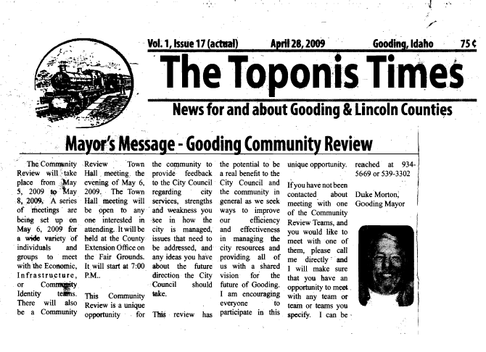
Appendix C: Mayor’s Message, the Toponis Times, April 28, 2009

Appendix D: Gooding Community Review Detailed Itinerary

Gooding Community Review Agenda
Tuesday, May 5th
4:00 P.M. Visiting Team Arrives - Introductions and orientation at GC Memorial Hospital
4:30 P.M. Home Team Arrives – Introductions and orientation at GC Memorial Hospital
5:30 P.M. Town Tour (Time is approximate the tour will begin as soon as the orientation is over i.e. we will likely start the tour a bit before 5:30 PM
7:00 P.M. Dinner (provided by Gooding) at GC Memorial Hospital

Wednesday, May 6th
8:00 A.M. Breakfast (provided by Gooding) at the Lincoln Inn
9:00 A.M. Meetings by focus area
- Infrastructure Team – at City Hall Council Chambers
Airport review
- Economic Development Team – at City Fire Station
Public Officials
- Community Identity – at Sally’s Office Solutions
Historical Society – Coffee group
10:00 A.M. Meetings by focus area
- Infrastructure Team – at City Hall Council Chambers
Airport Review (cont)/ Water and Sewer review
- Economic Development Team – at City Fire Station
Banks, Financial leaders
- Community Identity– Sally’s Office Solutions
School Leaders
11:00 A.M. Meetings by focus area
- Infrastructure Team – at City Hall Council Chambers
Water and Sewer review (cont).
- Economic Development Team – at City Fire Station
Social services (Hospital, Walker Center, Health Dept, Helping Hands
- Community Identity– at Sally’s Office Solutions
High School Senior Students
Noon Lunch (provided by Gooding) at the Gooding High School
1:00 P.M. Meetings by focus area
- Infrastructure Team – at City Hall Council Chambers
Water/Sewer Review (cont)
- Economic Development Team –
Major Businesses (Kiefer Built, Glambia, Brockman, New Cabinets, United Metals)
- Community Identity/Listening Session Team – at Sally’s Office Solutions
Rodeo, Faire, Cowboys
2:00 P.M. Meetings by focus area
- Infrastructure Team – at City Hall Council Chambers
Parks and Recreation review
- Economic Development Team – at City Fire Station
Main Street businesses
- Community Identity– at Sally’s Office Solutions
Church Leaders
3:00 P.M. Meetings by focus area
- Infrastructure Team – City Hall Council Chambers
Elected Officials and staff
- Economic Development Team – at City Fire Station
Realtors and Developers
- Community Identity – at Sally’s Office Solutions
Service Groups
4:00 P.M. Free time / follow up time – Teams can use this time to rest, get caught up on work messages or embark on self guided tours and interviews. Team leaders should check in with the coordinators to arrange any last minute meetings or tours for Thursday Morning. Coordinators will check in with the home team coordinators to arrange Thursday Morning tours if needed.

5:30 P.M. Dinner (provided by Gooding) Coupons provided for every restaurant (Visiting Team members should mix and mingle with other Visiting Team members.
7:00 – 8:30 PM Public Forum at County Extension Building at the Fair Grounds

Thursday, May 7th
8:00 A.M. Breakfast (provided by Gooding) at the Lincoln Inn
Visiting Team work time (each team will work at their Wednesday meeting site)
Noon Lunch (provided by Gooding) at the Sr. Citizen’s Center
1:00 – 3:30P.M Visiting Team Work Time.
4:00 - 5:30 P.M. Visiting Team Sharing Time – Gooding Council Chambers – the Visiting Team will get together to discuss their 2-3 main issues and share with the Visiting Team as a whole.
6:30 – 8:00 P.M. Dinner/Wrap Up Presentation (provided by Gooding) County P&Z Office

Friday, May 8th
8:00 – 9:00 AM Continental Breakfast (provided by Gooding) – at City Hall Council Chambers
9:15 – 11:00 AM Debriefing Meeting Gooding City Hall Council Chambers

*Need home team to be present and available on Tuesday and Wednesday, and at dinner on Thursday.

Appendix E: Write-up concerning restoration of the Schubert Theater by Visiting Team member Dan Everhart

Schubert Theater, Gooding
Comments and Suggestions Provided by Preservation Idaho – June 2009

Overview
The Schubert Theatre is located at 402 Main Street in downtown Gooding, Idaho, a small farming community of approximately 3,300 people in southwestern Idaho. The Theatre is a two-story structure in a commercial style. The Theatre faces west abutting a one-story, commercial structure immediately to the south. The building sits on a concrete foundation, has red brick exterior walls and a flat roof. A two-and-a-half story theater “fly” is located at the rear of the building.
Built by Frank R. Gooding, for whom the town is named, the building was designed by Hugo Clausen. This historic site was added to the National Register of Historic Places in 2004 – see nomination for additional historical and architectural descriptions.
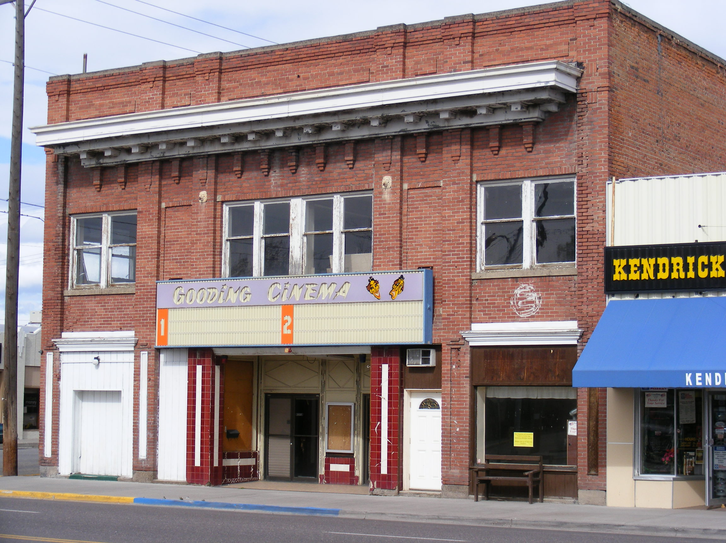
The Theatre underwent remodeling in 1946 and 1983 to accommodate patrons in the changing times and changing décor; but, more recently, restoration efforts have failed and the theater has remained un-used or underused for several years. Within the past two years, the property was acquired by Lonnie and Charmy LeaVell. The LeaVell’s are committed to the protection and restoration of this important piece of Gooding County history.
The following comments and suggestions are meant to provide a general introduction to the steps that could be taken to initiate the care and renovation of this building. These comments are not exhaustive and should be reviewed with the knowledge that they are provided as suggested guidance.
Possible Business Models
In considering the best steps to take toward the eventual renovation and restoration of this significant structure, the owners should consider all options. Both the non-profit and for-profit business models have positive aspects that should be given weight. These two options, presented below with their respective attributes, must be balanced with the needs of the owners, the viability of the project, and the attitude of the community.
For-profit:
- The theater is already privately held, eliminating the need for acquisition.
- For-profit use is a necessary requirement in the process that allows for the use of the Federal Historic Preservation Tax Incentives program – see http://www.nps.gov/history/hps/tps/tax/index.htm
  - Note: Jerry Myers of Myers-Anderson Architects in Pocatello, Idaho has extensive experience with the tax credit/incentives program.
- For-profit renovation and use can attract the investment of outside capital.

Non-profit:
- Though the theater is privately held, the ownership could easily be passed to an established non-profit entity.
  - Note that no entity currently exists and would need to be created and properly overseen.
- Non-profit status would allow for the acquisition of grants and tax-exempt donations, which would be difficult or inaccessible if the building were held in private ownership.
  - Note that grants available for historic preservation projects in Idaho are extremely limited.
- Non-profit status may engender more community support than a project financed privately.

(The historic Wilson Theater in Rupert, Idaho is a good example of the efforts and steps that have been taken to bring a structure of this type back to viability.)
Structural Assessment and Master Plan
Regardless of the ultimate decision reached regarding business models, the Schubert Theater requires the attention of expert architectural and engineering guidance. This attention should be sought initially in the form of a Historic Structure Assessment. This assessment should document the current condition of the building, evaluate those conditions, and prioritize future work to be completed.
A master plan would also be a useful tool to evaluate not only the physical needs and priorities of the building, but the philosophical expectations of the owners and the community. This document may help to define the best business model for continued use of the building.
The National Trust for Historic Preservation, through its National Trust Preservation Fund (http://www.preservationnation.org/resources/find-funding), is a potential source for funding either of these documents. This grant program is dedicated to the planning of preservation. Though these grants are typically reserved for non-profit entities, a privately owned structure, such as the Schubert Theater, may take advantage of this grant opportunity by partnering with a sympathetic non-profit such as the Gooding County Historical Society or the City of Gooding. Note: These grants must be matched.
Contacts
Individuals and organizations throughout the State of Idaho are willing and able to lend their advice and expertise to the cause of historic preservation. A short list is provided below.
Non-profit Organizations:
Preservation Idaho – Dan Everhart
P.O. Box 1495
Boise, ID 83701
208-424-5111
www.preservationidaho.org

Idaho Heritage Trust – Gaetha Pace
P.O. Box 830
Weiser, Idaho 83672
208-549-1778
www.idahoheritage.org

Idaho State Historic Preservation Office – Tricia Canaday/Don Watts
210 Main Street
Boise, ID 83702
208-334-3861
www.idahohistory.net

The National Trust for Historic Preservation – Sheri Freemuth
P.O. Box 9107
Boise Idaho 83707
208-891-4121
www.preservationnation.org

Renaissance Arts Center, Inc. (Wilson Theater in Rupert) – Chris Jackson
614 Fremont St
Rupert, ID 83350
208-436-2787

Architect:
Myers-Anderson Architects – Jerry Myers
101 N Main St
Pocatello, ID 83204
208-232-3741

